

Dynamics GRC/HSE Release notes



Governance Risk & Compliance

Health, Safety & Environment

for

**Microsoft Dynamics 365 for Finance & Operations™**

*Dynamics GRC/HSE version* 10.28.1080.6

2024-01-15



|  |  |
| --- | --- |
| Dynamics 365 FO GRC module GRC is an add-on for Dynamics 365 suite of business application software.  This software provides compelling functionality to support Governance, Risk management and Compliance. |  |
| Dynamics 365 FO HSE/OHS OHS/HSE is an add-on for Dynamics 365 suite of business application software.  This software adds to GRC in that compliance is now deeper with explicit functionality for Health, Safety and Environment as per the depicted sub-modules below. | |
|  | |

Release version

**GRC/HSE Package version:** OHSDeployablePackage_10_28_1080_6

This package was created on Microsoft Dynamics 365 for Finance and Operations:

|  |  |  |
| --- | --- | --- |
| **Release** | **Version** | **Build number** |
| Application release | 10.0.37 | 10.28.1080 |
| Platform release | Platform update 61 | 7.0.7068.67 |

# Enhancements:

|  |  |
| --- | --- |
| **Module** | **Description** |
| Contract management | * On the **Contract** detail form, under the **Projects** Fast tab, **Statement of work** Index tab:   + An **Update contract value** button was added.   + The following columns are now hidden:     - **Currency**, **Exchange rate**, **Converted amount.** * On the **Contract** detail form, under the **Trading partners** Fast tab, a **KPI list** button was added. When this button is clicked, a **KPI list** dialog opens where the user can add/remove KPIs for the selected trading partner. * **Vendor offboarding** can now be done:   + On the **Vendor**, under the **General** Fast tab, an **Offboarding checklist** lookup was added. * On the **Purchase agreement**:   + The **RACI** Fast tab is now moved to be an Index tab under the **Contract administration** Fast tab   + The following labels were changed:     - Under the **Contract administration** Fast tab, **Commercials** Index tab:       * The **Max value enforced** field group label was changed to **Limit spend.**       * The **Max enforced** slider label is now **Contract value enforce.**     - In the Related information pane, the **Max value enforced** Fast tab is now **Contract value enforce.** * On the **Approval** of a **Contract:**   + The user has the option to copy certain values from the **Contract** to the new **Purchase agreement**.   + The following Fast tabs are non-editable (after approval):     - **Content**     - **Trading partner**     - **Projects**     - **Payment schedule**     - **Terms and conditions** |

|  |  |
| --- | --- |
| **Module** | **Description** |
| Policies, contracts and reports | A few minor rules were added to the PCR forms to show/hide applicable fields and Fast tabs according to the **document type**. |
| Internal audit | * A new **Audit engagement letter** SSRS report was created. * The indicator (color) field on the **Audit universe** list page is now hidden. * On the **Audit universe** lines, under the **Auditable entity** Fast tab:   + **Help text** was added to some fields.   + The following fields were removed from the grid and are now displayed under the grid:     - **Last schedule run date.**     - **Last schedule completed.**     - **Next scheduled start date**     - **Schedule ID** * On the **Auditable entity:**   + **U**nder the **Risk** Fast tab, the **Manual residual risk** field is now editable.   + A **Coverage** Fast tab was added. * A new **Audit plan** form was created. **Planned hours** will be updated from here tothe **Auditable entity** on the **Audit universe.** |
| Meetings | * A **Meeting** lookup was added on the **Gate pass.** * A **Create new meeting** dialog was added. |
| Management of change | * A new **Employer’s instruction** report was created. * A new **Engineers instructions** report was created. * A **Create new change request** dialog was added. * The following was done on the **Change request**:   + Some labels were changed under the **General** Fast tab.   + Under the **Scope of change** Fast tab, help text was added to the **Qty impact** field.   + Under the **Funding** Fast tab, a **From budget** lookup was added   + There are now two memo boxes under the **Justification** Fast tab: **Justification** and **Reason for change**. |
| Risk management | A few enhancements were done on the **Enterprise risk profile and controls report** |
| Safety and security | The label of the **Objects listing by location and type** report was changed to **Safety objects listing by location and type.** |
| Operational and sustainability reporting | Performance was enhanced. Please refer to the Maintenance job below. |

|  |  |
| --- | --- |
| **Module** | **Description** |
| Permits to work | * **Security on PTW**: * The following privileges now also give access to the buttons not linked to menu steps:   + - Permit to work control buttons (OHSSafetyPermitControlButtons)     - Permit to work function buttons (OHSSafetyPermitFunctionButtons)     - Permits to work (OHSSafetyPermit) * All these privileges are assigned to the standard duties:   + - Permits to work administrator (OHSSafetyPermitAdministrator)     - Permits to work issuer (OHSSafetyPermitIssuer) * Only roles/duties with the below privileges, now have access to the P2W Control and Function button groups. The standard OHS PTW duties and roles still have access to it:   + - Permit to work control buttons (OHSSafetyPermitControlButtons)     - Permit to work function buttons (OHSSafetyPermitFunctionButtons)   **NOTE: The Permits to work (OHSSafetyPermit) privilege does not have access to the Controls and Function button groups.**   * **Help text** was added to the following sliders on the **HSE parameters, General** tab,under the **Permits to work** Fast tab:   + Allow submission before ‘Valid from date’   + ‘Due date’ same as ‘Valid to date’   + Sync ‘Valid dates’ with ‘Planned dates’ |

# Bug fixes:

|  |  |
| --- | --- |
| **Module** | **Description** |
| Operational and sustainability reporting | There was an error when the **Year to date report** was printed.  The report will now show **all** lines regardless of whether they are marked as **hidden** on the **Targets and responsibility** form, or whether a header line has no 'child' type lines (i.e. Data, Calculation, Source). |

Release Data impact

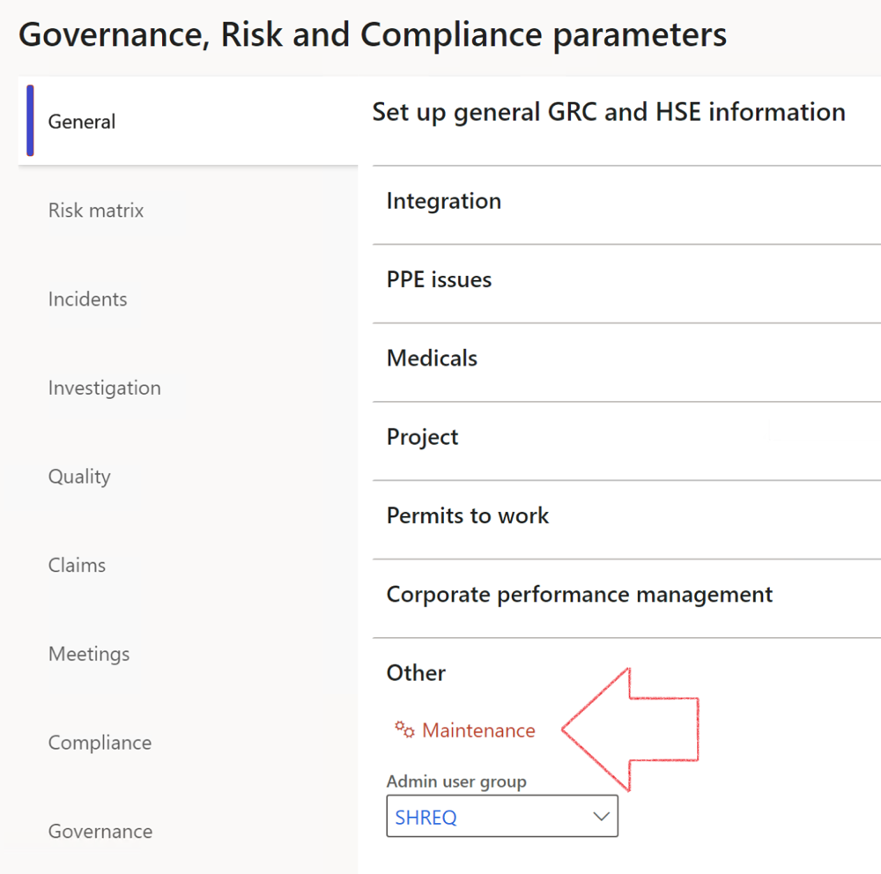

|  |  |
| --- | --- |
|  | The **Maintenance** button is there for designated user. This button repairs any possible data issues. For a full history of all Data related repairs; see table below: |

|  |  |  |
| --- | --- | --- |
| **Process** | **Description/notes** | **Release** |
| Fix location vs. work centres | Populate the new **LocationRecID** field with the related location associated with previously used work centre location (Location) fields on the following tables:   * OHSHazardLocations, * OHSRiskHazard, * OHSRiskHazardWizard, * OHSRiskRegister, * OHSRisksWizard, * OHSSafetyLocations, * OHSSafetyPermit, * OHSSafetyPermitLocations * OHSSafetyPermitOverlap, * OHSSafetyPlan, * OHSInvestigation | 10.0.80.10 |
| Fix risk hazards | Assigning the value "Default Risk" to the new mandatory field **RiskID** (Key field) where empty | 10.0.80.10 |
| Fix incident HRM injury link | Delete all orphaned records from the **OHSIncidentHRMInjuryLnk** table | 10.0.11785.3 |
| Populate SRS analysis enums | Still in concept phase. To provide a link between enum numerical value and value name for use with BYOD data entities. Enums available:   * OHSIncidentType, * OHSIncidentSeverityType.   Table populated: **SRSAnalysisEnums** | 10.0.11785.3 |
| Fix budget transaction lines stock\item dimension | Set **OHSInventDimId** field value to "**AllBlank**" on table **BudgetTransactionLine**, where no value was recorded. This will solve the issue of records not displaying in the form.  **Note: this step will only fix existing budget transaction records in the system. Should any new transactions be uploaded or changed via the data entity Budget Account Entries, special care needs to be taken to specify the Stock dimension = AllBlank and the Item on the excel sheet to import.** | 10.1.1366.6 |
| Update existing incidents with the new **Incident types** | Update existing incidents with the **Incident types** that are setup on the new **Incident type** setup form. (IncidentTypeRecId) | 10.17.1250 |
| Update existing risks with the new **Control types** | Update existing risks with the **Control types** that are setup on the new **Control type** setup form. | 10.17.1250 |
| Fix Inspection locations: Replace Work centre-based locations with HSE locations | Populate the new **ObjectLocation** field with the related HSE location associated with previously used work centre location (**Location**) field on the following tables:   * OHSInspectionJournalName * OHSInspectionJournalTable * OHSInspectionJournalTrans * OHSInspectionHistory * OHSSchedule | 10.24.1114.3 |
| Display of non-calculation lines | Run this job to ensure data consistency and correct display of historical data. |  |

The information contained in this document represents the current view of Axnosis and Microsoft Corporation on the issues discussed as of the date of publication. Because Axnosis and Microsoft must respond to changing market conditions, this document should not be interpreted to be a commitment on the part of Axnosis and Microsoft, and Axnosis and Microsoft cannot guarantee the accuracy of any information presented after the date of publication.

This test script is for informational purposes only. AXNOSIS AND MICROSOFT MAKE NO WARRANTIES, EXPRESS, IMPLIED, OR STATUTORY, AS TO THE INFORMATION IN THIS DOCUMENT.

Complying with all applicable copyright laws is the responsibility of the user. Without limiting the rights under copyright, no part of this document may be reproduced, stored in or introduced into a retrieval system, or transmitted in any form or by any means (electronic, mechanical, photocopying, recording, or otherwise), or for any purpose, without the express written permission of Axnosis and Microsoft Corporation.

Axnosis and Microsoft may have patents, patent applications, trademarks, copyrights, or other intellectual property rights covering subject matter in this document. Except as expressly provided in any written license agreement from Axnosis and Microsoft, the furnishing of this document does not give you any license to these patents, trademarks, copyrights, or other intellectual property.

© 2021 Microsoft Corporation. All rights reserved. Any use or distribution of these materials without express authorization of Microsoft Corp. is strictly prohibited.

Microsoft and Windows are both registered trademarks of Microsoft Corporation in the United States and/or other countries.

The names of actual companies and products mentioned herein may be the trademarks of their respective owners.