

Dynamics GRC/HSE Release notes



Governance Risk & Compliance

Health, Safety & Environment

for

**Microsoft Dynamics 365 for Finance & Operations™**

*Dynamics GRC/HSE version* 10.28.1080.5

2023-12-22



|  |  |
| --- | --- |
| Dynamics 365 FO GRC module GRC is an add-on for Dynamics 365 suite of business application software.  This software provides compelling functionality to support Governance, Risk management and Compliance. |  |
| Dynamics 365 FO HSE/OHS OHS/HSE is an add-on for Dynamics 365 suite of business application software.  This software adds to GRC in that compliance is now deeper with explicit functionality for Health, Safety and Environment as per the depicted sub-modules below. | |
|  | |

Release version

**GRC/HSE Package version:** OHSDeployablePackage_10_28_1080_5

This package was created on Microsoft Dynamics 365 for Finance and Operations:

|  |  |  |
| --- | --- | --- |
| **Release** | **Version** | **Build number** |
| Application release | 10.0.37 | 10.28.1080 |
| Platform release | Platform update 61 | 7.0.7068.67 |

# Enhancements:

|  |  |
| --- | --- |
| **Module** | **Description** |
| Permits to work | * On the **Permit to work register report** dialog, a filter for **Permit to work type ID** was added. * A **Permit to work pool** can now be selected on a **Work order line**. * When a **PTW** is copied, the user can specify the number of copies to be made. The user selects a PTW pool on the copy dialog and the new copies of the permit will be added to the selected **PTW pool**. * The **Start date** of the copied permits is adjusted according to the start date of the original permit based on the **Change date with** field. * When a **new PTW** is created from a **Work order line**, the **Work order line** **description** is used as the text for the **Work to be performed** on the new PTW. * On the **PTW** detail form **lines** view, the **Permit to work** Fast tab was renamed to **Permit to work header**. * **Help text** was added for the **Requires approved safety plan** slider on the **Record a new permit to work dialog**. * The **Permit to work type** is now sorted alphabetically on the **Record a new permit to work dialog**. * The **Permit issue status** is now exposed on the forms (detail form and list pages). * On the **PTW pool**:   + **Unsuspend** only works on line level.   + Additional columns were added to the **Permit to work lookup**.   + A slider was added on the **Header** to re-enabling the **Suspend button** on the **Header**. * On the HSE menu, under **Permits to work**, a new folder was created for **Permit to work list pages** and the list page menu items are grouped inside. * Two sliders were added on the **HSE parameters** under the **Permits to work** Fast tab:   + One for allowing the **Submit** button to be clicked before the “Valid from date”.   + One for allowing the **Due date** to be edited. |

|  |  |
| --- | --- |
| **Module** | **Description** |
| Internal audit | On the **Audit project**, Internal audit Fast tab, under the **Audit procedures** Index tab, a **Planned from date** and **Planned to date** fields were added. |
| Operational and sustainability reporting | * **Custom Spanish labels** were added to the ‘**es Spanish**’ label file. * The **Reporting template** is **locked for editing** when a repository exists for template.Only users belonging to the **Admin user group** can edit templates**.** * An **Alternative** checkbox was added on the **Reporting template lines** grid. When ticked, the user can do an **alternative calculation** of the YTD values for the summary method. |
| Management of change | On the **Change request**, under the **Scope of change** Fast tab:   * The **Project name** is displayed in the **Description** field in the **Scope of change element** lookup. * The table **key** was extended to include the **Element type** and the **Element.** * **Other** was added to the **Element type** enum |

# Bug fixes:

|  |  |
| --- | --- |
| **Module** | **Description** |
| Corporate performance management | The **Asset management counters** (e.g. km) were not displayed after a PU upgrade.  A default **Blank dimension** value will now be assigned on creation of any asset counter record. This will prevent the record form disappearing in future. |
| Operational and sustainability reporting | When a line was marked to be **hidden** on the **Targets and responsibilities** form, it only worked for **Month 1**. The issue has been resolved. |

Release Data impact

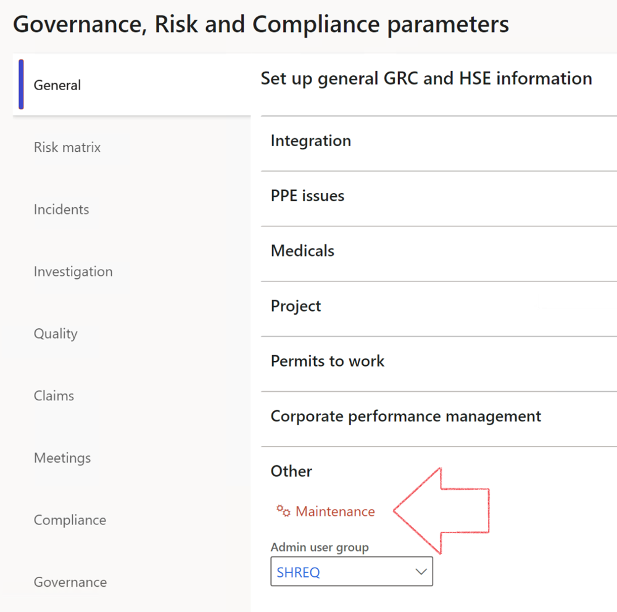

|  |  |
| --- | --- |
|  | The **Maintenance** button is there for designated user. This button repairs any possible data issues. For a full history of all Data related repairs; see table below: |

|  |  |  |
| --- | --- | --- |
| **Process** | **Description/notes** | **Release** |
| Fix location vs. work centres | Populate the new **LocationRecID** field with the related location associated with previously used work centre location (Location) fields on the following tables:   * OHSHazardLocations, * OHSRiskHazard, * OHSRiskHazardWizard, * OHSRiskRegister, * OHSRisksWizard, * OHSSafetyLocations, * OHSSafetyPermit, * OHSSafetyPermitLocations * OHSSafetyPermitOverlap, * OHSSafetyPlan, * OHSInvestigation | 10.0.80.10 |
| Fix risk hazards | Assigning the value "Default Risk" to the new mandatory field **RiskID** (Key field) where empty | 10.0.80.10 |
| Fix incident HRM injury link | Delete all orphaned records from the **OHSIncidentHRMInjuryLnk** table | 10.0.11785.3 |
| Populate SRS analysis enums | Still in concept phase. To provide a link between enum numerical value and value name for use with BYOD data entities. Enums available:   * OHSIncidentType, * OHSIncidentSeverityType.   Table populated: **SRSAnalysisEnums** | 10.0.11785.3 |
| Fix budget transaction lines stock\item dimension | Set **OHSInventDimId** field value to "**AllBlank**" on table **BudgetTransactionLine**, where no value was recorded. This will solve the issue of records not displaying in the form.  **Note: this step will only fix existing budget transaction records in the system. Should any new transactions be uploaded or changed via the data entity Budget Account Entries, special care needs to be taken to specify the Stock dimension = AllBlank and the Item on the excel sheet to import.** | 10.1.1366.6 |
| Update existing incidents with the new **Incident types** | Update existing incidents with the **Incident types** that are setup on the new **Incident type** setup form. (IncidentTypeRecId) | 10.17.1250 |
| Update existing risks with the new **Control types** | Update existing risks with the **Control types** that are setup on the new **Control type** setup form. | 10.17.1250 |
| Fix Inspection locations: Replace Work centre-based locations with HSE locations | Populate the new **ObjectLocation** field with the related HSE location associated with previously used work centre location (**Location**) field on the following tables:   * OHSInspectionJournalName * OHSInspectionJournalTable * OHSInspectionJournalTrans * OHSInspectionHistory * OHSSchedule | 10.24.1114.3 |

The information contained in this document represents the current view of Axnosis and Microsoft Corporation on the issues discussed as of the date of publication. Because Axnosis and Microsoft must respond to changing market conditions, this document should not be interpreted to be a commitment on the part of Axnosis and Microsoft, and Axnosis and Microsoft cannot guarantee the accuracy of any information presented after the date of publication.

This test script is for informational purposes only. AXNOSIS AND MICROSOFT MAKE NO WARRANTIES, EXPRESS, IMPLIED, OR STATUTORY, AS TO THE INFORMATION IN THIS DOCUMENT.

Complying with all applicable copyright laws is the responsibility of the user. Without limiting the rights under copyright, no part of this document may be reproduced, stored in or introduced into a retrieval system, or transmitted in any form or by any means (electronic, mechanical, photocopying, recording, or otherwise), or for any purpose, without the express written permission of Axnosis and Microsoft Corporation.

Axnosis and Microsoft may have patents, patent applications, trademarks, copyrights, or other intellectual property rights covering subject matter in this document. Except as expressly provided in any written license agreement from Axnosis and Microsoft, the furnishing of this document does not give you any license to these patents, trademarks, copyrights, or other intellectual property.

© 2021 Microsoft Corporation. All rights reserved. Any use or distribution of these materials without express authorization of Microsoft Corp. is strictly prohibited.

Microsoft and Windows are both registered trademarks of Microsoft Corporation in the United States and/or other countries.

The names of actual companies and products mentioned herein may be the trademarks of their respective owners.