

Dynamics GRC/HSE Release notes



Governance Risk & Compliance

Health, Safety & Environment

for

**Microsoft Dynamics 365 for Finance & Operations™**

*Dynamics GRC/HSE version* 10.28.1080.4

2023-12-18



|  |  |
| --- | --- |
| Dynamics 365 FO GRC module GRC is an add-on for Dynamics 365 suite of business application software.  This software provides compelling functionality to support Governance, Risk management and Compliance. |  |
| Dynamics 365 FO HSE/OHS OHS/HSE is an add-on for Dynamics 365 suite of business application software.  This software adds to GRC in that compliance is now deeper with explicit functionality for Health, Safety and Environment as per the depicted sub-modules below. | |
|  | |

Release version

**GRC/HSE Package version:** OHSDeployablePackage_10_28_1080_4

This package was created on Microsoft Dynamics 365 for Finance and Operations:

|  |  |  |
| --- | --- | --- |
| **Release** | **Version** | **Build number** |
| Application release | 10.0.37 | 10.28.1080 |
| Platform release | Platform update 61 | 7.0.7068.67 |

# Enhancements:

|  |  |
| --- | --- |
| **Module** | **Description** |
| Corporate performance management | * On the **Procurement plan** header, a new **Mining** slider was added. * Based on above new slider; the following menu items were added under **GRC, Performance**:   + **Sourcing plans** (where slider = “no”)   + **Mine plans** (where slider = “yes”) * On the **Procurement plan lines**, under the **Procurement plan lines** Fast tab:   + A column for **Quantity type** was added   + Also 12 new **Forecast** columns were added   + The current **Show** button now includes an option to show/hide the newly added forecast columns. * The following columns were added on the **Key performance inventory items** setup form:   + **Trans type**   + **Activity** |
| Internal audit | * An **Audit project** lookup was added to the **Action plan header** under the **General** Fast tab, as well as on the **Create Action plan** canvas. * The **Risk control matrix** report was renamed to **Risk control matrix per audit file**. A few changes were made to the report to display data from the **Audit files** of the selected **Audit**. * When a **risk assessment** is done from the **RCM**, a record is added on the **Enterprise risk register** under the **Associations** Fast tab. * A **Risk category** lookup was added on the **RCM** under the **Risk** Fast tab. When a risk assessment is done, the selected value is passed to the risk line. * On the **Audit universe header**, under the **Scope** Fast tab, the **Scope and objective** label was changed to **Audit approach.** When an **Audit** is created, the value from this field is passed to the **Audit**. (A new **Audit approach** display was added on the Audit project) * On the **Audit project**, under the **Internal audit** Fast tab, **Audit initiation** Index tab, a lookup to meetings was added, with label **Engagement meeting**. |

|  |  |
| --- | --- |
| **Module** | **Description** |
| Management of change | * A new **Change authorisation request** (**CAR**) report was created. A **Print** button group with a **Change request** button, was added on the Action pane of the Change request detail form, for printing this new report. * On the **Change request:**   + Under the **Scope of change** Fast tab, the following columns were added to the grid:     - **Worker** lookup     - **Vendor** lookup   + When a Change request is **approved**:     - The text on the notification that pops up was changed to “One or more **scope of change** lines are not approved…” * The **total amount** in the header is updated with the sum of all the **approved** lines |
| Safety and security | * The **Hours worked graph** was enhanced with the following:   + The **Year** selected on the dialog is now printed on the report   + The **Budget** label was changed to **Estimate**   + A **thousand separator** was added to all numbers   + The **actual value** for each month is printed on the graph   + The report is now printing on one page * On the **Object safety report** and the **Location safety report**, the **Risk** label was changed to **Key risks**.   On both reports, the **Key risks** graphs display objects/locations as selected on the Risk register header under the **Applicable** **areas** Fast tab.   * **Hazard listing by classification** report:   + The **headings** are now printed on every page   + The **blank page** at the end of the report was removed   + **Blank lines** printed at the beginning of each new classification were removed |
| PPE | * The **PPE stock movement report** is now printed in landscape |
| Permits to work | * On the **Permits to work pool**, permits can be **Suspended**/**Unsuspended**:   + A **Bulk suspend** button was added on the Action pane   + A **Suspend**/**Unsuspend** button was added under the **Permits to work** (lines) Fast tab * On the **Permits to work pool**, under the **General** Fast tab, an **Integration** field group was added where the **Work order ID** and the **Work order line** are displayed (if the PTW was copied form a Work order). * Users can copy a permit from an existing permit and/or copy a permit that was created on a work order line. To make the copy easier the following was added to the **Create a copy of the current permit** canvas:   + A new **Bulk selection** enum which gives the user the option to select one of the following: **All** / **All** **header** / **All line items** / **No**   + A **Copy into this pool** lookup was also added to allow users to group many permits together for ONE work order line. * The **Print permit in columns** menu item is now hidden * A new **Permit to work register** menu item and report were created |

# Bug fixes:

|  |  |
| --- | --- |
| **Module** | **Description** |
| Risk management | * An error message popped up when the **Enterprise risk mitigation efficiency graph** was printed. * The wrong data for the selected **From** and **To** **dates**, was printed on the **Enterprise risk movement analysis report.**   These issues have been resolved. |
| Legal | The **Legal register report** did not have a heading and an empty page was printed at the end of the report. These issues have been resolved. |
| Corporate performance management | Posted stock journal transactions were not categorized in the correct month in the **Monthly PGM statistics inquiry** form.  The **Performance transaction lines** created from the Movement journal, are now created with the **transaction date** of the Movement journal lines, and not the system date. |
| Tender management | * Only vendors that are already listed on the RFQ are now available to be selected on the **Recommendation** dialog * The **Recommended by** and **Seconded by** worker details are now displayed under the **Recommendation** Index tab on the **RFQ** |

Release Data impact

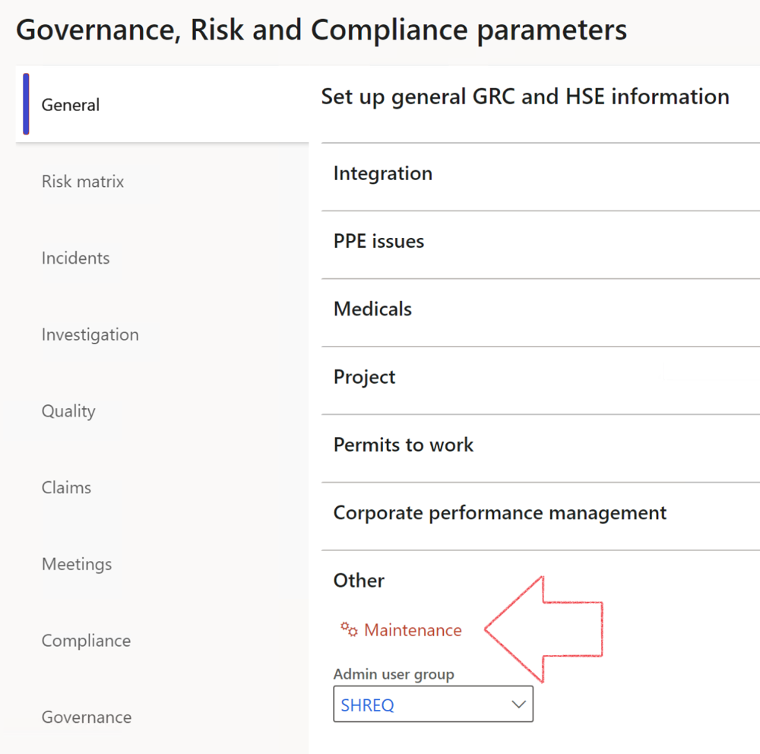

|  |  |
| --- | --- |
|  | The **Maintenance** button is there for designated user. This button repairs any possible data issues. For a full history of all Data related repairs; see table below: |

|  |  |  |
| --- | --- | --- |
| **Process** | **Description/notes** | **Release** |
| Fix location vs. work centres | Populate the new **LocationRecID** field with the related location associated with previously used work centre location (Location) fields on the following tables:   * OHSHazardLocations, * OHSRiskHazard, * OHSRiskHazardWizard, * OHSRiskRegister, * OHSRisksWizard, * OHSSafetyLocations, * OHSSafetyPermit, * OHSSafetyPermitLocations * OHSSafetyPermitOverlap, * OHSSafetyPlan, * OHSInvestigation | 10.0.80.10 |
| Fix risk hazards | Assigning the value "Default Risk" to the new mandatory field **RiskID** (Key field) where empty | 10.0.80.10 |
| Fix incident HRM injury link | Delete all orphaned records from the **OHSIncidentHRMInjuryLnk** table | 10.0.11785.3 |
| Populate SRS analysis enums | Still in concept phase. To provide a link between enum numerical value and value name for use with BYOD data entities. Enums available:   * OHSIncidentType, * OHSIncidentSeverityType.   Table populated: **SRSAnalysisEnums** | 10.0.11785.3 |
| Fix budget transaction lines stock\item dimension | Set **OHSInventDimId** field value to "**AllBlank**" on table **BudgetTransactionLine**, where no value was recorded. This will solve the issue of records not displaying in the form.  **Note: this step will only fix existing budget transaction records in the system. Should any new transactions be uploaded or changed via the data entity Budget Account Entries, special care needs to be taken to specify the Stock dimension = AllBlank and the Item on the excel sheet to import.** | 10.1.1366.6 |
| Update existing incidents with the new **Incident types** | Update existing incidents with the **Incident types** that are setup on the new **Incident type** setup form. (IncidentTypeRecId) | 10.17.1250 |
| Update existing risks with the new **Control types** | Update existing risks with the **Control types** that are setup on the new **Control type** setup form. | 10.17.1250 |
| Fix Inspection locations: Replace Work centre-based locations with HSE locations | Populate the new **ObjectLocation** field with the related HSE location associated with previously used work centre location (**Location**) field on the following tables:   * OHSInspectionJournalName * OHSInspectionJournalTable * OHSInspectionJournalTrans * OHSInspectionHistory * OHSSchedule | 10.24.1114.3 |

The information contained in this document represents the current view of Axnosis and Microsoft Corporation on the issues discussed as of the date of publication. Because Axnosis and Microsoft must respond to changing market conditions, this document should not be interpreted to be a commitment on the part of Axnosis and Microsoft, and Axnosis and Microsoft cannot guarantee the accuracy of any information presented after the date of publication.

This test script is for informational purposes only. AXNOSIS AND MICROSOFT MAKE NO WARRANTIES, EXPRESS, IMPLIED, OR STATUTORY, AS TO THE INFORMATION IN THIS DOCUMENT.

Complying with all applicable copyright laws is the responsibility of the user. Without limiting the rights under copyright, no part of this document may be reproduced, stored in or introduced into a retrieval system, or transmitted in any form or by any means (electronic, mechanical, photocopying, recording, or otherwise), or for any purpose, without the express written permission of Axnosis and Microsoft Corporation.

Axnosis and Microsoft may have patents, patent applications, trademarks, copyrights, or other intellectual property rights covering subject matter in this document. Except as expressly provided in any written license agreement from Axnosis and Microsoft, the furnishing of this document does not give you any license to these patents, trademarks, copyrights, or other intellectual property.

© 2021 Microsoft Corporation. All rights reserved. Any use or distribution of these materials without express authorization of Microsoft Corp. is strictly prohibited.

Microsoft and Windows are both registered trademarks of Microsoft Corporation in the United States and/or other countries.

The names of actual companies and products mentioned herein may be the trademarks of their respective owners.