

Dynamics GRC/HSE Release notes



Governance Risk & Compliance

Health, Safety & Environment

for

**Microsoft Dynamics 365 for Finance & Operations™**

*Dynamics GRC/HSE version* 10.28.1080.10

2024-02-19



|  |  |
| --- | --- |
| Dynamics 365 FO GRC module GRC is an add-on for Dynamics 365 suite of business application software.  This software provides compelling functionality to support Governance, Risk management and Compliance. |  |
| Dynamics 365 FO HSE/OHS OHS/HSE is an add-on for Dynamics 365 suite of business application software.  This software adds to GRC in that compliance is now deeper with explicit functionality for Health, Safety and Environment as per the depicted sub-modules below. | |
|  | |

Release version

**GRC/HSE Package version:** OHSDeployablePackage_10_28_1080_10

This package was created on Microsoft Dynamics 365 for Finance and Operations:

|  |  |  |
| --- | --- | --- |
| **Release** | **Version** | **Build number** |
| Application release | 10.0.37 | 10.28.1080 |
| Platform release | Platform update 61 | 7.0.7068.67 |

# Enhancements:

|  |  |
| --- | --- |
| **Module** | **Description** |
| Permits to work | * On the **All work order maintenance jobs** list page, a **Permits to work in pool** Fast tab was added in the **Related information pane** to display the permit IDs linked to the selected pool. * On the PTW header, the size of the memo box under the **Possible risk impact on other work**Fast tab, was fixed. * Two non-editable fields were added on the **Safety plan** **header** under the **General** Fast tab:   + **Approved by**, and **Approved date**. * The following columns were added to the **Safety plan list page**:   + **Created by**   + **Approved by**   + **Approved date** |
| Investigations | A few lines were removed from the **Investigation report** because they are not required anymore. |

|  |  |
| --- | --- |
| **Module** | **Description** |
| Tender management | * Help text was added to the **Include in checklist** field, on the **Scoring criteria** form. * The **Include in checklist** enum was added on the **Scoring method** setup form. The values selected here will be on the **RFQ scoring criteria** form. * On the **Solicitation type** under the **Governance** Fast tab:   + A field for selecting a **Default item** was added. When an RFQ for **services** is created, this default item can be selected.   + A yes/no **slider** was added to give users the option to allow any team member to be able to **open envelopes**.   + A yes/no **slider** was added for the user to indicate whether **Reply tasks** should be **created**. * When the **Create checklist** button is clicked on the **RFQ**, a validation is done on the status of the vendors. The status of at least one vendor has to be **Sent – Sent**, before a checklist will be created. * On the **Checklist feedback** form:   + The first three tick box columns are hidden for **RFQ checklist feedback.**   + When a **score** is entered on a line:     - The logged in user’s **name** will populate the **Worker** field.       * The **current date** will populate the **Date** field.       * The **Task status** will change to **In progress**. * On the **RFQ list page**, a **Vendor** column was added which displays the number of vendors linked to the RFQ. * On the **RFQ**, in the **Action pane**, the following buttons were added:   (These buttons are only active when the status of the RFQ = **Approved**)   * + **Start**, **Pause** and **Stop** * A **Create qualification checklist** button was added to the **RFQ** Action pane. * On the **RFQ header**, under the **Governance** Fast tab, an **envelope icon** was added to the following Index tab labels:   + **Technical checklist**   + **Commercial checklist** * On the **Procurement plan header:**   + Under the **General** Fast tab:     - A free text field was added for **Execution strategy**     - A field was added for **Target saving %**   + Under the **Governance** Fast tab, a new **Risk** field group was added with the following field under it:   + **Risk register** lookup   + **Risk assessment** lookup * On the **RFQ replies** form:   + Two buttons were added on the **Action pane** in the **Process** group:     - **Technical checklist** – Opens the Technical checklist for the selected vendor.     - **Commercial checklist** – Opens the Commercial checklist for the selected vendor.   + Under the **Bid scoring** Fast tab, an **Adjudicator’s score** column was added to the grid. Only users that belong to the **Adjudication committee**, can enter scores in this new field. * On the **Job plan**, under the General Fast tab, **Percentage %** was added to the **Checklist option** enum. |

# Bug fixes:

|  |  |
| --- | --- |
| **Module** | **Description** |
| Tender management | * The **latest record** is now always at the top of the **All checklist list page**. * On creation of a **new RFQ**, the **Committees** from the selected **Solicitation type** were not pulled to the new RFQ. The issue has been resolved. |

Release Data impact

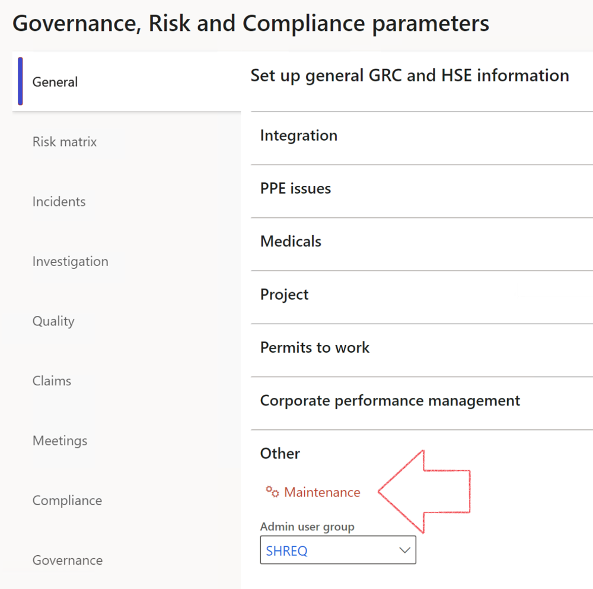

|  |  |
| --- | --- |
|  | The **Maintenance** button is there for designated user. This button repairs any possible data issues. For a full history of all Data related repairs; see table below: |

|  |  |  |
| --- | --- | --- |
| **Process** | **Description/notes** | **Release** |
| Fix location vs. work centres | Populate the new **LocationRecID** field with the related location associated with previously used work centre location (Location) fields on the following tables:   * OHSHazardLocations, * OHSRiskHazard, * OHSRiskHazardWizard, * OHSRiskRegister, * OHSRisksWizard, * OHSSafetyLocations, * OHSSafetyPermit, * OHSSafetyPermitLocations * OHSSafetyPermitOverlap, * OHSSafetyPlan, * OHSInvestigation | 10.0.80.10 |
| Fix risk hazards | Assigning the value "Default Risk" to the new mandatory field **RiskID** (Key field) where empty | 10.0.80.10 |
| Fix incident HRM injury link | Delete all orphaned records from the **OHSIncidentHRMInjuryLnk** table | 10.0.11785.3 |
| Populate SRS analysis enums | Still in concept phase. To provide a link between enum numerical value and value name for use with BYOD data entities. Enums available:   * OHSIncidentType, * OHSIncidentSeverityType.   Table populated: **SRSAnalysisEnums** | 10.0.11785.3 |
| Fix budget transaction lines stock\item dimension | Set **OHSInventDimId** field value to "**AllBlank**" on table **BudgetTransactionLine**, where no value was recorded. This will solve the issue of records not displaying in the form.  **Note: this step will only fix existing budget transaction records in the system. Should any new transactions be uploaded or changed via the data entity Budget Account Entries, special care needs to be taken to specify the Stock dimension = AllBlank and the Item on the excel sheet to import.** | 10.1.1366.6 |
| Update existing incidents with the new **Incident types** | Update existing incidents with the **Incident types** that are setup on the new **Incident type** setup form. (IncidentTypeRecId) | 10.17.1250 |
| Update existing risks with the new **Control types** | Update existing risks with the **Control types** that are setup on the new **Control type** setup form. | 10.17.1250 |
| Fix Inspection locations: Replace Work centre-based locations with HSE locations | Populate the new **ObjectLocation** field with the related HSE location associated with previously used work centre location (**Location**) field on the following tables:   * OHSInspectionJournalName * OHSInspectionJournalTable * OHSInspectionJournalTrans * OHSInspectionHistory * OHSSchedule | 10.24.1114.3 |
| Display of non-calculation lines | Run this job to ensure data consistency and correct display of historical data. |  |

The information contained in this document represents the current view of Axnosis and Microsoft Corporation on the issues discussed as of the date of publication. Because Axnosis and Microsoft must respond to changing market conditions, this document should not be interpreted to be a commitment on the part of Axnosis and Microsoft, and Axnosis and Microsoft cannot guarantee the accuracy of any information presented after the date of publication.

This test script is for informational purposes only. AXNOSIS AND MICROSOFT MAKE NO WARRANTIES, EXPRESS, IMPLIED, OR STATUTORY, AS TO THE INFORMATION IN THIS DOCUMENT.

Complying with all applicable copyright laws is the responsibility of the user. Without limiting the rights under copyright, no part of this document may be reproduced, stored in or introduced into a retrieval system, or transmitted in any form or by any means (electronic, mechanical, photocopying, recording, or otherwise), or for any purpose, without the express written permission of Axnosis and Microsoft Corporation.

Axnosis and Microsoft may have patents, patent applications, trademarks, copyrights, or other intellectual property rights covering subject matter in this document. Except as expressly provided in any written license agreement from Axnosis and Microsoft, the furnishing of this document does not give you any license to these patents, trademarks, copyrights, or other intellectual property.

© 2021 Microsoft Corporation. All rights reserved. Any use or distribution of these materials without express authorization of Microsoft Corp. is strictly prohibited.

Microsoft and Windows are both registered trademarks of Microsoft Corporation in the United States and/or other countries.

The names of actual companies and products mentioned herein may be the trademarks of their respective owners.