

Dynamics GRC/HSE Release notes



Governance Risk & Compliance

Health, Safety & Environment

for

**Microsoft Dynamics 365 for Finance & Operations™**

*Dynamics GRC/HSE version* 10.26.1087.7

2023-10-16



|  |  |
| --- | --- |
| Dynamics 365 FO GRC module GRC is an add-on for Dynamics 365 suite of business application software.  This software provides compelling functionality to support Governance, Risk management and Compliance. |  |
| Dynamics 365 FO HSE/OHS OHS/HSE is an add-on for Dynamics 365 suite of business application software.  This software adds to GRC in that compliance is now deeper with explicit functionality for Health, Safety and Environment as per the depicted sub-modules below. | |
|  | |

Release version

**GRC/HSE Package version:** OHSDeployablePackage_10_26_1087_7

This package was created on Microsoft Dynamics 365 for Finance and Operations:

|  |  |  |
| --- | --- | --- |
| **Release** | **Version** | **Build number** |
| Application release | 10.0.35 | 10.26.1087 |
| Platform release | Platform update 59 | 7.0.6972.45 |

# Enhancements:

|  |  |
| --- | --- |
| **Module** | **Description** |
| General | * On the **HSE parameters**, under the **General** tab, Integration fast tab, the following sliders were hidden as they were used with the “old” Dynaway EAM ISV product:   + **Use engineering asset register**   + **Use engineering locations** * An **Auto create object and location** yes/no slider was added on the HSE and GRC parameters. This is a one way option. Once selected it cannot be unselected. This basically replaces the auto creation of HSE Objects and Locations from the (now) standard Microsoft Asset Management module. |
| Permit to work | * A label was fixed on the **Create a copy of the current permit** dialog * On the **Show SOPs** (Permit detail form) dialog:   + The lines are now sorted from the smallest SOP# number to largest SOP#   + A tick box was added to the front of the grid for indicating which lines are **Applicable** * On the PTW, on the **Request due date extension** drop dialog, the **Reasons** label was changed to **Reason**. * On the **Permit to work type signatures** setup form:   + A **From** column was added with the following enum (planned for future use)     - **Other** (default)     - **Operations**     - **Maintenance**   + The **Description** label was changed to **Default text for comments**. Help text was also added to the field. * On the **PTW checklist feedback** form, a tick box for **Require** was added * A **Compliance framework** Fast tab was added on the **Safety plan**. The values selected under this Fast tab are defaulted into the PTW. * A PTW can now be created form a Project **Work breakdown structure**. * When a PTW is created, the **Start** and **End** **dates** from the create form are by default populated under the Tools and planning Fast tab. The **Start time** = **07:00**, and the **end time** = **17:00** (these times are the default and are editable) * A new menu item and list page were added for **Permit to work in the field** |

|  |  |
| --- | --- |
| **Module** | **Description** |
| Incidents | * The layout of the **Incidents by country and severity** report is now **landscape**. A column was added to display the **Incident ID**. * A new **Data entity** was created for **Incident documents** |
| Critical control measures | * A new menu item and form were created for **Material unwanted events** * On the **Control measures** form:   + A column for entering **Specific objectives** was added   + A grid for **Activities** was added |
| Corporate performance management | A create dialog was added for **Create new monitoring schedule** |
| Internal audit | The **Audit finding report** was fixed. Some labels were changed, field mappings done, and deprecated columns removed. |
| Contract & tender management | * **Accounts payable accruals** now works from the **Statement of work** on the **Contract** and not the Purchase agreement. * The following fields were added on the **Prospective vendors** form:   + **Address**   + **Bank details**   + **Profile** * Two buttons were added on the **vendors** form: **Checklists** and **Task maintenance** * On the **Procurement plan** Header, under the **Planned dates** Fast tab, a field for **Planned start date year** was added. |
| Operational and sustainability reporting | * On the **Reporting template**, under the **Calculation setup** Fast tab, a column for **Month** was added. The user can now choose use values from the current month or the previous month for the calculation. * Security **privileges** were added on the **Attribute values** form. * The **Year to date report** can now be printed from the **Reporting data** form. * A new **Label file maintenance** setup form was created for translating the OSR labels from **English** to for example **Spanish** |

# Bug fixes:

|  |  |
| --- | --- |
| **Module** | **Description** |
| Operational and sustainability reporting | The **Trend** line is displaying correctly on the **Environmental management** workspace, under the **Waste graph** Index tab. |
| Contract & tender management | An error message popped up when the **Open procurement plans** tile on the **Legal, Contracts and Tender management workspace** was clicked. The issue has been resolved. |

Release Data impact

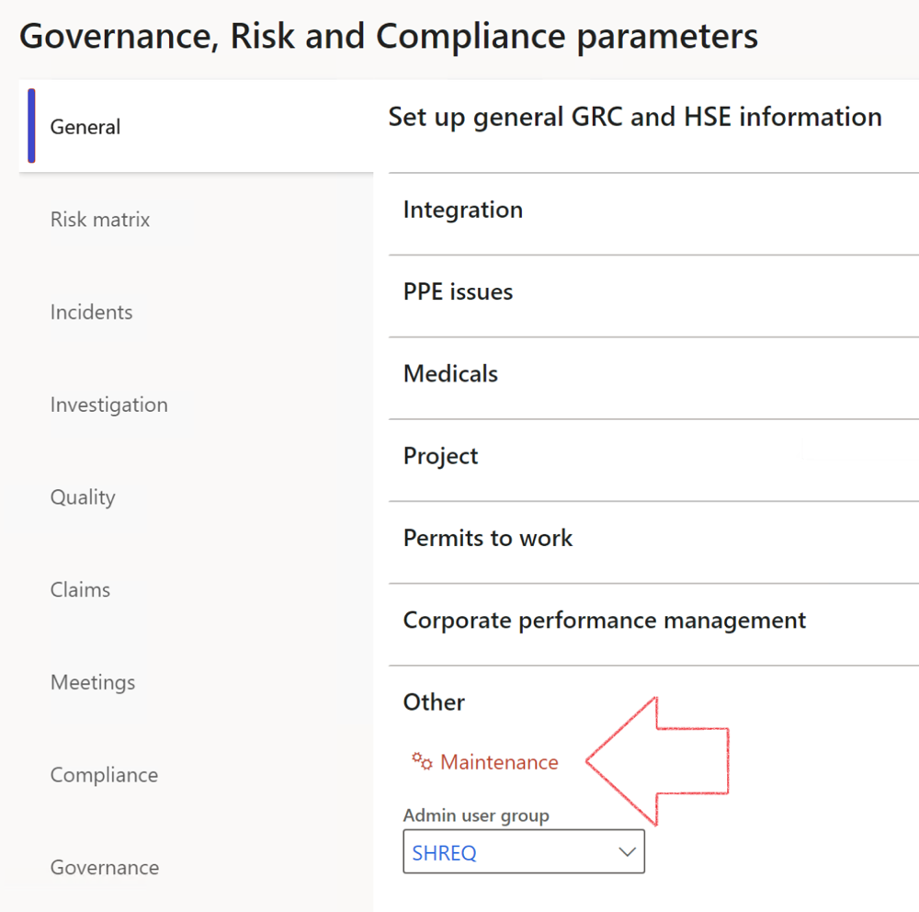

|  |  |
| --- | --- |
|  | The **Maintenance** button is there for designated user. This button repairs any possible data issues. For a full history of all Data related repairs; see table below: |

|  |  |  |
| --- | --- | --- |
| **Process** | **Description/notes** | **Release** |
| Fix location vs. work centres | Populate the new **LocationRecID** field with the related location associated with previously used work centre location (Location) fields on the following tables:   * OHSHazardLocations, * OHSRiskHazard, * OHSRiskHazardWizard, * OHSRiskRegister, * OHSRisksWizard, * OHSSafetyLocations, * OHSSafetyPermit, * OHSSafetyPermitLocations * OHSSafetyPermitOverlap, * OHSSafetyPlan, * OHSInvestigation | 10.0.80.10 |
| Fix risk hazards | Assigning the value "Default Risk" to the new mandatory field **RiskID** (Key field) where empty | 10.0.80.10 |
| Fix incident HRM injury link | Delete all orphaned records from the **OHSIncidentHRMInjuryLnk** table | 10.0.11785.3 |
| Populate SRS analysis enums | Still in concept phase. To provide a link between enum numerical value and value name for use with BYOD data entities. Enums available:   * OHSIncidentType, * OHSIncidentSeverityType.   Table populated: **SRSAnalysisEnums** | 10.0.11785.3 |
| Fix budget transaction lines stock\item dimension | Set **OHSInventDimId** field value to "**AllBlank**" on table **BudgetTransactionLine**, where no value was recorded. This will solve the issue of records not displaying in the form.  **Note: this step will only fix existing budget transaction records in the system. Should any new transactions be uploaded or changed via the data entity Budget Account Entries, special care needs to be taken to specify the Stock dimension = AllBlank and the Item on the excel sheet to import.** | 10.1.1366.6 |
| Update existing incidents with the new **Incident types** | Update existing incidents with the **Incident types** that are setup on the new **Incident type** setup form. (IncidentTypeRecId) | 10.17.1250 |
| Update existing risks with the new **Control types** | Update existing risks with the **Control types** that are setup on the new **Control type** setup form. | 10.17.1250 |
| Fix Inspection locations: Replace Work centre-based locations with HSE locations | Populate the new **ObjectLocation** field with the related HSE location associated with previously used work centre location (**Location**) field on the following tables:   * OHSInspectionJournalName * OHSInspectionJournalTable * OHSInspectionJournalTrans * OHSInspectionHistory * OHSSchedule | 10.24.1114.3 |

The information contained in this document represents the current view of Axnosis and Microsoft Corporation on the issues discussed as of the date of publication. Because Axnosis and Microsoft must respond to changing market conditions, this document should not be interpreted to be a commitment on the part of Axnosis and Microsoft, and Axnosis and Microsoft cannot guarantee the accuracy of any information presented after the date of publication.

This test script is for informational purposes only. AXNOSIS AND MICROSOFT MAKE NO WARRANTIES, EXPRESS, IMPLIED, OR STATUTORY, AS TO THE INFORMATION IN THIS DOCUMENT.

Complying with all applicable copyright laws is the responsibility of the user. Without limiting the rights under copyright, no part of this document may be reproduced, stored in or introduced into a retrieval system, or transmitted in any form or by any means (electronic, mechanical, photocopying, recording, or otherwise), or for any purpose, without the express written permission of Axnosis and Microsoft Corporation.

Axnosis and Microsoft may have patents, patent applications, trademarks, copyrights, or other intellectual property rights covering subject matter in this document. Except as expressly provided in any written license agreement from Axnosis and Microsoft, the furnishing of this document does not give you any license to these patents, trademarks, copyrights, or other intellectual property.

© 2021 Microsoft Corporation. All rights reserved. Any use or distribution of these materials without express authorization of Microsoft Corp. is strictly prohibited.

Microsoft and Windows are both registered trademarks of Microsoft Corporation in the United States and/or other countries.

The names of actual companies and products mentioned herein may be the trademarks of their respective owners.