

Dynamics GRC/HSE Release notes



Governance Risk & Compliance

Health, Safety & Environment

for

**Microsoft Dynamics 365 for Finance & Operations™**

*Dynamics GRC/HSE version* 10.26.1087.4

2023-09-06



|  |  |  |
| --- | --- | --- |
| Dynamics 365 FO GRC module GRC is an add-on for Dynamics 365 suite of business application software.  This software provides compelling functionality to support Governance, Risk management and Compliance. |  | |
| Dynamics 365 FO HSE/OHS OHS/HSE is an add-on for Dynamics 365 suite of business application software.  This software adds to GRC in that compliance is now deeper with explicit functionality for Health, Safety and Environment as per the depicted sub-modules below. | | |
|  | |

Release version

**GRC/HSE Package version:** OHSDeployablePackage_10_26_1087_4

This package was created on Microsoft Dynamics 365 for Finance and Operations:

|  |  |  |
| --- | --- | --- |
| **Release** | **Version** | **Build number** |
| Application release | 10.0.35 | 10.26.1087 |
| Platform release | Platform update 59 | 7.0.6972.45 |

# Enhancements:

|  |  |
| --- | --- |
| **Module** | **Description** |
| Tender management | * On the **RFQ header**, under the **Vendor** Fast tab, a **Vendor options** button group was added. The user has the option to create a **New vendor** or create vendors from **prospective bidders**. * On the **RFQ reply** form, under the **Bid scoring** Fast tab, a column for **Average score** was added that displays decimal values. * On the view **RFQ scores** form, two **decimals** are supported in the **Average score** column * The following columns were added to the **Prospective vendor registration requests** form: **Linked to**, **Linked element** and **Source**. This is used by the mobile app when bidders register for an RFQ. * **Joint ventures** are now supported on **RFQs**   + On the **Vendor:**     - Under the General Fast tab, a **yes/no** slider with label **Joint venture** was added     - A **JV partners** Fast tab was added to list the vendors making up the JV.   + On the **RFQ** header, **Vendor** Fast tab, a **JV** column was added to indicate which vendors are part of a joint venture * **Contract requests** can now be done from the **RFQ** * On the **Compare requests for quotation replies**, a column to display **Waivers** was added * On the **RFQ header**, under the Vendor Fast tab, the **Bid waiver answers** button was renamed to **View bid waiver answers** * A new menu item and report was created for **Bid waivers** |
| Corporate performance management | * A new **Fuel bulk receipt** report was created under **Asset management**, Fuel management |

|  |  |
| --- | --- |
| **Module** | **Description** |
| Permit to work | * On the **Record a new permit to work** dialog, an enum for **Duration** was added. User can now create the permit, and the **start** and **end dates** will auto populate based on this selected value. * On the **Permit to work type actions and questions** setup form, the **Sequence** enum was increased from **10** to **15**. * **Job plans** can now be selected on the **Permit to work** under the **Preparation checklist** Fast tab and **Safety test checklist** Fast tab. * A free text field for **Notes** was added on the **Permit types** dialog * A free text field for **Notes**, was added on the **Activities** dialog (SOPs) * Under the **Mitigation** Fast tab, a **Note** field was added on all Index tabs (except Emergency procedures and Other precautions) * On the Permit to work **checklist feedback** forms:   + Under the **Measurements** index tab, a column for **Date and time** was added   + Under the **Checklist** Index tab, the following two columns were added: **Continuous** and **Ready** |
| Contract management | * On the **New declaration of interest register** dialog, a new field group with label **On behalf of,** was added, with a **Vendor** lookup * On the **Declaration of interest register**, columns for **Vendor account** and **Name** were added. * When a **Purchase agreement** is created from a “restricted” vendor, a warning comes up to warn the user of the **trade restrictions** against the vendor. * A column that displays the number of **Clauses** was added to all **Policies, contracts and reports** list pages |
| Operational and sustainability reporting | * **Data repositories** can now be deleted if the **Actual values = 0** * The **Month** column was removed on the **Data repository** form. * The **Year to date report** menu item and report, were renamed to **Year to date report (Forecast)** * On the **Year to date report (Forecast)** dialog, a filter for **Unit of measure** was added. |

# Bug fixes:

|  |  |
| --- | --- |
| **Module** | **Description** |
| Permit to work | Some question groups were being cut off on the **Permit to work issue and accept** dialog. The question groups are now displayed underneath one another. |
| Contract management | * The **Reporting** column on the **Checklist feedback** form is now only visible for audit checklist feedback * On the **Purchase agreement**, under the **Performance** Fast tab, only **KRI & goals** where the **GRC only** tick = **Yes**, are now on the **Goals** dropdown list |
| Operational and sustainability reporting | On the **Year to date report (Forecast)** report, the values under the **Forecasted** column were from the **Target** column on the Reporting data form. This was fixed. |

Release Data impact

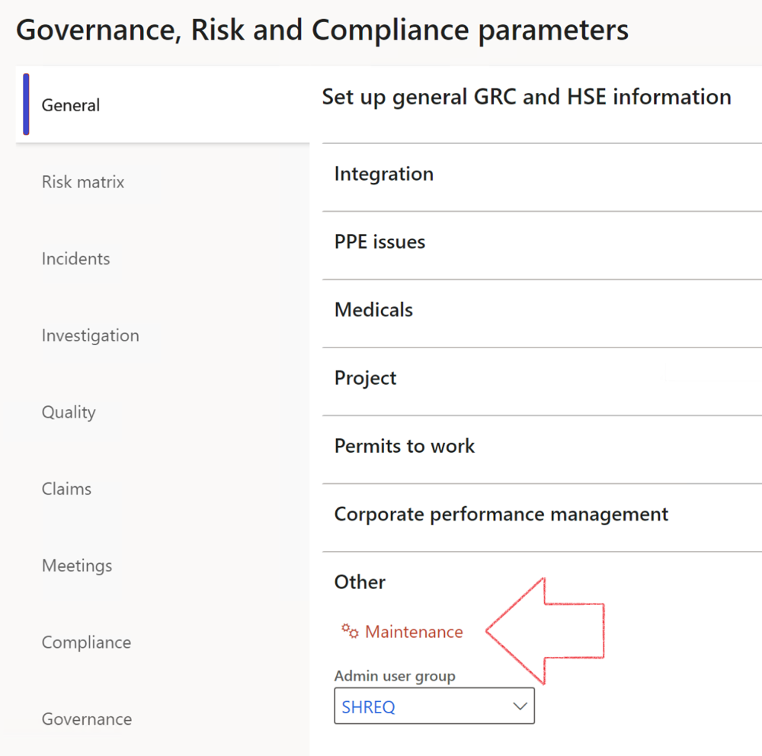

|  |  |
| --- | --- |
|  | The **Maintenance** button is there for designated user. This button repairs any possible data issues. For a full history of all Data related repairs; see table below: |

|  |  |  |
| --- | --- | --- |
| **Process** | **Description/notes** | **Release** |
| Fix location vs. work centres | Populate the new **LocationRecID** field with the related location associated with previously used work centre location (Location) fields on the following tables:   * OHSHazardLocations, * OHSRiskHazard, * OHSRiskHazardWizard, * OHSRiskRegister, * OHSRisksWizard, * OHSSafetyLocations, * OHSSafetyPermit, * OHSSafetyPermitLocations * OHSSafetyPermitOverlap, * OHSSafetyPlan, * OHSInvestigation | 10.0.80.10 |
| Fix risk hazards | Assigning the value "Default Risk" to the new mandatory field **RiskID** (Key field) where empty | 10.0.80.10 |
| Fix incident HRM injury link | Delete all orphaned records from the **OHSIncidentHRMInjuryLnk** table | 10.0.11785.3 |
| Populate SRS analysis enums | Still in concept phase. To provide a link between enum numerical value and value name for use with BYOD data entities. Enums available:   * OHSIncidentType, * OHSIncidentSeverityType.   Table populated: **SRSAnalysisEnums** | 10.0.11785.3 |
| Fix budget transaction lines stock\item dimension | Set **OHSInventDimId** field value to "**AllBlank**" on table **BudgetTransactionLine**, where no value was recorded. This will solve the issue of records not displaying in the form.  **Note: this step will only fix existing budget transaction records in the system. Should any new transactions be uploaded or changed via the data entity Budget Account Entries, special care needs to be taken to specify the Stock dimension = AllBlank and the Item on the excel sheet to import.** | 10.1.1366.6 |
| Update existing incidents with the new **Incident types** | Update existing incidents with the **Incident types** that are setup on the new **Incident type** setup form. (IncidentTypeRecId) | 10.17.1250 |
| Update existing risks with the new **Control types** | Update existing risks with the **Control types** that are setup on the new **Control type** setup form. | 10.17.1250 |
| Fix Inspection locations: Replace Work centre-based locations with HSE locations | Populate the new **ObjectLocation** field with the related HSE location associated with previously used work centre location (**Location**) field on the following tables:   * OHSInspectionJournalName * OHSInspectionJournalTable * OHSInspectionJournalTrans * OHSInspectionHistory * OHSSchedule | 10.24.1114.3 |

The information contained in this document represents the current view of Axnosis and Microsoft Corporation on the issues discussed as of the date of publication. Because Axnosis and Microsoft must respond to changing market conditions, this document should not be interpreted to be a commitment on the part of Axnosis and Microsoft, and Axnosis and Microsoft cannot guarantee the accuracy of any information presented after the date of publication.

This test script is for informational purposes only. AXNOSIS AND MICROSOFT MAKE NO WARRANTIES, EXPRESS, IMPLIED, OR STATUTORY, AS TO THE INFORMATION IN THIS DOCUMENT.

Complying with all applicable copyright laws is the responsibility of the user. Without limiting the rights under copyright, no part of this document may be reproduced, stored in or introduced into a retrieval system, or transmitted in any form or by any means (electronic, mechanical, photocopying, recording, or otherwise), or for any purpose, without the express written permission of Axnosis and Microsoft Corporation.

Axnosis and Microsoft may have patents, patent applications, trademarks, copyrights, or other intellectual property rights covering subject matter in this document. Except as expressly provided in any written license agreement from Axnosis and Microsoft, the furnishing of this document does not give you any license to these patents, trademarks, copyrights, or other intellectual property.

© 2021 Microsoft Corporation. All rights reserved. Any use or distribution of these materials without express authorization of Microsoft Corp. is strictly prohibited.

Microsoft and Windows are both registered trademarks of Microsoft Corporation in the United States and/or other countries.

The names of actual companies and products mentioned herein may be the trademarks of their respective owners.