

Dynamics GRC/HSE Release notes



Governance Risk & Compliance

Health, Safety & Environment

for

**Microsoft Dynamics 365 for Finance & Operations™**

*Dynamics GRC/HSE version* 10.26.1087.3

2023-08-18



|  |  |  |
| --- | --- | --- |
| Dynamics 365 FO GRC module GRC is an add-on for Dynamics 365 suite of business application software.  This software provides compelling functionality to support Governance, Risk management and Compliance. |  | |
| Dynamics 365 FO HSE/OHS OHS/HSE is an add-on for Dynamics 365 suite of business application software.  This software adds to GRC in that compliance is now deeper with explicit functionality for Health, Safety and Environment as per the depicted sub-modules below. | | |
|  | |

Release version

**GRC/HSE Package version:** OHSDeployablePackage_10_26_1087_3

This package was created on Microsoft Dynamics 365 for Finance and Operations:

|  |  |  |
| --- | --- | --- |
| **Release** | **Version** | **Build number** |
| Application release | 10.0.35 | 10.26.1087 |
| Platform release | Platform update 59 | 7.0.6972.45 |

# Enhancements:

|  |  |
| --- | --- |
| **Module** | **Description** |
| Contract management | * On the **Contract**, a new Fast tab was added for **Payment schedule** * On the **Contract**, Content Fast tab, the help text for the **Name** field was improved |
| Tender management | * On the **RFQ** header, Governance Fast tab, under the **Bid specification** Index tab, two field groups were added:   + **Statement of work** (with a grid)   + **Items** (with 4 displays) * Two Fast tabs were added on the **RFQ header**:   + **Terms and conditions**   + **Sign off** * **Due date extension** can now be done on an **RFQ:**   + On the **RFQ Action pane**:     - A new **Status** enum was added.     - An **Extend due date** button was added, which opens a new **Request due date extension** dialog.   + On the **RFQ header**, General Fast tab:     - A slider was added for **Allow due date extension.**     - Display for **Status** was added.   + On the **RFQ header**, Governance Fast tab:     - **Business information** Index tab: display for **Original due date** was added.     - **Contracts** Index tab: 3 new lookups to **Projects** were added.     - **Bid specification** Index tab: **Send email to vendor** button was added * The following Fast tabs are now exposed on the **Specification**:   + **Projects**   + **Terms and conditions** * When no **Solicitation type** is selected on the RFQ**,** a warning will come up when the user clicks on the **Manage replies** or **Compare replies** buttons on the RFQ. * When a contract is created from an RFQ, the **BOM value** is passed from the RFQ to the contract |

|  |  |
| --- | --- |
| **Module** | **Description** |
| Permit to work | * On the **Record a new permit to work** dialog, **Work week** was added to the **Duration** enum. * A dedicated table was created for SOPs on Permits to work. Records can now be added/removed on the Show SOPs dialog. * On the **Permit to work type** setup form, a lookup to **Permit to work lifecycle** was added |
| Operational and sustainability reporting | * The **Reporting template** is now displayed in the **Reporting data** header. * When the **Monthly** and the **Year to date** reports are printed from the **Reporting data** form, the data of the selected record is printed. |

# Bug fixes:

|  |  |
| --- | --- |
| **Module** | **Description** |
| Internal audit | On **Projects**, if the **Internal audit** slider is on No, the following is hidden on the Project:   * The **Execute** tab in the Action pane * The **Internal audit** Fast tab |
| Risk management | When a risk assessment was done from a **Project**, the risk **class** was not populated on the dialog. The issue has been resolved. |

Release Data impact

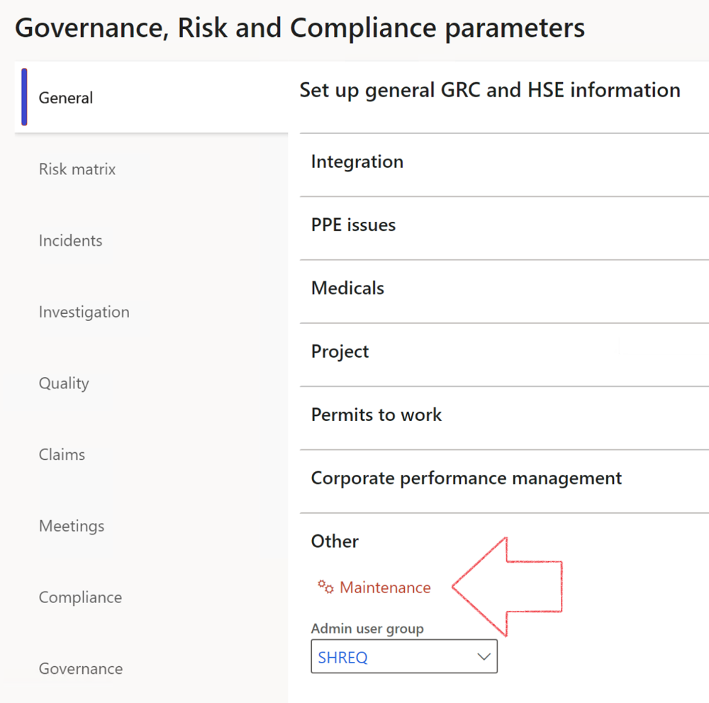

|  |  |
| --- | --- |
|  | The **Maintenance** button is there for designated user. This button repairs any possible data issues. For a full history of all Data related repairs; see table below: |

|  |  |  |
| --- | --- | --- |
| **Process** | **Description/notes** | **Release** |
| Fix location vs. work centres | Populate the new **LocationRecID** field with the related location associated with previously used work centre location (Location) fields on the following tables:   * OHSHazardLocations, * OHSRiskHazard, * OHSRiskHazardWizard, * OHSRiskRegister, * OHSRisksWizard, * OHSSafetyLocations, * OHSSafetyPermit, * OHSSafetyPermitLocations * OHSSafetyPermitOverlap, * OHSSafetyPlan, * OHSInvestigation | 10.0.80.10 |
| Fix risk hazards | Assigning the value "Default Risk" to the new mandatory field **RiskID** (Key field) where empty | 10.0.80.10 |
| Fix incident HRM injury link | Delete all orphaned records from the **OHSIncidentHRMInjuryLnk** table | 10.0.11785.3 |
| Populate SRS analysis enums | Still in concept phase. To provide a link between enum numerical value and value name for use with BYOD data entities. Enums available:   * OHSIncidentType, * OHSIncidentSeverityType.   Table populated: **SRSAnalysisEnums** | 10.0.11785.3 |
| Fix budget transaction lines stock\item dimension | Set **OHSInventDimId** field value to "**AllBlank**" on table **BudgetTransactionLine**, where no value was recorded. This will solve the issue of records not displaying in the form.  **Note: this step will only fix existing budget transaction records in the system. Should any new transactions be uploaded or changed via the data entity Budget Account Entries, special care needs to be taken to specify the Stock dimension = AllBlank and the Item on the excel sheet to import.** | 10.1.1366.6 |
| Update existing incidents with the new **Incident types** | Update existing incidents with the **Incident types** that are setup on the new **Incident type** setup form. (IncidentTypeRecId) | 10.17.1250 |
| Update existing risks with the new **Control types** | Update existing risks with the **Control types** that are setup on the new **Control type** setup form. | 10.17.1250 |
| Fix Inspection locations: Replace Work centre-based locations with HSE locations | Populate the new **ObjectLocation** field with the related HSE location associated with previously used work centre location (**Location**) field on the following tables:   * OHSInspectionJournalName * OHSInspectionJournalTable * OHSInspectionJournalTrans * OHSInspectionHistory * OHSSchedule | 10.24.1114.3 |

The information contained in this document represents the current view of Axnosis and Microsoft Corporation on the issues discussed as of the date of publication. Because Axnosis and Microsoft must respond to changing market conditions, this document should not be interpreted to be a commitment on the part of Axnosis and Microsoft, and Axnosis and Microsoft cannot guarantee the accuracy of any information presented after the date of publication.

This test script is for informational purposes only. AXNOSIS AND MICROSOFT MAKE NO WARRANTIES, EXPRESS, IMPLIED, OR STATUTORY, AS TO THE INFORMATION IN THIS DOCUMENT.

Complying with all applicable copyright laws is the responsibility of the user. Without limiting the rights under copyright, no part of this document may be reproduced, stored in or introduced into a retrieval system, or transmitted in any form or by any means (electronic, mechanical, photocopying, recording, or otherwise), or for any purpose, without the express written permission of Axnosis and Microsoft Corporation.

Axnosis and Microsoft may have patents, patent applications, trademarks, copyrights, or other intellectual property rights covering subject matter in this document. Except as expressly provided in any written license agreement from Axnosis and Microsoft, the furnishing of this document does not give you any license to these patents, trademarks, copyrights, or other intellectual property.

© 2021 Microsoft Corporation. All rights reserved. Any use or distribution of these materials without express authorization of Microsoft Corp. is strictly prohibited.

Microsoft and Windows are both registered trademarks of Microsoft Corporation in the United States and/or other countries.

The names of actual companies and products mentioned herein may be the trademarks of their respective owners.