

Dynamics GRC/HSE Release notes



Governance Risk & Compliance

Health, Safety & Environment

for

**Microsoft Dynamics 365 for Finance & Operations™**

*Dynamics GRC/HSE version* 10.26.1087.2

2023-08-14



|  |  |  |
| --- | --- | --- |
| Dynamics 365 FO GRC module GRC is an add-on for Dynamics 365 suite of business application software.  This software provides compelling functionality to support Governance, Risk management and Compliance. |  | |
| Dynamics 365 FO HSE/OHS OHS/HSE is an add-on for Dynamics 365 suite of business application software.  This software adds to GRC in that compliance is now deeper with explicit functionality for Health, Safety and Environment as per the depicted sub-modules below. | | |
|  | |

Release version

**GRC/HSE Package version:** OHSDeployablePackage_10_26_1087_2

This package was created on Microsoft Dynamics 365 for Finance and Operations:

|  |  |  |
| --- | --- | --- |
| **Release** | **Version** | **Build number** |
| Application release | 10.0.35 | 10.26.1087 |
| Platform release | Platform update 59 | 7.0.6972.45 |

# New additions:

|  |  |
| --- | --- |
| **Module** | **Description** |
| Operational & sustainability reporting | * A new **Workspace setup** form was created * A new **Operational & sustainability reporting workspace** was created |
| Fuel management | Upgraded old Ax 2012 functionality |

# Enhancements:

|  |  |
| --- | --- |
| **Module** | **Description** |
| General | The **Description** field under the **References** field group on the **Standard MS create non conformance**dialog was copied to all GRC/HSE **Create non conformance** dialogs |
| Operational & sustainability reporting | * On the **Reporting template:**   + The help text for the **Calculation expression** field was improved.   + A **Source** button was added in the Action pane   + On the **Line type** enum, **CPM** was changed to **Source** * On **Performance transactions**:   + **Date** is now part of the ‘key’   + On the **New performance transaction** dialog, a lookup for **Activity** was added * On the **Reporting data** form:   + A warning comes up when the user tries to **divide** a value by **0**   + In the filter section, **Header** and **Lines** were added as field group headings * The **Year to date report** menu item is now under **GRC, Operational sustainability, Reports and inquiries, Year to date report** * The following two filters were added to the **Year to date report** and the **Monthly report** dialogs:   + **Reporting area**   + **Reporting template** * A few layout changes were done on the **Monthly report** |

|  |  |
| --- | --- |
| **Module** | **Description** |
| Internal audit | * On the **Internal audit project**, when the **Audit report** is marked as **Final**, the **Generate audit report** button is disabled * On the **Fieldwork** form, Quality assurance Fast tab, the **Improvement plan** lookup now filters to list only Job plans where the **Audit tick** is on * The following label were changed on the **Risk control matrix report**:   + **Control title** is now **Control ID**   + **Finding raised** is now **Findings raised** * On the **Audit universe inquiry**, the **Division** label was changed to **Department** * A few labels were changed on the **Detailed findings and action plans report** * The **Audit plan (not approved) report** was renamed to **Audit plan report** * The **Internal audit workspace** is now only accessible to users in the **Applicable user group** (GRC parameters, Compliance and audit tab) |
| Tender management | If no **Baseline contract** was selected on the **Solicitation type**, a warning pops up on the **Manage** and **Compare** **RFQ** forms |
| Contracts | On the **Contract**, **Trading partners** Fast tab, a **Create agreement** button was added. Allowing users to create a **purchase** or **sales agreement** directly from the contract. |
| Incidents | The **Incident rules** for all **Incident types** are now ignored on all the Incident list pages |
| Permit to work | * The **Reporting** column on the **PTW checklist feedback** form is now hidden * On the **Record a new permit to work** dialog, a new lookup was added for **Duration**, with the following values: **Day**, **week**, **month**. |
| Environmental | The following labels were changed:   * On the **Water and dust sampling points** list page and detail form:   + **Monitoring point ID** is now **Sampling point ID**   + **Monitoring type** is now **Sample type** * The **Monitoring types** menu item and detail form are now **Sample types** * On the **Environmental management workspace**:   + The **Monitoring point** is now **Sampling point** |

# Bug fixes:

|  |  |
| --- | --- |
| **Module** | **Description** |
| Internal audit | * Duplicate lines were printed on the **Audit plan report**. The issue has been resolved. * On the **Internal audit project**: The filter for **Audit files** on the **Create initiation checklist** dialog now only lists audit files of the selected audit |
| Operational & sustainability reporting | * On the **Reporting area row target vs actual graph,** the **Template row** lookup was changed to display the correct line description value and not the placeholder template line value. * On the **Reporting data** form, the replacement text is now displayed for all months |
| Permit to work | * The **Preparation checklist** selected on the **Safety plan** was not pulling through to the PTW. * A duplicate record error popped up on the **Permit to work type groups** setup form. The issue has been resolved. |

Release Data impact

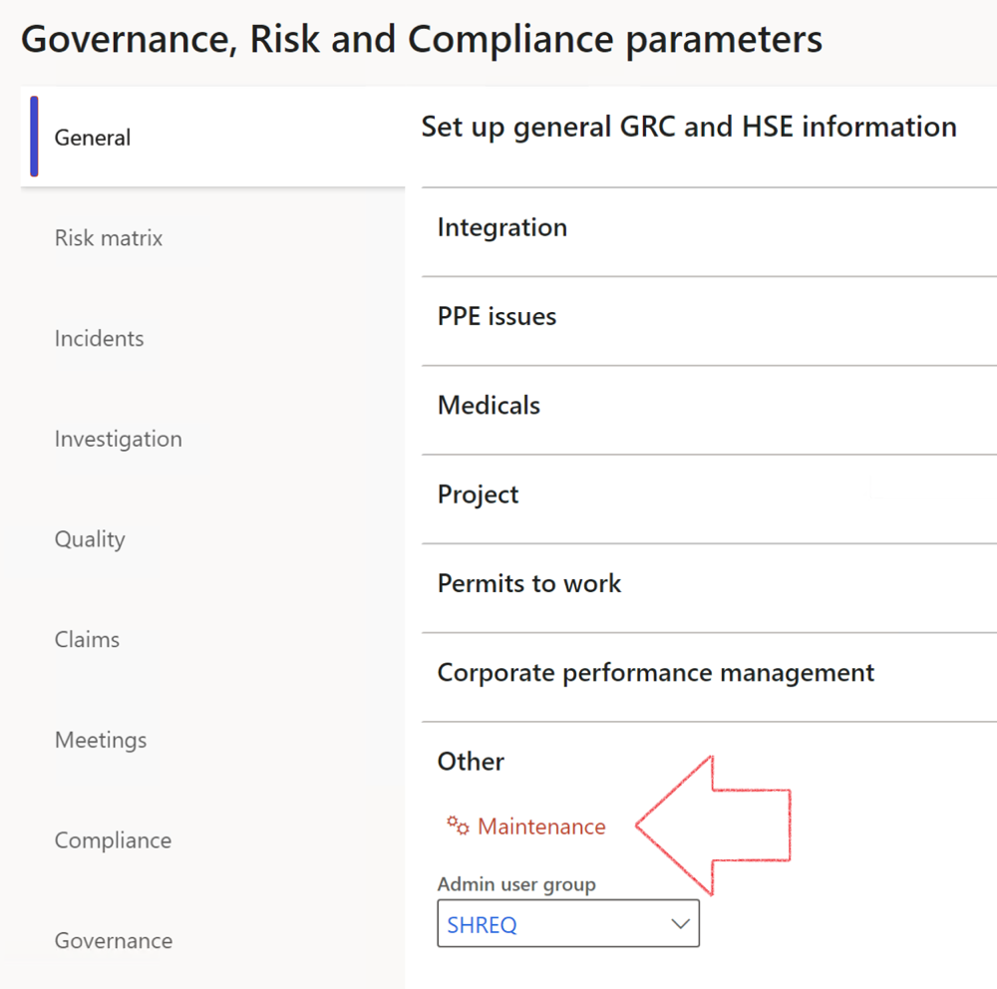

|  |  |
| --- | --- |
|  | The **Maintenance** button is there for designated user. This button repairs any possible data issues. For a full history of all Data related repairs; see table below: |

|  |  |  |
| --- | --- | --- |
| **Process** | **Description/notes** | **Release** |
| Fix location vs. work centres | Populate the new **LocationRecID** field with the related location associated with previously used work centre location (Location) fields on the following tables:   * OHSHazardLocations, * OHSRiskHazard, * OHSRiskHazardWizard, * OHSRiskRegister, * OHSRisksWizard, * OHSSafetyLocations, * OHSSafetyPermit, * OHSSafetyPermitLocations * OHSSafetyPermitOverlap, * OHSSafetyPlan, * OHSInvestigation | 10.0.80.10 |
| Fix risk hazards | Assigning the value "Default Risk" to the new mandatory field **RiskID** (Key field) where empty | 10.0.80.10 |
| Fix incident HRM injury link | Delete all orphaned records from the **OHSIncidentHRMInjuryLnk** table | 10.0.11785.3 |
| Populate SRS analysis enums | Still in concept phase. To provide a link between enum numerical value and value name for use with BYOD data entities. Enums available:   * OHSIncidentType, * OHSIncidentSeverityType.   Table populated: **SRSAnalysisEnums** | 10.0.11785.3 |
| Fix budget transaction lines stock\item dimension | Set **OHSInventDimId** field value to "**AllBlank**" on table **BudgetTransactionLine**, where no value was recorded. This will solve the issue of records not displaying in the form.  **Note: this step will only fix existing budget transaction records in the system. Should any new transactions be uploaded or changed via the data entity Budget Account Entries, special care needs to be taken to specify the Stock dimension = AllBlank and the Item on the excel sheet to import.** | 10.1.1366.6 |
| Update existing incidents with the new **Incident types** | Update existing incidents with the **Incident types** that are setup on the new **Incident type** setup form. (IncidentTypeRecId) | 10.17.1250 |
| Update existing risks with the new **Control types** | Update existing risks with the **Control types** that are setup on the new **Control type** setup form. | 10.17.1250 |
| Fix Inspection locations: Replace Work centre-based locations with HSE locations | Populate the new **ObjectLocation** field with the related HSE location associated with previously used work centre location (**Location**) field on the following tables:   * OHSInspectionJournalName * OHSInspectionJournalTable * OHSInspectionJournalTrans * OHSInspectionHistory * OHSSchedule | 10.24.1114.3 |

The information contained in this document represents the current view of Axnosis and Microsoft Corporation on the issues discussed as of the date of publication. Because Axnosis and Microsoft must respond to changing market conditions, this document should not be interpreted to be a commitment on the part of Axnosis and Microsoft, and Axnosis and Microsoft cannot guarantee the accuracy of any information presented after the date of publication.

This test script is for informational purposes only. AXNOSIS AND MICROSOFT MAKE NO WARRANTIES, EXPRESS, IMPLIED, OR STATUTORY, AS TO THE INFORMATION IN THIS DOCUMENT.

Complying with all applicable copyright laws is the responsibility of the user. Without limiting the rights under copyright, no part of this document may be reproduced, stored in or introduced into a retrieval system, or transmitted in any form or by any means (electronic, mechanical, photocopying, recording, or otherwise), or for any purpose, without the express written permission of Axnosis and Microsoft Corporation.

Axnosis and Microsoft may have patents, patent applications, trademarks, copyrights, or other intellectual property rights covering subject matter in this document. Except as expressly provided in any written license agreement from Axnosis and Microsoft, the furnishing of this document does not give you any license to these patents, trademarks, copyrights, or other intellectual property.

© 2021 Microsoft Corporation. All rights reserved. Any use or distribution of these materials without express authorization of Microsoft Corp. is strictly prohibited.

Microsoft and Windows are both registered trademarks of Microsoft Corporation in the United States and/or other countries.

The names of actual companies and products mentioned herein may be the trademarks of their respective owners.