

Dynamics GRC/HSE Release notes



Governance Risk & Compliance

Health, Safety & Environment

for

**Microsoft Dynamics 365 for Finance & Operations™**

*Dynamics GRC/HSE version* 10.26.1087.10

2023-11-10



|  |  |
| --- | --- |
| Dynamics 365 FO GRC module GRC is an add-on for Dynamics 365 suite of business application software.  This software provides compelling functionality to support Governance, Risk management and Compliance. |  |
| Dynamics 365 FO HSE/OHS OHS/HSE is an add-on for Dynamics 365 suite of business application software.  This software adds to GRC in that compliance is now deeper with explicit functionality for Health, Safety and Environment as per the depicted sub-modules below. | |
|  | |

Release version

**GRC/HSE Package version:** OHSDeployablePackage_10_26_1087_10

This package was created on Microsoft Dynamics 365 for Finance and Operations:

|  |  |  |
| --- | --- | --- |
| **Release** | **Version** | **Build number** |
| Application release | 10.0.35 | 10.26.1087 |
| Platform release | Platform update 59 | 7.0.6972.45 |

# Enhancements:

|  |  |
| --- | --- |
| **Module** | **Description** |
| General | * The **Type** enum value on the **Free text invoice template** defaults to “Other” when record is created. * A new display method was added to the **smmActivities**, stripping **HTML tags**. * The legend on the **Safety management workspace** was being cut off, so it was moved. |
| Tender management | * A new **Recommendation** button was added on the **RFQ**. * On the **Procurement plan** header, under the **General** Fast tab:   + A lookup for **Department** was added   + A display for **Expense budget** was added |
| Operational and sustainability reporting | * A new **Data entity** was created for **Global reporting**. * **Reporting templates** can now be copied:   + A new **Copy** buttonwas added on the **Reporting template**. * On **Targets and responsibilities:**   + The **UOM** of a selected **replacement text** will only overwrite the UOM of the line if there is no UOM specified on the template.   + A **Line type** column was added.   + **T**he **Min value** and **Max value** fields are now not editable for **Header** type lines.   + **Template** was added as a filter. * The **Order of calculations** is now updated automatically by the system when a repository is created. * **Template ID** was added as a filter on the **Reporting data** and **My reporting data** forms * As a 1st step; users can now select a **source** to pull data into the **Reporting data**. For now, only **GL transactions** are taken into account as a source. Later it will include **Item transactions** and more. * The following labels were changed:   + **Global reporting initiative**, menu item and form, are now **Global reporting**   + **GRI standard** on the Global reporting and Reporting template forms,is now **GR standard** |

|  |  |
| --- | --- |
| **Module** | **Description** |
| Safety and security | * On the **Safety plan**, the help text for the **Closed** slider was fixed. * The Safety pan report was not printing correctly. It has been fixed. |
| Management of change | Two new Fast tabs were added on the **Change request** form:   * **Instruction** – with a memo box * **Funding** – with a memo box, Budget lookup, and Transferred Yes/no slider |
| Risk | * Bowtie risk register now displays the relevant MUE * When an Operational risk assessment is done, and the residual risk score is more than the material criteria (on the MUE), the user is asked if they want to place this assessment into the Bowtie focus. |
| Permit to work | * The **Preparation** button on the **PTW** is now greyed out when the following actions were performed: **Void**, **Signed off**, **Cancelled**, **Filed**. * **Signature type** is now displayed in the **Actions** grid. * The **Reject** action button now also commits a record under the **Actions grid**. * **Co signatories** can now add comments on the PTW when signing:   + A column for **Co signature** was added on the **Permit to work type signatures** setup form.   + A record is added under the **action log**. |

# Bug fixes:

|  |  |
| --- | --- |
| **Module** | **Description** |
| Permit to work | * The **PTW signature sequence** was fixed to work with multiple workers. * The wrong comments were displayed when **approvals** and **declarations** were done. * The buttons on the **PTW list page** were not sensitive to the status of the selected permit. * On the **PTW**, when the user clicked on the **Show SOPs** button, no records were listed even though a the PTW was created from an existing **Safety plan**. * On the project **WBS lines:**   + The **PTW button** group is now disabled for **Header** type lines.   + When the **Add existing permit** button is clicked, only **approved** permits with the **same functional location** as the WBS line, will be on the list to be selected.   + The wrong permit opened when clicking on the **PTW hyper link**. |
| Claims | On the **Claims management workspace**, the filter for selecting the **Company** was not working. The issue has been resolved. |
| Operational and sustainability reporting | * When a new repository is created, the wrong data for the **Previous year responsible worker** and **Previous year targets** was used. * When a **Reporting data** form was opened where no data has been entered, the **YTD actual** and **YTD target** fields had values. * The YTD actual value was not updated on the line on the My reporting data form. |
| Internal audit | On the **Audit universe inquiry**:   * The hyper link to the **Auditable entities** was removed. * The **Area of compliance** list page opened when clicking on the **Audit universe** dropdown. * The **Department** and **Risk register** references were removed. They were from the old **OHS risks table**. |
| General | The **wrong** (item) **description** printed on the **Free text invoice report**. |

Release Data impact

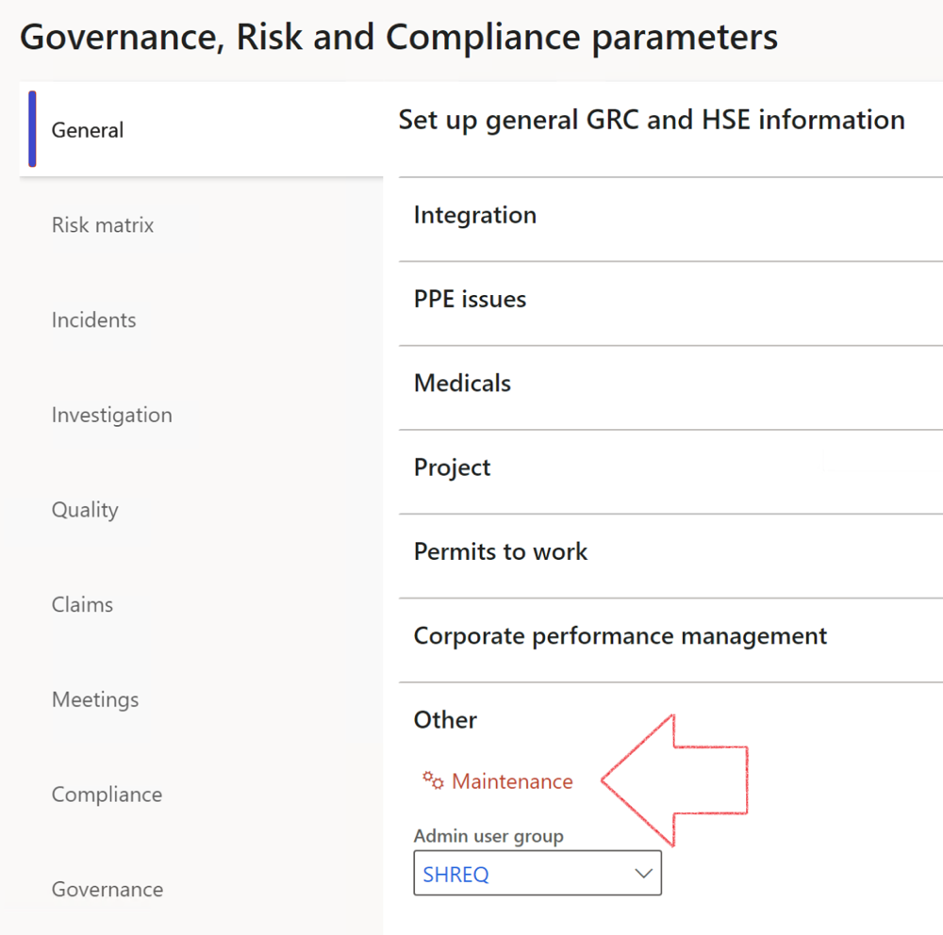

|  |  |
| --- | --- |
|  | The **Maintenance** button is there for designated user. This button repairs any possible data issues. For a full history of all Data related repairs; see table below: |

|  |  |  |
| --- | --- | --- |
| **Process** | **Description/notes** | **Release** |
| Fix location vs. work centres | Populate the new **LocationRecID** field with the related location associated with previously used work centre location (Location) fields on the following tables:   * OHSHazardLocations, * OHSRiskHazard, * OHSRiskHazardWizard, * OHSRiskRegister, * OHSRisksWizard, * OHSSafetyLocations, * OHSSafetyPermit, * OHSSafetyPermitLocations * OHSSafetyPermitOverlap, * OHSSafetyPlan, * OHSInvestigation | 10.0.80.10 |
| Fix risk hazards | Assigning the value "Default Risk" to the new mandatory field **RiskID** (Key field) where empty | 10.0.80.10 |
| Fix incident HRM injury link | Delete all orphaned records from the **OHSIncidentHRMInjuryLnk** table | 10.0.11785.3 |
| Populate SRS analysis enums | Still in concept phase. To provide a link between enum numerical value and value name for use with BYOD data entities. Enums available:   * OHSIncidentType, * OHSIncidentSeverityType.   Table populated: **SRSAnalysisEnums** | 10.0.11785.3 |
| Fix budget transaction lines stock\item dimension | Set **OHSInventDimId** field value to "**AllBlank**" on table **BudgetTransactionLine**, where no value was recorded. This will solve the issue of records not displaying in the form.  **Note: this step will only fix existing budget transaction records in the system. Should any new transactions be uploaded or changed via the data entity Budget Account Entries, special care needs to be taken to specify the Stock dimension = AllBlank and the Item on the excel sheet to import.** | 10.1.1366.6 |
| Update existing incidents with the new **Incident types** | Update existing incidents with the **Incident types** that are setup on the new **Incident type** setup form. (IncidentTypeRecId) | 10.17.1250 |
| Update existing risks with the new **Control types** | Update existing risks with the **Control types** that are setup on the new **Control type** setup form. | 10.17.1250 |
| Fix Inspection locations: Replace Work centre-based locations with HSE locations | Populate the new **ObjectLocation** field with the related HSE location associated with previously used work centre location (**Location**) field on the following tables:   * OHSInspectionJournalName * OHSInspectionJournalTable * OHSInspectionJournalTrans * OHSInspectionHistory * OHSSchedule | 10.24.1114.3 |

The information contained in this document represents the current view of Axnosis and Microsoft Corporation on the issues discussed as of the date of publication. Because Axnosis and Microsoft must respond to changing market conditions, this document should not be interpreted to be a commitment on the part of Axnosis and Microsoft, and Axnosis and Microsoft cannot guarantee the accuracy of any information presented after the date of publication.

This test script is for informational purposes only. AXNOSIS AND MICROSOFT MAKE NO WARRANTIES, EXPRESS, IMPLIED, OR STATUTORY, AS TO THE INFORMATION IN THIS DOCUMENT.

Complying with all applicable copyright laws is the responsibility of the user. Without limiting the rights under copyright, no part of this document may be reproduced, stored in or introduced into a retrieval system, or transmitted in any form or by any means (electronic, mechanical, photocopying, recording, or otherwise), or for any purpose, without the express written permission of Axnosis and Microsoft Corporation.

Axnosis and Microsoft may have patents, patent applications, trademarks, copyrights, or other intellectual property rights covering subject matter in this document. Except as expressly provided in any written license agreement from Axnosis and Microsoft, the furnishing of this document does not give you any license to these patents, trademarks, copyrights, or other intellectual property.

© 2021 Microsoft Corporation. All rights reserved. Any use or distribution of these materials without express authorization of Microsoft Corp. is strictly prohibited.

Microsoft and Windows are both registered trademarks of Microsoft Corporation in the United States and/or other countries.

The names of actual companies and products mentioned herein may be the trademarks of their respective owners.