

Dynamics GRC/HSE Release notes



Governance Risk & Compliance

Health, Safety & Environment

for

**Microsoft Dynamics 365 for Finance & Operations™**

*Dynamics GRC/HSE version* 10.24.1114.8

2023-07-26



|  |  |  |
| --- | --- | --- |
| Dynamics 365 FO GRC module GRC is an add-on for Dynamics 365 suite of business application software.  This software provides compelling functionality to support Governance, Risk management and Compliance. |  | |
| Dynamics 365 FO HSE/OHS OHS/HSE is an add-on for Dynamics 365 suite of business application software.  This software adds to GRC in that compliance is now deeper with explicit functionality for Health, Safety and Environment as per the depicted sub-modules below. | | |
|  | |

Release version

**GRC/HSE Package version:** OHSDeployablePackage_10_24_1114_8

This package was created on Microsoft Dynamics 365 for Finance and Operations:

|  |  |  |
| --- | --- | --- |
| **Release** | **Version** | **Build number** |
| Application release | 10.0.33 | 10.24.1114 |
| Platform release | Platform update 57 | 7.0.6861.30 |

# Enhancements:

|  |  |
| --- | --- |
| **Module** | **Description** |
| General | The **OHS label files** are now available in several languages:   * Spanish (Mexico), Spanish (Chile), Spanish, Russian, Portuguese (Brazil), Portuguese, Polish, Italian, French, Dutch (Belgium), Dutch, Danish, Chinese (Simplified, Mainland), Arabic, Afrikaans (South Africa), German. |
| Corporate performance management | * The **Responsible person** lookup is now hidden under the filter section on the **My reporting data** form, and only record assigned to the logged in user are displayed * On the **Targets and responsibility** form, users can select a replacement text from a list for every line where needed.   + A new menu item and form for creating **Replacement lists** were created for **Operational & sustainability reporting**.   + The following menu items were copied from **Product information management** to **GRC, Operational & sustainability reporting, Setup for Operational & sustainability reporting**     - **Attribute types**     - **Attributes**     - **Attribute groups** |
| Legal | **Meetings** and the **Declaration of interest register** can now be associated:   * A **Meeting** column was added on the **Declaration of interest register** grid * A **Meeting ID** lookup was added on the **New declaration of interest register** dialog * On the Action pane of the **Meetings** list page and detail form, a new button was added in the **Preparation** group: **Declaration of interest** |
| Environmental | * On the **Waste register**: * An **Actuals** button was added. This opens the **Waste actual values** form for the selected record * A **Target effective from** date column was added to the grid * On the **Environmental management workspace**, the **Monitoring point graph** label was renamed to **Water and dust sampling point** |

|  |  |
| --- | --- |
| **Module** | **Description** |
| Internal audit | * On the **Audit procedure** list page:   + Records cannot be deleted   + **Void** is now a value on the **Status** enum   + When the status is changed to **Void**, the user is notified that the audit procedure and the working paper will be marked as **voided**   + When the status of a **Working paper** is changed to **Void** on the Audit file, the status of the audit procedure (header) will be **Void.** * The following buttons are now only available on the **Audit procedure checklist feedback** form:   + **Comments**   + **Complete all**   + **Create audit findings** * The following buttons are disabled on the **Audit procedure feedback** form when the status of the Audit procedure is **Closed**:   + **Complete all**   + **Create audit finding** * On the **Audit file** header, General Fast tab, the **Internal audit project** label was changed to **Internal audit project ID** * On the **Auditable entity**:   + A new field group was added for **Manual risk rating**   + A display for **Manual residual risk** was added under this new field group * On the **Audit universe** lines:   + Under the **Audit universe** Fast tab:     - The **Demarcation** field group was renamed to **To be audited**     - A **Planned audit manager** lookup was added under the **Details** field group   + Under the **Controls** Fast tab, the **Planned user** field was renamed to **Planned auditor**   + The **Planned audit manager** and the selected **Team**  is passed to the audit project via the scheduling.   + Under the **Auditable entity** Fast tab, the **Audit need** label was changed to **Audit need/Priority** * A few changes were done on the **Risk control matrix** **report** * The **Audit non-conformance report** menu item was moved from **Internal audit** to **Compliance, Reports and inquiries** * On the **Fieldwork** form:   + There is now no validation done on whether the **logged in user** is the **Assessor** when the record is posted   + In the **Audit file** dropdown list, the **Assessor** was replaced with the **Preparer** on the audit file |

# Bug fixes:

|  |  |
| --- | --- |
| **Module** | **Description** |
| Internal audit | On the **Create new internal audit file** dialog, the Audit type was being displayed in the **Audit name** field. The issue was resolved. |
| Corporate performance management | The **Reporting template line calculation** Data entity was not exporting and importing the **Value from line number** fieldon the Reporting template, under the Calculation setup Fast tab. The issue was resolved: **Template ID** and **Line number** were added to the Data entity. |

Release Data impact

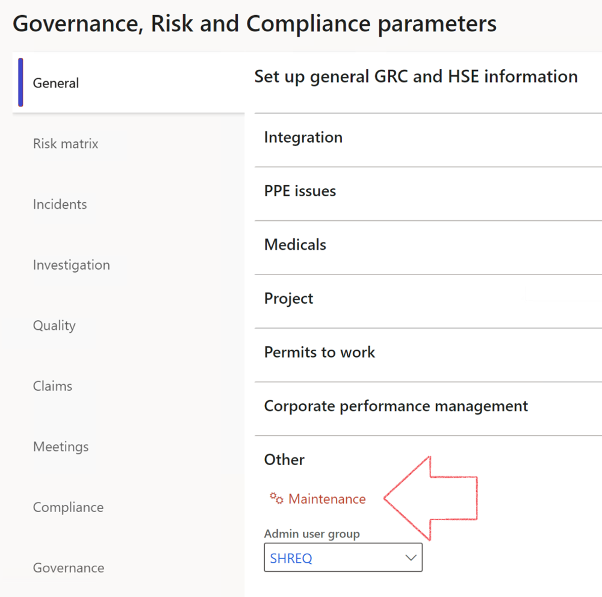

|  |  |
| --- | --- |
|  | The **Maintenance** button is there for designated user. This button repairs any possible data issues. For a full history of all Data related repairs; see table below: |

|  |  |  |
| --- | --- | --- |
| **Process** | **Description/notes** | **Release** |
| Fix location vs. work centres | Populate the new **LocationRecID** field with the related location associated with previously used work centre location (Location) fields on the following tables:   * OHSHazardLocations, * OHSRiskHazard, * OHSRiskHazardWizard, * OHSRiskRegister, * OHSRisksWizard, * OHSSafetyLocations, * OHSSafetyPermit, * OHSSafetyPermitLocations * OHSSafetyPermitOverlap, * OHSSafetyPlan, * OHSInvestigation | 10.0.80.10 |
| Fix risk hazards | Assigning the value "Default Risk" to the new mandatory field **RiskID** (Key field) where empty | 10.0.80.10 |
| Fix incident HRM injury link | Delete all orphaned records from the **OHSIncidentHRMInjuryLnk** table | 10.0.11785.3 |
| Populate SRS analysis enums | Still in concept phase. To provide a link between enum numerical value and value name for use with BYOD data entities. Enums available:   * OHSIncidentType, * OHSIncidentSeverityType.   Table populated: **SRSAnalysisEnums** | 10.0.11785.3 |
| Fix budget transaction lines stock\item dimension | Set **OHSInventDimId** field value to "**AllBlank**" on table **BudgetTransactionLine**, where no value was recorded. This will solve the issue of records not displaying in the form.  **Note: this step will only fix existing budget transaction records in the system. Should any new transactions be uploaded or changed via the data entity Budget Account Entries, special care needs to be taken to specify the Stock dimension = AllBlank and the Item on the excel sheet to import.** | 10.1.1366.6 |
| Update existing incidents with the new **Incident types** | Update existing incidents with the **Incident types** that are setup on the new **Incident type** setup form. (IncidentTypeRecId) | 10.17.1250 |
| Update existing risks with the new **Control types** | Update existing risks with the **Control types** that are setup on the new **Control type** setup form. | 10.17.1250 |
| Fix Inspection locations: Replace Work centre-based locations with HSE locations | Populate the new **ObjectLocation** field with the related HSE location associated with previously used work centre location (**Location**) field on the following tables:   * OHSInspectionJournalName * OHSInspectionJournalTable * OHSInspectionJournalTrans * OHSInspectionHistory * OHSSchedule | 10.24.1114.3 |

The information contained in this document represents the current view of Axnosis and Microsoft Corporation on the issues discussed as of the date of publication. Because Axnosis and Microsoft must respond to changing market conditions, this document should not be interpreted to be a commitment on the part of Axnosis and Microsoft, and Axnosis and Microsoft cannot guarantee the accuracy of any information presented after the date of publication.

This test script is for informational purposes only. AXNOSIS AND MICROSOFT MAKE NO WARRANTIES, EXPRESS, IMPLIED, OR STATUTORY, AS TO THE INFORMATION IN THIS DOCUMENT.

Complying with all applicable copyright laws is the responsibility of the user. Without limiting the rights under copyright, no part of this document may be reproduced, stored in or introduced into a retrieval system, or transmitted in any form or by any means (electronic, mechanical, photocopying, recording, or otherwise), or for any purpose, without the express written permission of Axnosis and Microsoft Corporation.

Axnosis and Microsoft may have patents, patent applications, trademarks, copyrights, or other intellectual property rights covering subject matter in this document. Except as expressly provided in any written license agreement from Axnosis and Microsoft, the furnishing of this document does not give you any license to these patents, trademarks, copyrights, or other intellectual property.

© 2021 Microsoft Corporation. All rights reserved. Any use or distribution of these materials without express authorization of Microsoft Corp. is strictly prohibited.

Microsoft and Windows are both registered trademarks of Microsoft Corporation in the United States and/or other countries.

The names of actual companies and products mentioned herein may be the trademarks of their respective owners.