

Dynamics GRC/HSE Release notes



Governance Risk & Compliance

Health, Safety & Environment

for

**Microsoft Dynamics 365 for Finance & Operations™**

*Dynamics GRC/HSE version* 10.24.1114.7

2023-07-19



|  |  |  |
| --- | --- | --- |
| Dynamics 365 FO GRC module GRC is an add-on for Dynamics 365 suite of business application software.  This software provides compelling functionality to support Governance, Risk management and Compliance. |  | |
| Dynamics 365 FO HSE/OHS OHS/HSE is an add-on for Dynamics 365 suite of business application software.  This software adds to GRC in that compliance is now deeper with explicit functionality for Health, Safety and Environment as per the depicted sub-modules below. | | |
|  | |

Release version

**GRC/HSE Package version:** OHSDeployablePackage_10_24_1114_7

This package was created on Microsoft Dynamics 365 for Finance and Operations:

|  |  |  |
| --- | --- | --- |
| **Release** | **Version** | **Build number** |
| Application release | 10.0.33 | 10.24.1114 |
| Platform release | Platform update 57 | 7.0.6861.30 |

# Bug fixes:

|  |  |
| --- | --- |
| **Module** | **Description** |
| Corporate performance management | An error message popped up when the **Reporting data** form was opened. The issue has been resolved. |
| Internal audit | * The **Observation** text on the **Fieldwork** form was not pulling through to the **Description** field on the **Create activity** dialog. * The **Checklist ID** in the **Last created checklist** field was not updating on the RCM. * When an **Audit report** is generated from the Internal audit project, only the following non conformances are now created inside the **Audit report**, under the **References** Index tab:   + **Reportable** non conformances   + **Not closed** non conformances |

# Enhancements:

|  |  |
| --- | --- |
| **Module** | **Description** |
| Incidents | * **LTI** was added to the **KPI** enum under **Targets and goals**. The calculations are done, and the results displayed on the **Safety management workspace**, **Target vs actual index** tab. |
| Safety and security | * On the **QR code generator setup** form, a **QR code** record cannot be edited/deleted if it is created form the **Gate pass** * The **Print access card** button on the **Gate pass** will be disabled until the access card is issued |
| Permit to work | * A dialog for printing the **Permit to work report** was created. The parameters enable the user to select the areas that will be printed on the report. |
| Environmental | * Under HSE, Environmental, the **Monitoring points** menu item’s labels were changed to **Water and dust sampling points** |
| General | * A hyper link was added to the **Checklist Id** to open the **Checklist feedback** form |

|  |  |
| --- | --- |
| **Module** | **Description** |
| Internal audit | * On the **Internal audit project**:   + **Internal audit** Fast tab, **Audit initiation index** tab and **QAIP index tab**: The **Job plan** dropdown lists filter on records where the **Audit tick** is selected   + The **Audit files** Fast tab in the **Related information pane** is now removed hidden   + A **View working papers** button was added in the Action pane, Execute tab, under the **Related** button group   + **General** Index tab:     - The **Owner** field was renamed to **Owner (department manager)**   + **Audit extension** Index tab:     - Help text was improved for the **Extend** slider     - When the slider is moved to **No**, the following fields are cleared:       * **Extension done by**       * **Reason for extension**   + **Audit report** Index tab:     - A **Planned review date** field was added     - A **Review actual date** field was added     - When the **Final** slider is moved to **Yes**, the user is warned that the fields will be locked, and that the audit report will be **Approved** * On the **RCM:**   + A memo box with label **Control walkthrough** was added   + A free text field with label **Control objective** was added   + The **Testing procedures** Fast tab was renamed to **Audit procedures**   + A new **Audit procedure** Field group with worker lookup, was added under the **Required signatures** Fast tab   + The **Samples** (per control) are now automatically going to the **Audit procedure lines.** * On the **Fieldwork** form:   + Under the **General** Fast tab, the **Observation/notes** label was changed to **Activity observation/notes**   + In the **Audit procedures** Fast tab, a column for **Actual score** was added   + The order of the **buttons** in the Action pane was changed   + The text on the dialog that comes up when the **Post** button is clicked, was changed to **Which audit file must be used to commit control scores to?** * When feedback is done on the **Initiation checklist** and on the **QAIP checklist**, the name of the **Project manager** is passed to the **Person in charge** field in the Related information pane on the **Checklist** form. * On the **Create audit universe** dialog: the **Audit type** dropdown only show records of type Internal audit |

|  |  |
| --- | --- |
| **Module** | **Description** |
| Internal audit | * New Index tabs for **Audit result summary** was added to the **Internal audit workspace**, as well as the **Risk and compliance workspace** * A few changes were made to the **Audit working paper** , **RCM** & **Audit plan** report * On the GRC parameters, Compliance and audit tab, the**“Auto open audit file”** label was changed to "**Auto open audit project and audit file**" * When a new **Internal audit project** is created, the job plan selected on the Audit type, will populate the **Job plan** field under the Audit initiation Index tab on the Audit * The **Audit procedure** from the Audit universe is passed to the **Auditable entity** when it is selected on the Audit universe * On the **Nonconformances**, under the **Audit observation** Index tab, a display for **Audit procedure line** was added * On the **Audit procedures** list page:   + A **Show closed** filter was added   + A column for **Effectiveness score** was added.   + The **New** button was disabled. * On the **Audit procedure checklist feedback** (lines) form:   + Reviewed was added as a value to the Task status enum.   + A new slider for Sustainable was added under the Assertions field group.   + A free text field for Negative outcome was added under the Result field group.   + A display for Nonconformance number was added under the Result field group.   + A new field group for Sampling was added   + The Control ID and the Control description from the RCM, are displayed in the Related information pane   + Two buttons were added on the Action pane:     - **Complete all** (The effectiveness of the control can be rated)     - **Create audit finding** * On the **Audit universe** lines, under the **Controls** Fast tab, the following two non-editable fields were added:   + **Last audited** date   + **Effectiveness score** * On the **Audit file** in the **Working paper and samples** Fast tab   + A column for Planned auditor was added to the grid.   + A column for Actual score was added to the grid.   + The Supporting documents button is hidden   + A Working paper status button was added (Void/Completed)   + A checklist Feedback button was added. * The **Comments** Fast tab was renamed to **Audit file comments** |

|  |  |
| --- | --- |
| **Module** | **Description** |
| Corporate performance management | * **Roles** and **Duties** were created for **Operational & sustainability reporting** * A new **Year to date report** was created * On the **Procurement plan Lines**, under the **Procurement plan Lines** Fast tab, the following buttons were added: * **Import survey results** * **Open lines in Excel** * On the **Performance transactions** grid:   + Additional filters were added for:     - **Activity** (process and activity)     - **Reporting data**     - **Show** (All/Posted/Not posted)   + **Posted** was added to the **Record status** enum   + Columns were added for:     - **Reporting area**     - **Activity** (process and activity) * A new menu item was added under **Operational & sustainability reporting** for **Daily reporting data** * The HSE **Process and activity** menu item was copied to **GRC, Setup** * On the **Reporting template**, under the **Lines** Fast tab:   + **CPM** was added to the **Line type** enum   + An **Activity** lookup was added (process and activity) * On the **Reporting data** form, under the **Monthly data** Fast tab:   + An **Activity** lookup was added (process and activity)   + **Line type** was added to the grid   + A display for the **Note** that was added on the **Targets and responsibility** form, was added under the grid   + A legend was added under the grid to guide the user when entering **Actual** values   + A **Print** button was added in the Action pane. The following reports can be printed form the **Reporting data** form:     - **Monthly report**     - **Year to date report** * On the **Targets and responsibility** form:   + The **Reporting template ID** is now displayed in the “Cards” on the left-hand side of the form   + A field for adding a **Note** was added under the grid   + A **Lock/Reopen** button was added in the Action pane   + A **Log** Fast tab was added * The abovementioned **Notes** are now also printed on the **Monthly report** * The amount columns on the **Monthly report** are now “right justified” * On the **Create data repository** dialog, the following fields were swapped: **Site** and **Template ID** |

Release Data impact

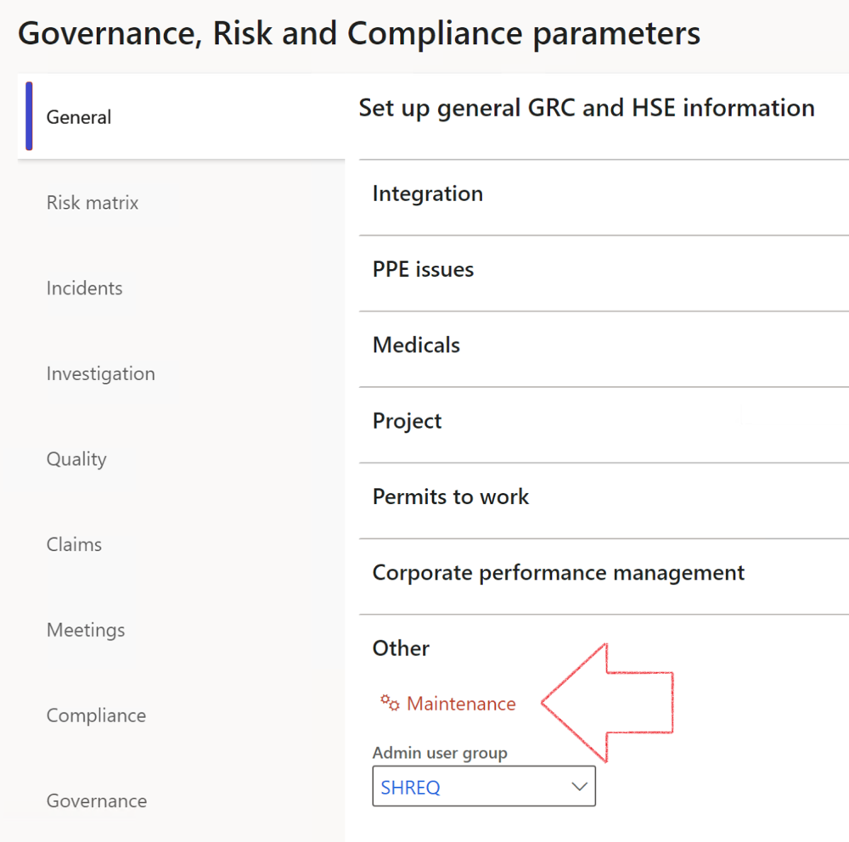

|  |  |
| --- | --- |
|  | The **Maintenance** button is there for designated user. This button repairs any possible data issues. For a full history of all Data related repairs; see table below: |

|  |  |  |
| --- | --- | --- |
| **Process** | **Description/notes** | **Release** |
| Fix location vs. work centres | Populate the new **LocationRecID** field with the related location associated with previously used work centre location (Location) fields on the following tables:   * OHSHazardLocations, * OHSRiskHazard, * OHSRiskHazardWizard, * OHSRiskRegister, * OHSRisksWizard, * OHSSafetyLocations, * OHSSafetyPermit, * OHSSafetyPermitLocations * OHSSafetyPermitOverlap, * OHSSafetyPlan, * OHSInvestigation | 10.0.80.10 |

|  |  |  |
| --- | --- | --- |
| **Process** | **Description/notes** | **Release** |
| Fix risk hazards | Assigning the value "Default Risk" to the new mandatory field **RiskID** (Key field) where empty | 10.0.80.10 |
| Fix incident HRM injury link | Delete all orphaned records from the **OHSIncidentHRMInjuryLnk** table | 10.0.11785.3 |
| Populate SRS analysis enums | Still in concept phase. To provide a link between enum numerical value and value name for use with BYOD data entities. Enums available:   * OHSIncidentType, * OHSIncidentSeverityType.   Table populated: **SRSAnalysisEnums** | 10.0.11785.3 |
| Fix budget transaction lines stock\item dimension | Set **OHSInventDimId** field value to "**AllBlank**" on table **BudgetTransactionLine**, where no value was recorded. This will solve the issue of records not displaying in the form.  **Note: this step will only fix existing budget transaction records in the system. Should any new transactions be uploaded or changed via the data entity Budget Account Entries, special care needs to be taken to specify the Stock dimension = AllBlank and the Item on the excel sheet to import.** | 10.1.1366.6 |
| Update existing incidents with the new **Incident types** | Update existing incidents with the **Incident types** that are setup on the new **Incident type** setup form. (IncidentTypeRecId) | 10.17.1250 |
| Update existing risks with the new **Control types** | Update existing risks with the **Control types** that are setup on the new **Control type** setup form. | 10.17.1250 |
| Fix Inspection locations: Replace Work centre-based locations with HSE locations | Populate the new **ObjectLocation** field with the related HSE location associated with previously used work centre location (**Location**) field on the following tables:   * OHSInspectionJournalName * OHSInspectionJournalTable * OHSInspectionJournalTrans * OHSInspectionHistory * OHSSchedule | 10.24.1114.3 |

The information contained in this document represents the current view of Axnosis and Microsoft Corporation on the issues discussed as of the date of publication. Because Axnosis and Microsoft must respond to changing market conditions, this document should not be interpreted to be a commitment on the part of Axnosis and Microsoft, and Axnosis and Microsoft cannot guarantee the accuracy of any information presented after the date of publication.

This test script is for informational purposes only. AXNOSIS AND MICROSOFT MAKE NO WARRANTIES, EXPRESS, IMPLIED, OR STATUTORY, AS TO THE INFORMATION IN THIS DOCUMENT.

Complying with all applicable copyright laws is the responsibility of the user. Without limiting the rights under copyright, no part of this document may be reproduced, stored in or introduced into a retrieval system, or transmitted in any form or by any means (electronic, mechanical, photocopying, recording, or otherwise), or for any purpose, without the express written permission of Axnosis and Microsoft Corporation.

Axnosis and Microsoft may have patents, patent applications, trademarks, copyrights, or other intellectual property rights covering subject matter in this document. Except as expressly provided in any written license agreement from Axnosis and Microsoft, the furnishing of this document does not give you any license to these patents, trademarks, copyrights, or other intellectual property.

© 2021 Microsoft Corporation. All rights reserved. Any use or distribution of these materials without express authorization of Microsoft Corp. is strictly prohibited.

Microsoft and Windows are both registered trademarks of Microsoft Corporation in the United States and/or other countries.

The names of actual companies and products mentioned herein may be the trademarks of their respective owners.