

D365FO GRC/HSE Release notes



Governance Risk & Compliance

Health, Safety & Environment

for

**Microsoft Dynamics 365 for Finance & Operations™**

*D365FO GRC/HSE version* 10.24.1114.5

2023-06-26

|  |  |  |  |
| --- | --- | --- | --- |
| Dynamics 365 FO GRC module GRC is an add-on for Dynamics 365 suite of business application software.  This software provides compelling functionality to support Governance, Risk management and Compliance. |  | | |
| Dynamics 365 FO OHS/HSE OHS/HSE is an add-on for Dynamics 365 suite of business application software.  This software adds to GRC in that compliance is now deeper with explicit functionality for Health, Safety and Environment as per the depicted sub-modules below. | | | |
|  | |  |

Release version

**GRC/HSE Package version:** OHSDeployablePackage_10_24_1114_5

This package was created on Microsoft Dynamics 365 for Finance and Operations:

|  |  |  |
| --- | --- | --- |
| **Release** | **Version** | **Build number** |
| Application release | 10.0.33 | 10.24.1114 |
| Platform release | Platform update 57 | 7.0.6861.30 |

# Enhancements:

|  |  |
| --- | --- |
| **Module** | **Description** |
| Performance | * Under GRC, **Performance**, the following menu item and form labels were changed: **Survey results enquiry** is now **Survey results import log** * When a **Monitoring schedule** is copied, all the fields on the drop dialog are now mandatory |
| Internal audit | * On the **Checklist feedback** form, a **Status** column was added at the end of the grid   The status is then displayed on the **Internal audit** project, Internal audit Fast tab, under the **Audit initiation** Index tab and the **QAIP** Index tab   * On the GRC parameters, under the **Compliance and audit** tab, Internal audit Fast tab, a Yes/No slider was added with label **Auto open audit file**.   If this slider = **Yes**, the audit file will be started, and the declaration done when an audit is created from the following:   * All internal audits list page, **New** button * **Manual audit** button on the Audit universe Lines, under the Auditable entity Fast tab * An **audit schedule** is approved |
| Contract management | The **Scoring method** menu item was copied from **Procurement and sourcing** to GRC, Governance, **Setup for governance** |
| Document management | The following was added to all Policies, contracts and reports:   * **Review** was added to the **Status** enum * A new Field group was added for **Editing**. A new worker lookup was added under this Field group, with label **Locked by**. |
| Operational and sustainability reporting | * On the **Reporting data** form, the **Template ID** is now displayed on the cards (lefthand side of the form) * The following was added to the **Targets and responsibility** form:   + **Min value**   + **Max value** * **Two icons** were added on the **Reporting data** form to give the user visual feedback when entering data * When a **Data repository** is created, a notification pops up to notify the user |
| Activity management | On the **Action plan** list page, a column displaying the number of **Activities** in the Action plan, was added. |

|  |  |
| --- | --- |
| **Module** | **Description** |
| General | * The **Job plan Data entity** was extended. The job plan and checklist lines can now be edited in the **Excel add in** and imported. * On the **QR code generator** form, **Gate pass** was added to the **Element type** enum |
| Investigations | An additional filter was added to Document management for the **Investigation management report**.  The following two menu items were added under HSE, **Investigations**:   * **Investigation management reports** * **Baseline investigation management reports** |
| Safety and security | * On the **HSE parameters**, under the **Notifications** tab, **Email templates for manual use** Fast tab, a lookup was added for **Safety induction notification** * A new **Induction type** table, form and data entity was created * On the **Create new induction** dialog:   + The selected worker’s **Identification number** is displayed   + selected worker’s **Contact number** is displayed   + The **Induction type** can be selected   + The **Checklist ID** field is hidden * The **Approval** Field group is now hidden on the **New gate pass** dialog |
| Occupational health | * A **Medical test** field was added on the **Current worker fitness** inquiry * On the **Tests** setup form under **Setup for occupational health**, **Periodical** was added as a value on the **When** enum under the **Test details** Fast tab |
| Permit to work | * On the **Permit to work**, in the Action pane, the **Create preparation checklist** button was swapped with the **Request extension** button * On the **Checklist feedback** form, a **Status** column was added at the end of the grid.   The status is then displayed on the **Permit to work** lines, under the **Preparation checklist** Fast tab.   * A new Fast tab for **Loto** was added op the permit to work lines. The **Tag out** grid is now displayed under this new Fast tab, with the following fields added to the grid:   + **Planned tag out status**   + **Actual tag out status**   + **Lock used** * The **Tag out** Index tab is now hidden under the **Mitigation** Fast tab. * On the Permit to work, on the Show permit types dialog, a **Description** field was added * A **Safety plan** no longer has to be **Approved** to be selected on a **Permit to work**   + On the **Permit to work type** setup form, a field was added for **Requires approved safety plan** |

# Bug fixes:

|  |  |
| --- | --- |
| **Module** | **Description** |
| Permit to work | * The wrong checklist was displayed on the **Permit to work** under the **Safety checklist** Fast tab. The bug was fixed. * An error message was popping up when a **Permit type** was added on the **Permit to work type group** setup form. The issue has been resolved. |
| Free text invoice | The OHSFreeTextInvoiceController class made a direct call to the OHSFreeTextInvoice report. The standard buttons on the Free text invoice will now call the standard Free text invoice report layout by default. |

Release Data impact

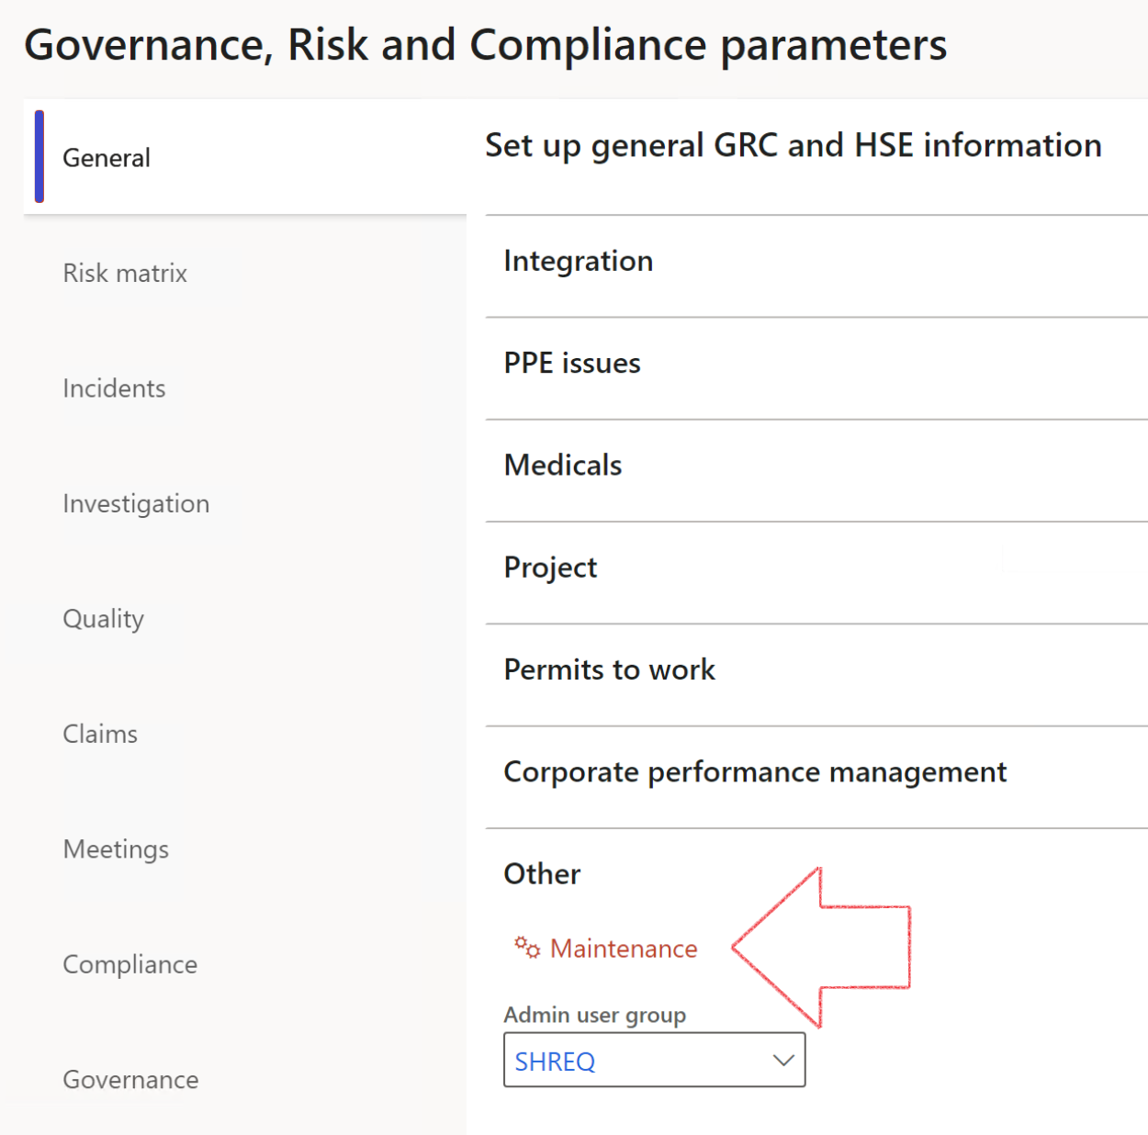

|  |  |
| --- | --- |
|  | The **Maintenance** button is there for designated user. This button repairs any possible data issues. For a full history of all Data related repairs; see table below: |

|  |  |  |
| --- | --- | --- |
| **Process** | **Description/notes** | **Release** |
| Fix location vs. work centres | Populate the new **LocationRecID** field with the related location associated with previously used work centre location (Location) fields on the following tables:   * OHSHazardLocations, * OHSRiskHazard, * OHSRiskHazardWizard, * OHSRiskRegister, * OHSRisksWizard, * OHSSafetyLocations, * OHSSafetyPermit, * OHSSafetyPermitLocations * OHSSafetyPermitOverlap, * OHSSafetyPlan, * OHSInvestigation | 10.0.80.10 |
| Fix risk hazards | Assigning the value "Default Risk" to the new mandatory field **RiskID** (Key field) where empty | 10.0.80.10 |
| Fix incident HRM injury link | Delete all orphaned records from the **OHSIncidentHRMInjuryLnk** table | 10.0.11785.3 |
| Populate SRS analysis enums | Still in concept phase. To provide a link between enum numerical value and value name for use with BYOD data entities. Enums available:   * OHSIncidentType, * OHSIncidentSeverityType.   Table populated: **SRSAnalysisEnums** | 10.0.11785.3 |
| Fix budget transaction lines stock\item dimension | Set **OHSInventDimId** field value to "**AllBlank**" on table **BudgetTransactionLine**, where no value was recorded. This will solve the issue of records not displaying in the form.  **Note: this step will only fix existing budget transaction records in the system. Should any new transactions be uploaded or changed via the data entity Budget Account Entries, special care needs to be taken to specify the Stock dimension = AllBlank and the Item on the excel sheet to import.** | 10.1.1366.6 |
| Update existing incidents with the new **Incident types** | Update existing incidents with the **Incident types** that are setup on the new **Incident type** setup form. (IncidentTypeRecId) | 10.17.1250 |
| Update existing risks with the new **Control types** | Update existing risks with the **Control types** that are setup on the new **Control type** setup form. | 10.17.1250 |

|  |  |  |
| --- | --- | --- |
| **Process** | **Description/notes** | **Release** |
| Fix Inspection locations: Replace Work centre-based locations with HSE locations | Populate the new **ObjectLocation** field with the related HSE location associated with previously used work centre location (**Location**) field on the following tables:   * OHSInspectionJournalName * OHSInspectionJournalTable * OHSInspectionJournalTrans * OHSInspectionHistory * OHSSchedule | 10.24.1114.3 |

The information contained in this document represents the current view of Axnosis and Microsoft Corporation on the issues discussed as of the date of publication. Because Axnosis and Microsoft must respond to changing market conditions, this document should not be interpreted to be a commitment on the part of Axnosis and Microsoft, and Axnosis and Microsoft cannot guarantee the accuracy of any information presented after the date of publication.

This test script is for informational purposes only. AXNOSIS AND MICROSOFT MAKE NO WARRANTIES, EXPRESS, IMPLIED, OR STATUTORY, AS TO THE INFORMATION IN THIS DOCUMENT.

Complying with all applicable copyright laws is the responsibility of the user. Without limiting the rights under copyright, no part of this document may be reproduced, stored in or introduced into a retrieval system, or transmitted in any form or by any means (electronic, mechanical, photocopying, recording, or otherwise), or for any purpose, without the express written permission of Axnosis and Microsoft Corporation.

Axnosis and Microsoft may have patents, patent applications, trademarks, copyrights, or other intellectual property rights covering subject matter in this document. Except as expressly provided in any written license agreement from Axnosis and Microsoft, the furnishing of this document does not give you any license to these patents, trademarks, copyrights, or other intellectual property.

© 2021 Microsoft Corporation. All rights reserved. Any use or distribution of these materials without express authorization of Microsoft Corp. is strictly prohibited.

Microsoft and Windows are both registered trademarks of Microsoft Corporation in the United States and/or other countries.

The names of actual companies and products mentioned herein may be the trademarks of their respective owners.