

D365FO GRC/HSE Release notes



Governance Risk & Compliance

Health, Safety & Environment

for

**Microsoft Dynamics 365 for Finance & Operations™**

*D365FO GRC/HSE version* 10.24.1114.3

2023-06-01

|  |  |  |  |
| --- | --- | --- | --- |
| Dynamics 365 FO GRC module GRC is an add-on for Dynamics 365 suite of business application software.  This software provides compelling functionality to support Governance, Risk management and Compliance. |  | | |
| Dynamics 365 FO OHS/HSE OHS/HSE is an add-on for Dynamics 365 suite of business application software.  This software adds to GRC in that compliance is now deeper with explicit functionality for Health, Safety and Environment as per the depicted sub-modules below. | | | |
|  | |  |

Release version

**GRC/HSE Package version:** OHSDeployablePackage_10_24_1114_3

This package was created on Microsoft Dynamics 365 for Finance and Operations:

|  |  |  |
| --- | --- | --- |
| **Release** | **Version** | **Build number** |
| Application release | 10.0.33 | 10.24.1114 |
| Platform release | Platform update 57 | 7.0.6861.30 |

# Enhancements:

|  |  |
| --- | --- |
| **Module** | **Description** |
| Inspections | * The **Location** lookup on the Inspection journal Header, under the **Areas covered by this inspection** Fast tab, is now a lookup to the **HSE locations**, and not the **Resource** of type locations table. * **Activities** can now be created from **Closed** inspection journals * A new **Maintain** button group was added on the Inspectionjournal Action pane, to move the following buttons into: RACI, Approval, Post and Inspector. * All the buttons in the **Function** group are available for use after the journal has been posted. * Related **Activities** are now displayed on the **Inspection journal report** |
| Corporate performance management | * The **Survey results** menu item was renamed to **Survey results enquiry**. This menu item was moved up to under the **All procurement plans** menu item. * A new dedicated **Create dialog** was added for creating **Performance transactions** |
| Contracts | On the **Contract** detail form:   * Under the **Projects** Fast tab:   + The **Change requests** label was changed to **Project changes**   + The **Penalties** Index tab is hidden * A new Fast tab for **Penalties** was added |
| Audits | * A new value, “**Other**” was added to the **ISO standard** enum. This is now the default when a new Compliance function is created. * **Recommendations** entered on the **Fieldwork** form are now displayed on the **Non conformances** form, under the **Audit observations** Index tab. * There was a wide white space on the **Audit RAG report**. This has been removed. * When an audit is scheduled from the Audit universe, and the scheduling period differs on the lines and on the Auditable entity, a warning comes up.   The warning text was changed to accommodate both **Internal audit** and **Compliance audit**. |
| Internal audit | * Added **create** **sample** functionality integrating with the **Audit workbench** module * On the **RCM**:   + The **Audit policy** label was changed to **Sampling rules (Audit policy)**   + Some fields were aligned |

|  |  |
| --- | --- |
| **Module** | **Description** |
| Permit to work | * On the Permit to work type **actions and questions** setup form: The Question text column was removed from the grid and is now a note box below the grid. * **Due date extension** functionality was added:   + New slider under the General Fast tab for Allow due date extension. If **Yes** is selected, the new Request extension button in the Action pane will become available which allows the user to select a new due date and enter a reason. * On the Permit to work Header:   + Under the General Fast tab, Comments Index tab, the control was extended so the user doesn’t have to scroll.   + A new **Extension** Fast tab was added   + A new **Tools and planning** Fast tab was added   + A new **Other** Fast tab was added * On the Permit to work Lines, under the Mitigation Fast tab, Tag out Index tab: the **Add all** button is only available when a hazard is selected under the Hazards Fast tab * On the HSE parameters, General tab, under the Permits to work Fast tab, **two free text fields were added** to enable the user to change the labels of the two note boxes on the PTW under the Other Fast tab. |

# Bug fixes:

|  |  |
| --- | --- |
| **Module** | **Description** |
| Internal audit | There was a refresh issue when the **Business process** was selected on the **Auditable entity**. The issue has been resolved. |

Release Data impact

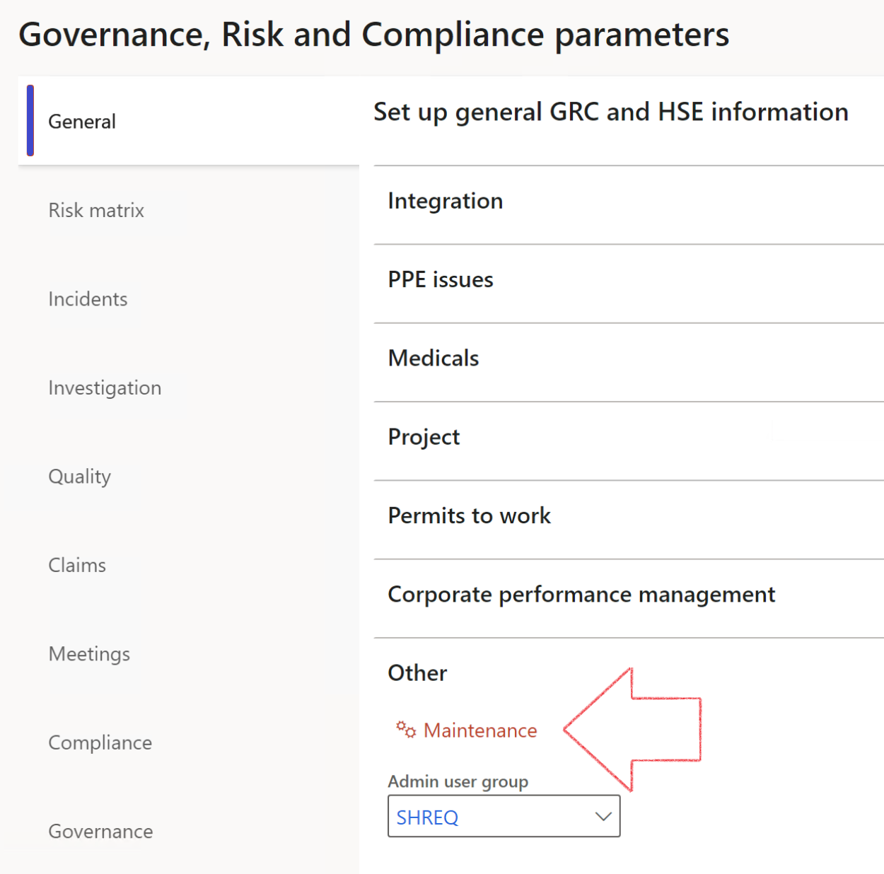

|  |  |
| --- | --- |
|  | The **Maintenance** button is there for designated user. This button repairs any possible data issues. For a full history of all Data related repairs; see table below: |

|  |  |  |
| --- | --- | --- |
| **Process** | **Description/notes** | **Release** |
| Fix location vs. work centres | Populate the new **LocationRecID** field with the related location associated with previously used work centre location (Location) fields on the following tables:   * OHSHazardLocations, * OHSRiskHazard, * OHSRiskHazardWizard, * OHSRiskRegister, * OHSRisksWizard, * OHSSafetyLocations, * OHSSafetyPermit, * OHSSafetyPermitLocations * OHSSafetyPermitOverlap, * OHSSafetyPlan, * OHSInvestigation | 10.0.80.10 |
| Fix risk hazards | Assigning the value "Default Risk" to the new mandatory field **RiskID** (Key field) where empty | 10.0.80.10 |
| Fix incident HRM injury link | Delete all orphaned records from the **OHSIncidentHRMInjuryLnk** table | 10.0.11785.3 |
| Populate SRS analysis enums | Still in concept phase. To provide a link between enum numerical value and value name for use with BYOD data entities. Enums available:   * OHSIncidentType, * OHSIncidentSeverityType.   Table populated: **SRSAnalysisEnums** | 10.0.11785.3 |
| Fix budget transaction lines stock\item dimension | Set **OHSInventDimId** field value to "**AllBlank**" on table **BudgetTransactionLine**, where no value was recorded. This will solve the issue of records not displaying in the form.  **Note: this step will only fix existing budget transaction records in the system. Should any new transactions be uploaded or changed via the data entity Budget Account Entries, special care needs to be taken to specify the Stock dimension = AllBlank and the Item on the excel sheet to import.** | 10.1.1366.6 |
| Update existing incidents with the new **Incident types** | Update existing incidents with the **Incident types** that are setup on the new **Incident type** setup form. (IncidentTypeRecId) | 10.17.1250 |
| Update existing risks with the new **Control types** | Update existing risks with the **Control types** that are setup on the new **Control type** setup form. | 10.17.1250 |

|  |  |  |
| --- | --- | --- |
| **Process** | **Description/notes** | **Release** |
| Fix Inspection locations: Replace Work centre-based locations with HSE locations | Populate the new **ObjectLocation** field with the related HSE location associated with previously used work centre location (**Location**) field on the following tables:   * OHSInspectionJournalName * OHSInspectionJournalTable * OHSInspectionJournalTrans * OHSInspectionHistory * OHSSchedule | 10.24.1114.3 |

The information contained in this document represents the current view of Axnosis and Microsoft Corporation on the issues discussed as of the date of publication. Because Axnosis and Microsoft must respond to changing market conditions, this document should not be interpreted to be a commitment on the part of Axnosis and Microsoft, and Axnosis and Microsoft cannot guarantee the accuracy of any information presented after the date of publication.

This test script is for informational purposes only. AXNOSIS AND MICROSOFT MAKE NO WARRANTIES, EXPRESS, IMPLIED, OR STATUTORY, AS TO THE INFORMATION IN THIS DOCUMENT.

Complying with all applicable copyright laws is the responsibility of the user. Without limiting the rights under copyright, no part of this document may be reproduced, stored in or introduced into a retrieval system, or transmitted in any form or by any means (electronic, mechanical, photocopying, recording, or otherwise), or for any purpose, without the express written permission of Axnosis and Microsoft Corporation.

Axnosis and Microsoft may have patents, patent applications, trademarks, copyrights, or other intellectual property rights covering subject matter in this document. Except as expressly provided in any written license agreement from Axnosis and Microsoft, the furnishing of this document does not give you any license to these patents, trademarks, copyrights, or other intellectual property.

© 2021 Microsoft Corporation. All rights reserved. Any use or distribution of these materials without express authorization of Microsoft Corp. is strictly prohibited.

Microsoft and Windows are both registered trademarks of Microsoft Corporation in the United States and/or other countries.

The names of actual companies and products mentioned herein may be the trademarks of their respective owners.