

D365FO GRC/HSE Release notes



Governance Risk & Compliance

Health, Safety & Environment

for

**Microsoft Dynamics 365 for Finance & Operations™**

*D365FO GRC/HSE version* 10.22.1561.3

2023-02-06

|  |  |  |  |
| --- | --- | --- | --- |
| Dynamics 365 FO GRC module GRC is an add-on for Dynamics 365 suite of business application software.  This software provides compelling functionality to support Governance, Risk management and Compliance. |  | | |
| Dynamics 365 FO OHS/HSE OHS/HSE is an add-on for Dynamics 365 suite of business application software.  This software adds to GRC in that compliance is now deeper with explicit functionality for Health, Safety and Environment as per the depicted sub-modules below. | | | |
|  | |  |

Release version

**GRC/HSE Package version:** OHSDeployablePackage_10_22_1561_3

This package was created on Microsoft Dynamics 365 for Finance and Operations:

|  |  |  |
| --- | --- | --- |
| **Release** | **Version** | **Build number** |
| Application release | 10.0.31 | 10.22.1561 |
| Platform release | Platform update 55 | 7.0.6651.92 |

# Enhancements:

|  |  |
| --- | --- |
| **Module** | **Description** |
| Sustainability | A new **Monthly report** was created under **Operational and sustainability** |
| Internal audit | * The **Expected score** column is now on the **Audit universe** under the **Controls** Fast tab * On the **Audit type** setup form:   + A display for **Compliance Yes/No** was added to the front of the grid   + A dialog now opens for creating a new **Audit type** * The buttons on the **All internal audits** list page are now the same as those on the detail form * On the **Internal audit project**:   + Under the **Internal audit** Fast tab, a new Index tab was added for **Audit procedures** * On the **Fieldwork** form: A new **Audit procedures** Fast tab was added where **Feedback** can be done from * On the **Checklist feedback** form, The **Audit project ID** is now displayed in the **Source ID** field * The **Go to the linked source** button on the Audit procedures, now opens the linked **Audit** * On the **Internal audit workspace**, under the **Details** Fast tab, a tab for **My audit procedures** was added * On the **RCM**:   + The following labels were changed:     - The **Create checklist** button is now **New audit procedure**     - The **Create new checklist** dialog is now **New audit procedure**   + The **Audit RCM report** was enhanced   + The help text for the **Population description** field was enhanced * A page for **High risk entities** was added on the **Internal audit workspace** * A new menu item and inquiry was added under Reports and inquiries for **Risk assessments for internal audits** |
| Risk management | * On the **Control galaxy**, **IT** was added as a value on the **Accounting area** enum * A new menu item and setup form was added under **Setups for risks**: **IT control** |

|  |  |
| --- | --- |
| **Module** | **Description** |
| Tender management | * On GRC actions and questions, two values were added to the Answer type enum:   + Date   + High/Medium/Low * On GRC action and question groups:   + A Line number field was added in the front of the grid   + The order of the questions can be changed by clicking on the new Up / Down buttons * On the Procurement plan, a new Field group for grouping the Project related fields, was added under the General Fast tab * The Actual value of contract display was moved from the RFQ details Fast tab to the General Fast tab * Help text was added on the Solicitation type for the following fields:   + Evaluation criteria   + Criteria second element |
| Inspections | On the Inspection journal name: When Jobs is selected as the Default inspection focus, the Type field will by default be Job observation |
| Incidents | * On the Safety management workspace, Details Fast tab the Incidents recorded by me label was changed to Incidents reported by me * The Injury and illness setup form was copied from the HR menu to the HSE menu. Security privileges were created for this new menu item. |

# Bug fixes:

|  |  |
| --- | --- |
| **Module** | **Description** |
| Internal audit | * On the **Checklist feedback** form:   + The **Validation** warning was popping up when no field was marked as mandatory   + The **Notes** from the **Job plan** were being displayed on the feedback form * When an audit was created from the **Audit universe**, and some Auditable entities marked as to be **Excluded**, all the controls from all the Auditable entities were displayed on the **RCM** * On the **RCM**, when an **Audit procedure** was created, all **Audit files** were in the drop-down list, not only Audit files linked to the Audit   These issues have been resolved |

Release Data impact

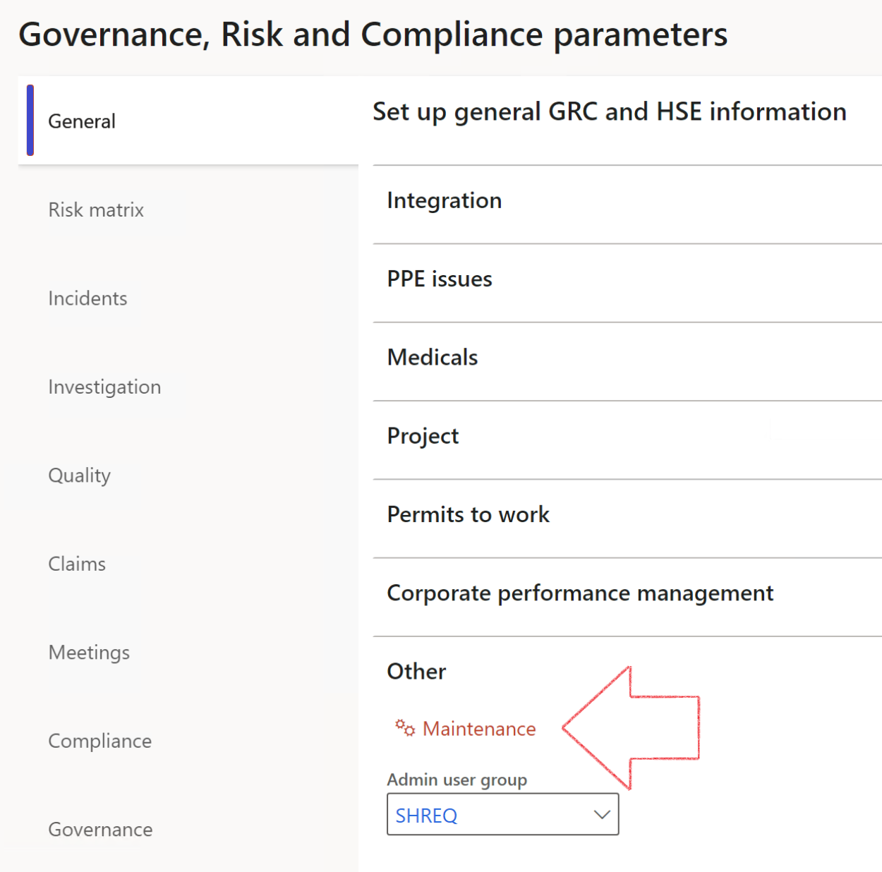

|  |  |
| --- | --- |
|  | The **Maintenance** button is there for designated user. This button repairs any possible data issues. For a full history of all Data related repairs; see table below: |

|  |  |  |
| --- | --- | --- |
| **Process** | **Description/notes** | **Release** |
| Fix location vs. work centres | Populate the new **LocationRecID** field with the related location associated with previously used work centre location (Location) fields on the following tables:   * OHSHazardLocations, * OHSRiskHazard, * OHSRiskHazardWizard, * OHSRiskRegister, * OHSRisksWizard, * OHSSafetyLocations, * OHSSafetyPermit, * OHSSafetyPermitLocations * OHSSafetyPermitOverlap, * OHSSafetyPlan, * OHSInvestigation | 10.0.80.10 |
| Fix risk hazards | Assigning the value "Default Risk" to the new mandatory field **RiskID** (Key field) where empty | 10.0.80.10 |
| Fix incident HRM injury link | Delete all orphaned records from the **OHSIncidentHRMInjuryLnk** table | 10.0.11785.3 |
| Populate SRS analysis enums | Still in concept phase. To provide a link between enum numerical value and value name for use with BYOD data entities. Enums available:   * OHSIncidentType, * OHSIncidentSeverityType.   Table populated: **SRSAnalysisEnums** | 10.0.11785.3 |
| Fix budget transaction lines stock\item dimension | Set **OHSInventDimId** field value to "**AllBlank**" on table **BudgetTransactionLine**, where no value was recorded. This will solve the issue of records not displaying in the form.  **Note: this step will only fix existing budget transaction records in the system. Should any new transactions be uploaded or changed via the data entity Budget Account Entries, special care needs to be taken to specify the Stock dimension = AllBlank and the Item on the excel sheet to import.** | 10.1.1366.6 |
| Update existing incidents with the new **Incident types** | Update existing incidents with the **Incident types** that are setup on the new **Incident type** setup form. (IncidentTypeRecId) | 10.17.1250 |
| Update existing risks with the new **Control types** | Update existing risks with the **Control types** that are setup on the new **Control type** setup form. | 10.17.1250 |

The information contained in this document represents the current view of Axnosis and Microsoft Corporation on the issues discussed as of the date of publication. Because Axnosis and Microsoft must respond to changing market conditions, this document should not be interpreted to be a commitment on the part of Axnosis and Microsoft, and Axnosis and Microsoft cannot guarantee the accuracy of any information presented after the date of publication.

This test script is for informational purposes only. AXNOSIS AND MICROSOFT MAKE NO WARRANTIES, EXPRESS, IMPLIED, OR STATUTORY, AS TO THE INFORMATION IN THIS DOCUMENT.

Complying with all applicable copyright laws is the responsibility of the user. Without limiting the rights under copyright, no part of this document may be reproduced, stored in or introduced into a retrieval system, or transmitted in any form or by any means (electronic, mechanical, photocopying, recording, or otherwise), or for any purpose, without the express written permission of Axnosis and Microsoft Corporation.

Axnosis and Microsoft may have patents, patent applications, trademarks, copyrights, or other intellectual property rights covering subject matter in this document. Except as expressly provided in any written license agreement from Axnosis and Microsoft, the furnishing of this document does not give you any license to these patents, trademarks, copyrights, or other intellectual property.

© 2021 Microsoft Corporation. All rights reserved. Any use or distribution of these materials without express authorization of Microsoft Corp. is strictly prohibited.

Microsoft and Windows are both registered trademarks of Microsoft Corporation in the United States and/or other countries.

The names of actual companies and products mentioned herein may be the trademarks of their respective owners.