

D365FO GRC/HSE Release notes



Governance Risk & Compliance

Health, Safety & Environment

for

**Microsoft Dynamics 365 for Finance & Operations™**

*D365FO GRC/HSE version* 10.21.982.2

2022-12-01

|  |  |  |  |
| --- | --- | --- | --- |
| Dynamics 365 FO GRC module GRC is an add-on for Dynamics 365 suite of business application software.  This software provides compelling functionality to support Governance, Risk management and Compliance. |  | | |
| Dynamics 365 FO OHS/HSE OHS/HSE is an add-on for Dynamics 365 suite of business application software.  This software adds to GRC in that compliance is now deeper with explicit functionality for Health, Safety and Environment as per the depicted sub-modules below. | | | |
|  | |  |

Release version

**GRC/HSE Package version:** OHSDeployablePackage_10_21_982_2

This package was created on Microsoft Dynamics 365 for Finance and Operations:

|  |  |  |
| --- | --- | --- |
| **Release** | **Version** | **Build number** |
| Application release | 10.0.30 | 10.21.982 |
| Platform release | Platform update 54 | 7.0.6592.33 |

# New additions:

|  |  |
| --- | --- |
| **Module** | **Description** |
| Operational and sustainability reporting | A new sub-module for **Operational and sustainability reporting** was created under the GRC module |
| Contract management | New integration template for PDF services |

# Enhancements:

|  |  |
| --- | --- |
| **Module** | **Description** |
| General | * On the **GRC/HSE parameter** form:   + The **SHEQ manager** field was moved from the **Compliance and audit** tab to the **Notifications** tab   + Under the **Compliance and audit** tab, the help text for the **Risk type when creating risk register** field, was improved * The **email** icon was added to the forms where it was not showing next to the Worker lookup |
| Business continuity management | The following was added on the **Business impact assessment** form:   * A **Create activity** button * A **Related information** pane with a Fast tab for displaying **Activities** that have been created |
| Risk management | On the **Control galaxy**, the **Control description** field was made mandatory |

|  |  |
| --- | --- |
| **Module** | **Description** |
| Contract and tender management | * A **Customer** field was added to the Policies, contracts and reports table * On the **Contracts** detail form:   + Under the **Trading partners** Fast tab, the **Worker** field is now hidden in the grid   + Under the **Content** Fast tab, when the **Contract classification** is selected, the following fields are populated with default values as specified on the **Contract classification** setup form:     - **Email template**     - **PDF integration template**   + Under the **Content** Fast tab, a lookup to the **Procurement stage** was added * A **Contracts** button was added on the Action pane of both the **Customer** and **Vendor** list pages and detail forms. This button opens a list page of contracts related to the selected Customer or Vendor. * On the **Create purchase agreement** dialog, a field to select a **Contract** was added * On the **Purchase agreement** Header:   + A **Contract** field group was created and the two **Contract** fields moved into this field group   + The **Contract commercials** Fast tab is now hidden     - The fields that were under the **Commercial** field group were moved to the **Contract administration** Fast tab, **Commercials** Index tab     - The fields that were in the **Max value enforced** field group were moved to the **Related information** pane     - The following fields are now hidden:  |  |  | | --- | --- | | * + - * **Version n umber**       * **Sales district** | * + - * **Meeting** |  * + - * On the **Scoring criteria** setup form, the **Team** column is now hidden       * On the **Document pack** under the General Fast tab, the **Form validation** field is now hidden       * The following was done on the **Solicitation type** setup form, under the Governance Fast tab:         + A new field group with label **Process** was added for the selection of Job plans and Teams         + A new field group with label **Rules** was added for specifying various “bidding rules”         + A new field group with label **Other** was added for B-BBEE information         + A new field group with label **Display on Request for quote (RFQ)** was added for specifying whether certain fields should be displayed on the RFQ         + The user can specify whether **RFQ score** OR **Vendor BEE level** should be used in the **Evaluation** dialog       * On the **Procurement plan Header**:         + The Procurement plan **Stage** is displayed at the top right-hand side of the form         + Three field groups were created in the **General** Fast tab to group the related fields:  |  |  | | --- | --- | | **Identification**  **Values** | **Rules** | |

|  |  |
| --- | --- |
| **Module** | **Description** |
| Contract and tender management | * + - * On the **RFQ Header**,under the Governance Fast tab:         + The Bid specification Index tab and the Bid documents Index tab were swapped         + The **Procurement plan** field was moved to the top under the **General** field group   On the **Compare request for quotation replies** form, when the **Accept** button is clicked, a **Contract** will be created if a baseline contract was selected on the Solicitation type |

Release Data impact

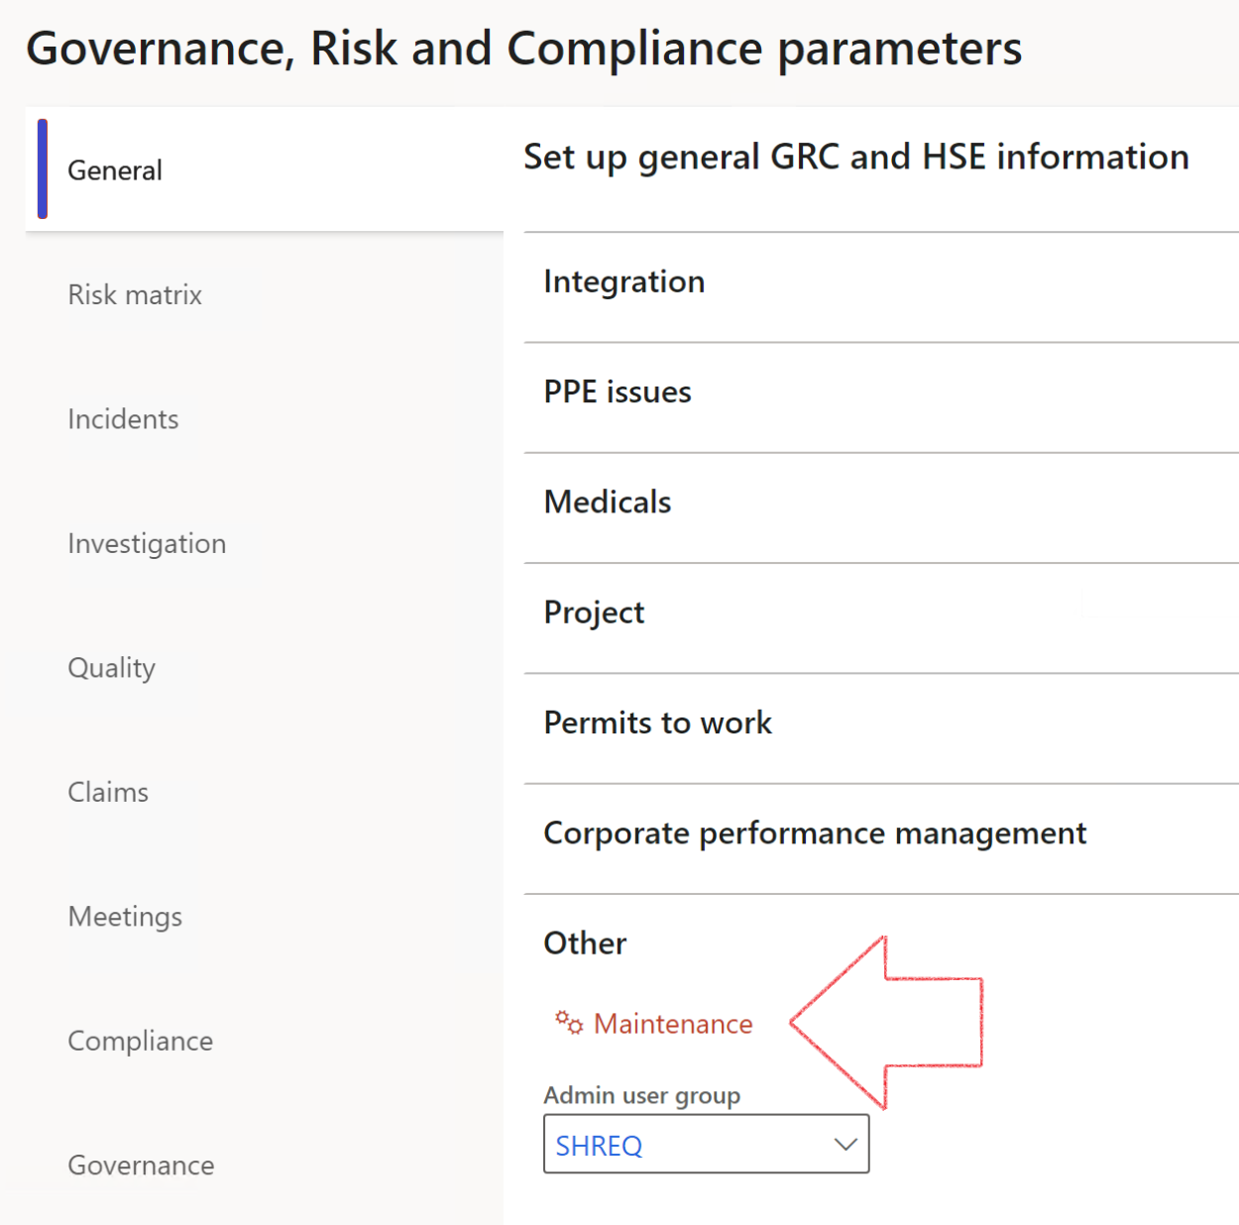

|  |  |
| --- | --- |
|  | The **Maintenance** button is there for designated user. This button repairs any possible data issues. For a full history of all Data related repairs; see table below: |

|  |  |  |
| --- | --- | --- |
| **Process** | **Description/notes** | **Release** |
| Fix location vs. work centres | Populate the new **LocationRecID** field with the related location associated with previously used work centre location (Location) fields on the following tables:   * OHSHazardLocations, * OHSRiskHazard, * OHSRiskHazardWizard, * OHSRiskRegister, * OHSRisksWizard, * OHSSafetyLocations, * OHSSafetyPermit, * OHSSafetyPermitLocations * OHSSafetyPermitOverlap, * OHSSafetyPlan, * OHSInvestigation | 10.0.80.10 |
| Fix risk hazards | Assigning the value "Default Risk" to the new mandatory field **RiskID** (Key field) where empty | 10.0.80.10 |
| Fix incident HRM injury link | Delete all orphaned records from the **OHSIncidentHRMInjuryLnk** table | 10.0.11785.3 |
| Populate SRS analysis enums | Still in concept phase. To provide a link between enum numerical value and value name for use with BYOD data entities. Enums available:   * OHSIncidentType, * OHSIncidentSeverityType.   Table populated: **SRSAnalysisEnums** | 10.0.11785.3 |
| Fix budget transaction lines stock\item dimension | Set **OHSInventDimId** field value to "**AllBlank**" on table **BudgetTransactionLine**, where no value was recorded. This will solve the issue of records not displaying in the form.  **Note: this step will only fix existing budget transaction records in the system. Should any new transactions be uploaded or changed via the data entity Budget Account Entries, special care needs to be taken to specify the Stock dimension = AllBlank and the Item on the excel sheet to import.** | 10.1.1366.6 |
| Update existing incidents with the new **Incident types** | Update existing incidents with the **Incident types** that are setup on the new **Incident type** setup form. (IncidentTypeRecId) | 10.17.1250 |
| Update existing risks with the new **Control types** | Update existing risks with the **Control types** that are setup on the new **Control type** setup form. | 10.17.1250 |

The information contained in this document represents the current view of Axnosis and Microsoft Corporation on the issues discussed as of the date of publication. Because Axnosis and Microsoft must respond to changing market conditions, this document should not be interpreted to be a commitment on the part of Axnosis and Microsoft, and Axnosis and Microsoft cannot guarantee the accuracy of any information presented after the date of publication.

This test script is for informational purposes only. AXNOSIS AND MICROSOFT MAKE NO WARRANTIES, EXPRESS, IMPLIED, OR STATUTORY, AS TO THE INFORMATION IN THIS DOCUMENT.

Complying with all applicable copyright laws is the responsibility of the user. Without limiting the rights under copyright, no part of this document may be reproduced, stored in or introduced into a retrieval system, or transmitted in any form or by any means (electronic, mechanical, photocopying, recording, or otherwise), or for any purpose, without the express written permission of Axnosis and Microsoft Corporation.

Axnosis and Microsoft may have patents, patent applications, trademarks, copyrights, or other intellectual property rights covering subject matter in this document. Except as expressly provided in any written license agreement from Axnosis and Microsoft, the furnishing of this document does not give you any license to these patents, trademarks, copyrights, or other intellectual property.

© 2021 Microsoft Corporation. All rights reserved. Any use or distribution of these materials without express authorization of Microsoft Corp. is strictly prohibited.

Microsoft and Windows are both registered trademarks of Microsoft Corporation in the United States and/or other countries.

The names of actual companies and products mentioned herein may be the trademarks of their respective owners.