

D365FO GRC/HSE Release notes



Governance Risk & Compliance

Health, Safety & Environment

for

**Microsoft Dynamics 365 for Finance & Operations™**

*D365FO GRC/HSE version* 10.19.1307.9

2022-09-15

|  |  |  |  |
| --- | --- | --- | --- |
| Dynamics 365 FO GRC module GRC is an add-on for Dynamics 365 suite of business application software.  This software provides compelling functionality to support Governance, Risk management and Compliance. |  | | |
| Dynamics 365 FO OHS/HSE OHS/HSE is an add-on for Dynamics 365 suite of business application software.  This software adds to GRC in that compliance is now deeper with explicit functionality for Health, Safety and Environment as per the depicted sub-modules below. | | | |
|  | |  |

Release version

**GRC/HSE Package version:** OHSDeployablePackage_10_19_1307_9

This package was created on Microsoft Dynamics 365 for Finance and Operations:

|  |  |  |
| --- | --- | --- |
| **Release** | **Version** | **Build number** |
| Application release | 10.0.28 | 10.19.1307 |
| Platform release | Platform update 52 | 7.0.6441.41 |

# New Additions:

|  |  |
| --- | --- |
| **Module** | **Description** |
| Hazards | Under **Safety and security**, **Hazards**, a new inquiry was created for **Default control per department** |

# Enhancements:

|  |  |
| --- | --- |
| **Module** | **Description** |
| Inspections | * The following text is now printed in red on the **Graphical inspection sheet**:   **Please answer Yes or No**   * On the **Inspection sheet** report:   + The label of the report was changed from **Inspection list** to **Inspection sheet**   + The **Hazard** column is only printed for inspections where the **Type** = **Behaviour/Safety/Construction** * On the **Posted inspections per line header** inquiry, **Job observation** was added to the **Type** filter list |
| Incidents | * On the **Incident** detail form, under the **Incident** Fast tab:   + **Which objects** Index tab: * A button was added in the Button strip: **Create maintenance request** * A field was added in the grid: **Asset** * **What** **happened** Index tab, the **Accident classification** Field group was extended * On the **Incident** detail form, under the **Interpretation** Fast tab:   + A new Index tab was added for **Compliance obligation**. Under this Index tab there is a lookup to the **Organization application** on the **Legal** **register** |
| Permit to work | On the **Permit to work Header**, under the **Applicable areas** Fast tab, field was added in the grid: **Asset** |
| Hazards | On the **Hazard** detail form, under the **Default control measures** Fast tab, a column was added to the grid for **Responsible worker** |

|  |  |
| --- | --- |
| **Module** | **Description** |
| Action management | * On the **Activity management workspace**:   + The size of the following tiles was reduced:     - **All activities**     - **All shreq activities**   + A tile was added for **All my action plans** |
| Audits | * Email icons with the free text email functionality, were added on the **Internal audit file Header** as well as on the **Compliance audit file Header**, under the **Administration** Field group * On the **Completed compliance scores** inquiry, the user can now use the **Show latest** filter to see only the latest scored records * The following was done on the **Internal audit workspace**:   + Under the **My work** Index tab, **Details** Fast tab:     - Under the **All open meetings** tab, only records where the **Audit** enum = **Yes**, are displayed     - Under the **All non-conformances** tab, only records where the **Non-conformance type** = **Internal audit**, are displayed     - Under the **All open checklists** tab, a **Feedback** button was added   + The **Open non-conformances** tile is hidden   + Under the **Audits and findings per department** Index tab:     - The **Department** details below the graph are now read only * On the **Control galaxy**, the help text of some fields was fixed |
| Performance management | On the **KRI & goals**, under the **General** Fast tab:   * A new enum was added for **Type** * The following labels were changed:   + **Purchase agreement** is now **Purchase agreement penalties**   + **Sales agreement** is now **Sales agreement penalties** |
| Legal | On the **Legal register**, under the **Organisation applications** Fast tab:   * The following columns were added:   + **Version**   + **Latest** * A **Show all button** was added in the Button strip |
| Risk management | * On the **Enterprise risk register** Lines:   + Under the **Assessment calculations and controls** Fast tab, the **Trigger** **event** field was moved to after the **Residual risk%** field * On the **Enterprise risk register** Action pane, a **Create activity** button was added * On the **Risk appetite** setup form:   + A new enum was added for **Action**   + The **Escalation** field is now hidden |

# Bug fixes:

|  |  |
| --- | --- |
| **Module** | **Description** |
| Action plans | * The **Priorities** on the escalations were not working correctly. The issue has been resolved. * **Escalations** are now working on past due date records |
| Audits | * On the **Internal audit workspace**, the **Open audit files** tile now opens a grid view of open **Internal audit files** * The filters for the following menu items under **GRC, Internal audit**, are now working:   + **Audit reports**   + **Baseline audit reports** |
| Risk management | On the **Risk register**, the “place holders” were not displayed in the **Layout** box on the **Send email notification** dialog. The issue has been resolved. |

Release Data impact

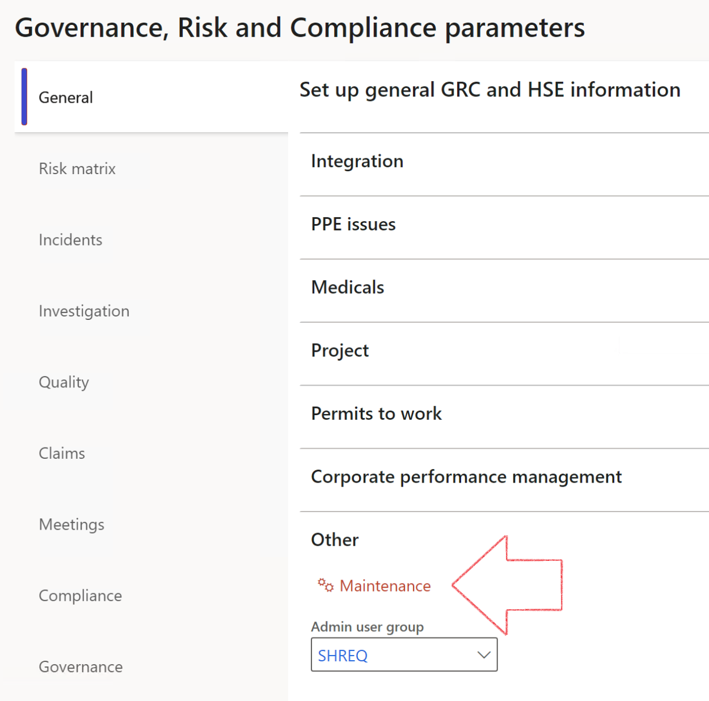

|  |  |
| --- | --- |
|  | The **Maintenance** button is there for designated user. This button repairs any possible data issues. For a full history of all Data related repairs; see table below: |

|  |  |  |
| --- | --- | --- |
| **Process** | **Description/notes** | **Release** |
| Fix location vs. work centres | Populate the new **LocationRecID** field with the related location associated with previously used work centre location (Location) fields on the following tables:   * OHSHazardLocations, * OHSRiskHazard, * OHSRiskHazardWizard, * OHSRiskRegister, * OHSRisksWizard, * OHSSafetyLocations, * OHSSafetyPermit, * OHSSafetyPermitLocations * OHSSafetyPermitOverlap, * OHSSafetyPlan, * OHSInvestigation | 10.0.80.10 |
| Fix risk hazards | Assigning the value "Default Risk" to the new mandatory field **RiskID** (Key field) where empty | 10.0.80.10 |
| Fix incident HRM injury link | Delete all orphaned records from the **OHSIncidentHRMInjuryLnk** table | 10.0.11785.3 |
| Populate SRS analysis enums | Still in concept phase. To provide a link between enum numerical value and value name for use with BYOD data entities. Enums available:   * OHSIncidentType, * OHSIncidentSeverityType.   Table populated: **SRSAnalysisEnums** | 10.0.11785.3 |
| Fix budget transaction lines stock\item dimension | Set **OHSInventDimId** field value to "**AllBlank**" on table **BudgetTransactionLine**, where no value was recorded. This will solve the issue of records not displaying in the form.  **Note: this step will only fix existing budget transaction records in the system. Should any new transactions be uploaded or changed via the data entity Budget Account Entries, special care needs to be taken to specify the Stock dimension = AllBlank and the Item on the excel sheet to import.** | 10.1.1366.6 |
| Update existing incidents with the new **Incident types** | Update existing incidents with the **Incident types** that are setup on the new **Incident type** setup form. (IncidentTypeRecId) | 10.17.1250 |
| Update existing risks with the new **Control types** | Update existing risks with the **Control types** that are setup on the new **Control type** setup form. | 10.17.1250 |

The information contained in this document represents the current view of Axnosis and Microsoft Corporation on the issues discussed as of the date of publication. Because Axnosis and Microsoft must respond to changing market conditions, this document should not be interpreted to be a commitment on the part of Axnosis and Microsoft, and Axnosis and Microsoft cannot guarantee the accuracy of any information presented after the date of publication.

This test script is for informational purposes only. AXNOSIS AND MICROSOFT MAKE NO WARRANTIES, EXPRESS, IMPLIED, OR STATUTORY, AS TO THE INFORMATION IN THIS DOCUMENT.

Complying with all applicable copyright laws is the responsibility of the user. Without limiting the rights under copyright, no part of this document may be reproduced, stored in or introduced into a retrieval system, or transmitted in any form or by any means (electronic, mechanical, photocopying, recording, or otherwise), or for any purpose, without the express written permission of Axnosis and Microsoft Corporation.

Axnosis and Microsoft may have patents, patent applications, trademarks, copyrights, or other intellectual property rights covering subject matter in this document. Except as expressly provided in any written license agreement from Axnosis and Microsoft, the furnishing of this document does not give you any license to these patents, trademarks, copyrights, or other intellectual property.

© 2021 Microsoft Corporation. All rights reserved. Any use or distribution of these materials without express authorization of Microsoft Corp. is strictly prohibited.

Microsoft and Windows are both registered trademarks of Microsoft Corporation in the United States and/or other countries.

The names of actual companies and products mentioned herein may be the trademarks of their respective owners.