

D365FO GRC/HSE Release notes



Governance Risk & Compliance

Health, Safety & Environment

for

**Microsoft Dynamics 365 for Finance & Operations™**

*D365FO GRC/HSE version* 10.19.1307.6

2022-08-30

|  |  |  |  |
| --- | --- | --- | --- |
| Dynamics 365 FO GRC module GRC is an add-on for Dynamics 365 suite of business application software.  This software provides compelling functionality to support Governance, Risk management and Compliance. |  | | |
| Dynamics 365 FO OHS/HSE OHS/HSE is an add-on for Dynamics 365 suite of business application software.  This software adds to GRC in that compliance is now deeper with explicit functionality for Health, Safety and Environment as per the depicted sub-modules below. | | | |
|  | |  |

Release version

**GRC/HSE Package version:** OHSDeployablePackage_10_19_1307_6

This package was created on Microsoft Dynamics 365 for Finance and Operations:

|  |  |  |
| --- | --- | --- |
| **Release** | **Version** | **Build number** |
| Application release | 10.0.28 | 10.19.1307 |
| Platform release | Platform update 52 | 7.0.6441.41 |

# New additions:

|  |  |
| --- | --- |
| **Module** | **Description** |
| Inspections | * A new inquiry was created to enable the user to “**View score per section**” form the Inspection journal * New menu item and inquiry for **Posted inspections per line header** |

# Enhancements:

|  |  |
| --- | --- |
| **Module** | **Description** |
| Risk management | * The **Assertions** button on the Action pane of the Risk registers is now only active for **Enterprise** and **Financial** risks * The **Control galaxy** menu item under GRC>Internal audit, was copied to **HSE>Risk** |
| Internal audit | On the **Auditable entity**, under the **Controls** Fast tab:   * Additional **filter** on the lookup was added and the following buttons updated:   + **Add from control galaxy**   + **Add form risk register** * **Help text** was expanded for the abovementioned buttons |
| Contracts | * On the **Policies, contract and reports** detail form, under the Content Fast tab, a **Vendor** lookup was exposed on the detail form. This lookup is only visible when: * Type = **Policy** * Insurance = **Yes** * The **Policy rules** Fast tab is only visible when:   + Type = **Policy**   + Insurance = **No** |
| Incidents | * A **Contact person** lookup was added on the **Reporting agencies** setup form * A **Send email** button was added on the **Incident** detail form under the **Incident** Fast tab, **Reportable** Index tab to allow users to send emails to these agencies. |

|  |  |
| --- | --- |
| **Module** | **Description** |
| Inspections | * On the **Inspection journal names** setup form:   + The **Inspection focus** field was moved to the **General** Fast tab   + The label of the **Inspection focus** field was changed to **Default inspection focus** * On the **Inspection list** setup form, under the **Lines** Fast tab, the **Hazard** column is now hidden. * The following fields are now hidden on the **Inspection journal create** dialog:   + **Type**   + **Yes/No** * On the **Inspection journal**:   + The **Inspection focus** and **Type** is non-editable   + The **Pass/fail icon** was moved from under the General Fast tab to the header   + A button was added on the Action pane for printing the **Inspection journal report**   + The **Graphical inspection sheet** button on the Action pane is only active for **yes/no type** inspections   + The following text was added on the dialog that opens when an Inspection journal is being posted: “Inspection was committed (posted). Would you like to do the following?” * On the **Inspection journal lines**:   + Under the **Lines** Fast tab, a button was added to give the user the option to **Show/hide** the following:     - Inspection **category**     - **Inspection date**     - **Start & end time** * On the **Inspection journal** report:   + The report can now also be printed for **scoring** type inspections   + **Header** lines are highlighted in grey * On the **Inspection sheet** report:   + The report is now printed in **landscape**   + The report can now also be printed for **scoring type** inspections   + **Header** lines are highlighted in blue   + A few **labels** were changed   + A column for **Comments** was added   + Every **Object/location** (with the inspection list) is printed on its own page |
| Action plans | * A Send email button was added on the Action plan Header, under the **Authorities** Fast tab * The Reporting agency can now be selected on the Create action plan dialog * Manual **escalations** allowed on Action plans |

|  |  |
| --- | --- |
| **Module** | **Description** |
| Contractor safety and security | On the Contractor safety and security Workspace:   * The following buttons were added to the Button strip:   + New – For creating the following:     - Work request     - Work order   + Send email notification – For sending an email to the primary email address of the selected Vendor   + Requested permits to work was added to the list of tabs under the Vendor safety and security section   + The following tiles were added:     - All inspections     - All non-conformances     - All meetings |

# Bug fixes:

|  |  |
| --- | --- |
| **Module** | **Description** |
| Inspections | * The “**Correct answer**”, setup on the **Inspection list**, is now included in the calculation of the display of the compliant/non-compliant icons on the **Inspection journal report** * On the **Graphical inspection sheet** report:   + The **order of the inspection lines** is now correct according to the lines on the Inspection journal   + The **Inspection reporting category description** is printed on the report |
| Environmental | * An error message popped up when following this path:   **HSE>Environmental>Record and environmental incident**  The issue has been resolved   * On the **Incident environment wizard:**   + **T**he line numbers under **Step 9** were incorrect   + The **Remove** buttons were greyed out under **Step 10**   These were fixed |
| Contractor safety and security | Only contacts for the **selected Vendor** are now displayed under the **All contractors for vendor** list |

Release Data impact

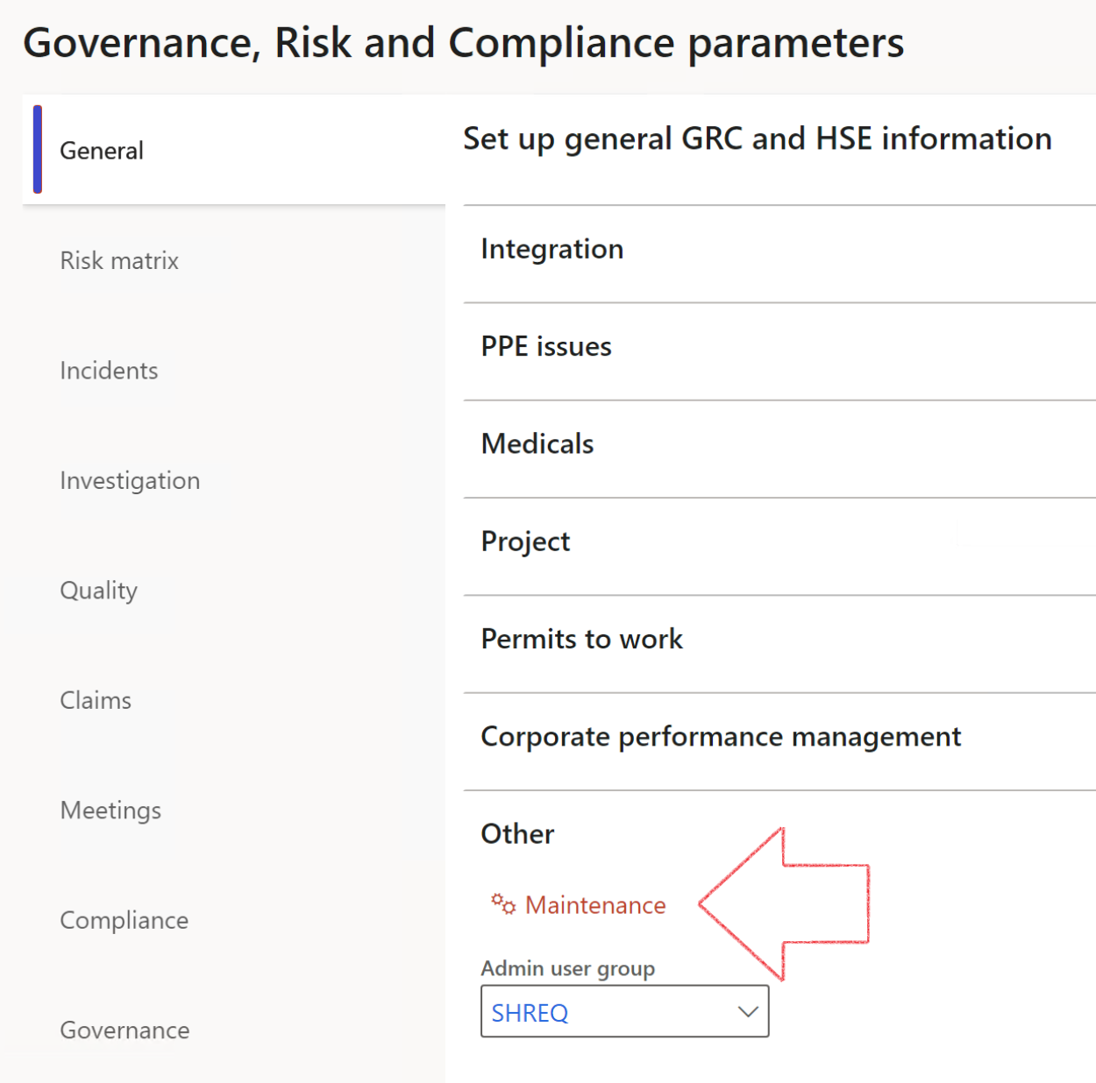

|  |  |
| --- | --- |
|  | The **Maintenance** button is there for designated user. This button repairs any possible data issues. For a full history of all Data related repairs; see table below: |

|  |  |  |
| --- | --- | --- |
| **Process** | **Description/notes** | **Release** |
| Fix location vs. work centres | Populate the new **LocationRecID** field with the related location associated with previously used work centre location (Location) fields on the following tables:   * OHSHazardLocations, * OHSRiskHazard, * OHSRiskHazardWizard, * OHSRiskRegister, * OHSRisksWizard, * OHSSafetyLocations, * OHSSafetyPermit, * OHSSafetyPermitLocations * OHSSafetyPermitOverlap, * OHSSafetyPlan, * OHSInvestigation | 10.0.80.10 |
| Fix risk hazards | Assigning the value "Default Risk" to the new mandatory field **RiskID** (Key field) where empty | 10.0.80.10 |
| Fix incident HRM injury link | Delete all orphaned records from the **OHSIncidentHRMInjuryLnk** table | 10.0.11785.3 |
| Populate SRS analysis enums | Still in concept phase. To provide a link between enum numerical value and value name for use with BYOD data entities. Enums available:   * OHSIncidentType, * OHSIncidentSeverityType.   Table populated: **SRSAnalysisEnums** | 10.0.11785.3 |
| Fix budget transaction lines stock\item dimension | Set **OHSInventDimId** field value to "**AllBlank**" on table **BudgetTransactionLine**, where no value was recorded. This will solve the issue of records not displaying in the form.  **Note: this step will only fix existing budget transaction records in the system. Should any new transactions be uploaded or changed via the data entity Budget Account Entries, special care needs to be taken to specify the Stock dimension = AllBlank and the Item on the excel sheet to import.** | 10.1.1366.6 |
| Update existing incidents with the new **Incident types** | Update existing incidents with the **Incident types** that are setup on the new **Incident type** setup form. (IncidentTypeRecId) | 10.17.1250 |
| Update existing risks with the new **Control types** | Update existing risks with the **Control types** that are setup on the new **Control type** setup form. | 10.17.1250 |

The information contained in this document represents the current view of Axnosis and Microsoft Corporation on the issues discussed as of the date of publication. Because Axnosis and Microsoft must respond to changing market conditions, this document should not be interpreted to be a commitment on the part of Axnosis and Microsoft, and Axnosis and Microsoft cannot guarantee the accuracy of any information presented after the date of publication.

This test script is for informational purposes only. AXNOSIS AND MICROSOFT MAKE NO WARRANTIES, EXPRESS, IMPLIED, OR STATUTORY, AS TO THE INFORMATION IN THIS DOCUMENT.

Complying with all applicable copyright laws is the responsibility of the user. Without limiting the rights under copyright, no part of this document may be reproduced, stored in or introduced into a retrieval system, or transmitted in any form or by any means (electronic, mechanical, photocopying, recording, or otherwise), or for any purpose, without the express written permission of Axnosis and Microsoft Corporation.

Axnosis and Microsoft may have patents, patent applications, trademarks, copyrights, or other intellectual property rights covering subject matter in this document. Except as expressly provided in any written license agreement from Axnosis and Microsoft, the furnishing of this document does not give you any license to these patents, trademarks, copyrights, or other intellectual property.

© 2021 Microsoft Corporation. All rights reserved. Any use or distribution of these materials without express authorization of Microsoft Corp. is strictly prohibited.

Microsoft and Windows are both registered trademarks of Microsoft Corporation in the United States and/or other countries.

The names of actual companies and products mentioned herein may be the trademarks of their respective owners.