

D365FO GRC/HSE Release notes



Governance Risk & Compliance

Health, Safety & Environment

for

**Microsoft Dynamics 365 for Finance & Operations™**

*D365FO GRC/HSE version* 10.19.1307.4

2022-08-18

|  |  |  |  |
| --- | --- | --- | --- |
| Dynamics 365 FO GRC module GRC is an add-on for Dynamics 365 suite of business application software.  This software provides compelling functionality to support Governance, Risk management and Compliance. |  | | |
|  | | Dynamics 365 FO OHS/HSE OHS/HSE is an add-on for Dynamics 365 suite of business application software.  This software adds to GRC in that compliance is now deeper with explicit functionality for Health, Safety and Environment as per the depicted sub-modules. |

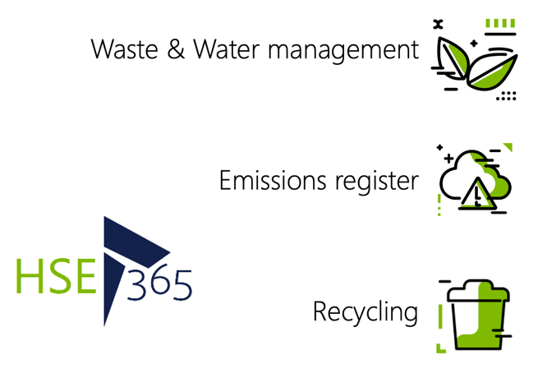

Release version

**GRC/HSE Package version:** OHSDeployablePackage_10_19_1307_4

This package was created on Microsoft Dynamics 365 for Finance and Operations:

|  |  |  |
| --- | --- | --- |
| **Release** | **Version** | **Build number** |
| Application release | 10.0.28 | 10.19.1307 |
| Platform release | Platform update 52 | 7.0.6441.41 |

# Enhancements:

|  |  |
| --- | --- |
| **Module** | **Description** |
| Inspections | * On the **HSE** **menu**, under Inspections, Reports and inquiries, the **Inspection history** menu item is now hidden * The **Print weight** yes/no slider on the **Print inspection sheet** dialog, has been hidden * The **Graphical inspection sheet** report is now printing the answers as well * On the **Inspection journal Header** (HSE now supports job observations)**:**   + When **Job** is selected as the **Inspection** **focus**, a **Worker** and/or **Vendor account** can be selected under the **Jobs and Work** Fast tab   + A **Job observation** can then be done against the selected **Worker** and/or **Vendor account** |
| Incidents | On the **Incident** detail form, under the Incident Fast tab, the “graph” section under the **Dangerous occurrences** Index tab was extended to show the full text |
| Risk management | * When **Scaling** is selected for a risk class (on the GRC parameters), the **Risk assessment wizard will** also use the scaling option instead of the traditional risk matrix. * The **Accounting controls** menu item and form name, have been renamed to **Control galaxy** with three new lookup tables:   + **Control framework**   + **Objectives**   + **Control type** * The **Control type** label has been changed to **Control category** (System wide) |
| Internal audit | On the **Auditable entity**, under the **Controls** Fast tab:   * The **Add from template** button was moved forward in the Button strip * The following labels were changed:   + The **Add from template** button is now **Add from control galaxy**   + The **Add from template** dialog is now **Add from control galaxy**   + **Control categories** on the dialog is now **Control galaxy** |

# Bug fixes:

|  |  |
| --- | --- |
| **Module** | **Description** |
| Internal audit | An error message was showing when a non-conformance was created form the **Fieldwork** form. The issue has been resolved. |
| Incidents | * The **All reported incidents in legal entity** list pagenow has the same **Report an incident** menu step as the other incident list pages * On the **Incident rules** setup form, when the **Line management** was de-selected from display grid, the email icons were still being displayed on the Incident detail form. The issue has been resolved. * When the **Send email notification** button on the Action pane is clicked, the email template is displayed in the layout box on the **Send email notification** dialog |

Release Data impact

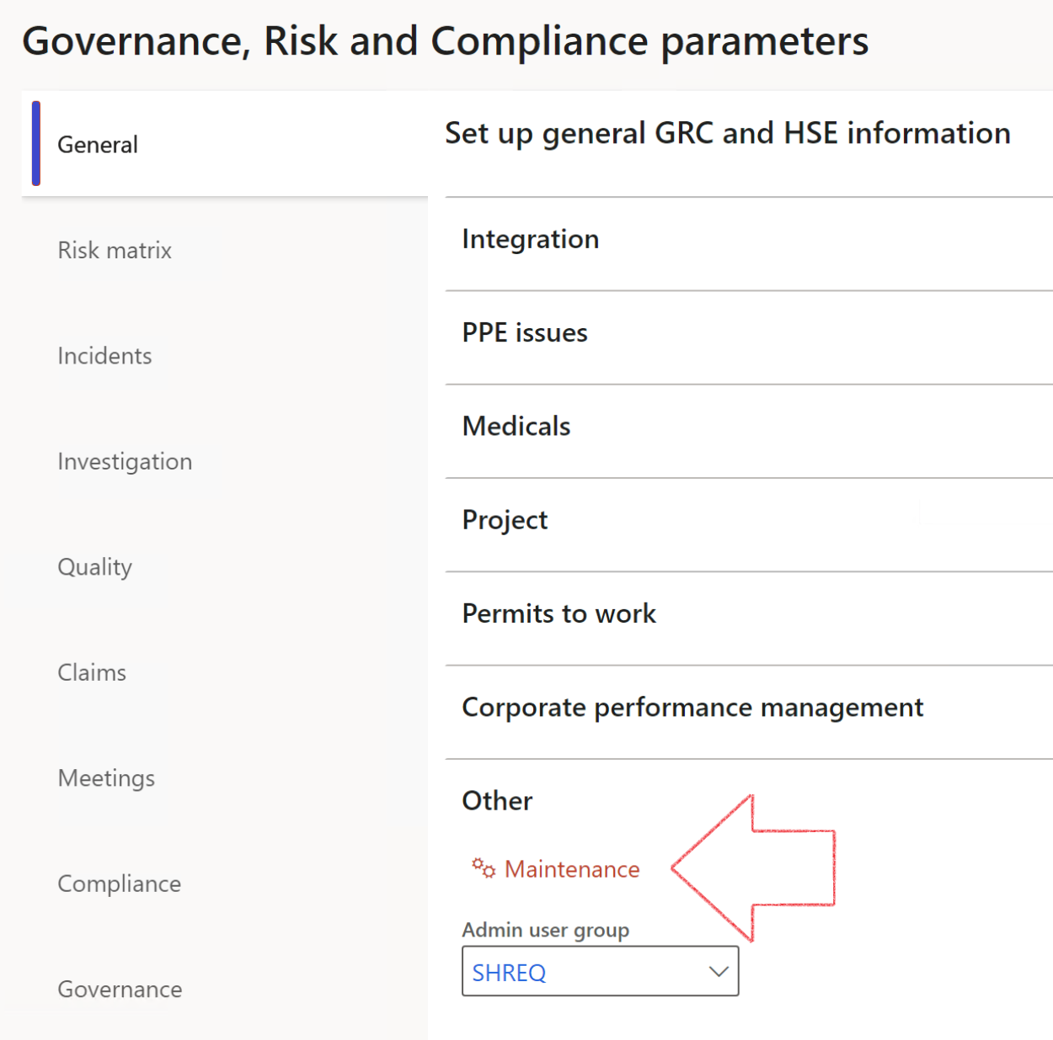

|  |  |
| --- | --- |
|  | The **Maintenance** button is there for designated user. This button repairs any possible data issues. For a full history of all Data related repairs; see table below: |

|  |  |  |
| --- | --- | --- |
| **Process** | **Description/notes** | **Release** |
| Fix location vs. work centres | Populate the new **LocationRecID** field with the related location associated with previously used work centre location (Location) fields on the following tables:   * OHSHazardLocations, * OHSRiskHazard, * OHSRiskHazardWizard, * OHSRiskRegister, * OHSRisksWizard, * OHSSafetyLocations, * OHSSafetyPermit, * OHSSafetyPermitLocations * OHSSafetyPermitOverlap, * OHSSafetyPlan, * OHSInvestigation | 10.0.80.10 |
| Fix risk hazards | Assigning the value "Default Risk" to the new mandatory field **RiskID** (Key field) where empty | 10.0.80.10 |
| Fix incident HRM injury link | Delete all orphaned records from the **OHSIncidentHRMInjuryLnk** table | 10.0.11785.3 |
| Populate SRS analysis enums | Still in concept phase. To provide a link between enum numerical value and value name for use with BYOD data entities. Enums available:   * OHSIncidentType, * OHSIncidentSeverityType.   Table populated: **SRSAnalysisEnums** | 10.0.11785.3 |
| Fix budget transaction lines stock\item dimension | Set **OHSInventDimId** field value to "**AllBlank**" on table **BudgetTransactionLine**, where no value was recorded. This will solve the issue of records not displaying in the form.  **Note: this step will only fix existing budget transaction records in the system. Should any new transactions be uploaded or changed via the data entity Budget Account Entries, special care needs to be taken to specify the Stock dimension = AllBlank and the Item on the excel sheet to import.** | 10.1.1366.6 |
| Update existing incidents with the new **Incident types** | Update existing incidents with the **Incident types** that are setup on the new **Incident type** setup form. (IncidentTypeRecId) | 10.17.1250 |
| Update existing risks with the new **Control types** | Update existing risks with the **Control types** that are setup on the new **Control type** setup form. | 10.17.1250 |

The information contained in this document represents the current view of Axnosis and Microsoft Corporation on the issues discussed as of the date of publication. Because Axnosis and Microsoft must respond to changing market conditions, this document should not be interpreted to be a commitment on the part of Axnosis and Microsoft, and Axnosis and Microsoft cannot guarantee the accuracy of any information presented after the date of publication.

This test script is for informational purposes only. AXNOSIS AND MICROSOFT MAKE NO WARRANTIES, EXPRESS, IMPLIED, OR STATUTORY, AS TO THE INFORMATION IN THIS DOCUMENT.

Complying with all applicable copyright laws is the responsibility of the user. Without limiting the rights under copyright, no part of this document may be reproduced, stored in or introduced into a retrieval system, or transmitted in any form or by any means (electronic, mechanical, photocopying, recording, or otherwise), or for any purpose, without the express written permission of Axnosis and Microsoft Corporation.

Axnosis and Microsoft may have patents, patent applications, trademarks, copyrights, or other intellectual property rights covering subject matter in this document. Except as expressly provided in any written license agreement from Axnosis and Microsoft, the furnishing of this document does not give you any license to these patents, trademarks, copyrights, or other intellectual property.

© 2021 Microsoft Corporation. All rights reserved. Any use or distribution of these materials without express authorization of Microsoft Corp. is strictly prohibited.

Microsoft and Windows are both registered trademarks of Microsoft Corporation in the United States and/or other countries.

The names of actual companies and products mentioned herein may be the trademarks of their respective owners.