

D365FO GRC/HSE Release notes



Governance Risk & Compliance

Health, Safety & Environment

for

**Microsoft Dynamics 365 for Finance & Operations™**

*D365FO GRC/HSE version* 10.19.1307.3

2022-08-15

## 

|  |  |  |
| --- | --- | --- |
| Dynamics 365 FO GRC module GRC is an add-on for Dynamics 365 suite of business application software.  This software provides functionality to support Governance, Risk management and Compliance as per the depicted sub-modules. |  | |
|  | | Dynamics 365 FO HSE module HSE is an add-on for Dynamics 365 suite of business application software.  This software provides functionality to support Health, Safety and Environment as per the depicted sub-modules. |

Release version

**GRC/HSE Package version:** OHSDeployablePackage_10_19_1307_3

This package was created on Microsoft Dynamics 365 for Finance and Operations:

|  |  |  |
| --- | --- | --- |
| **Release** | **Version** | **Build number** |
| Application release | 10.0.28 | 10.19.1307 |
| Platform release | Platform update 52 | 7.0.6441.41 |

# New additions:

|  |  |
| --- | --- |
| **Module** | **Description** |
| Contractor safety and security | Users can onboard Vendors/Suppliers via the **Task management workspace** |

# Enhancements:

|  |  |
| --- | --- |
| **Module** | **Description** |
| General | * **Workspaces:**   + The **Tiles** are now vertical   + The **details** are now grouped under Fast tabs * On the **GRC Parameters**, under the Notification Tab, the **Only SHREQ activities** slider was moved to under the **Activities alert** drop-down * On the **Activity manager workspace**, a Fast tab for **Performance indicator** was added, with the following filters:   + **From date**   + **To date**   + **Legal entity** |
| Risk | * On the **Control measures** setup form, a Yes/no enum was added for indicating **Critical** controls * On the **Enterprise risk register** lines, under the Assessment calculations and controls Fast tab, **Controls** Index tab:   + The following two fields were added to the grid:     - **Owner**     - **Frequency**   + An **Attachments** button was added to the Button strip * On the new **Risk assessment** dialogs for all the risk classes, the user can now indicate whether the risk register will be **Used for** **consolidation** |

|  |  |
| --- | --- |
| **Module** | **Description** |
| Safety and security | On the **Health, Safety and Environment** menu, the following menu items was added under the **Setup for safety and security folder**:   * **Process and activity** (Copied from the HSE Setups) * **Operations barriers and conditions** (Moved from the HSE Setups) * **Pre-activity conditions** (Moved from the HSE Setups) |
| Occupational health | The following labels were changed under Occupational health>Setup for occupational health:   * **Medical members** is now **Members** * **Medical member type** is now **Member type** |
| Incidents | On the **Incident detail** form:   * Under the **Incident** Fast tab: * The **Source** Index tab was moved to the back of the Index tabs * Under the Summary Index tab, a new Field group was added for **Security** * The following was added under the **Which objects** Index tab:   + **Serial number** (free text field)   + **Make and model** (free text field)   + **Correctly used** (Yes/no slider)   + **Is/was in good working order** (Yes/no slider) * An Index tab was added for **Members injured** * The following two fields were added to the **Others injured** grid:   + - **Minor**     - **Preventable** * Under the **Claims** Fast tab, the following indicators were added:   + **Written claim received**   + **Verbal threats or intent of legal action** * The following was added to the **Incident response** dialog:   + A free text field for **Which hospital**   + An indicator for **Dr present**   + A free text field for the **Doctor’s details** |
| Inspections | * On the **Inspection journal**:   + The **Graphical inspection sheet** button on the Action pane is greyed out for **Scoring type** inspections   + The **Print inspection sheet** button re-labelled to **Inspection sheet** * A few minor changes were made to the **Inspection sheet** (report) * The **Skull & bone** field is now on all inspection lists (Scoring and yes/No) |

Release Data impact

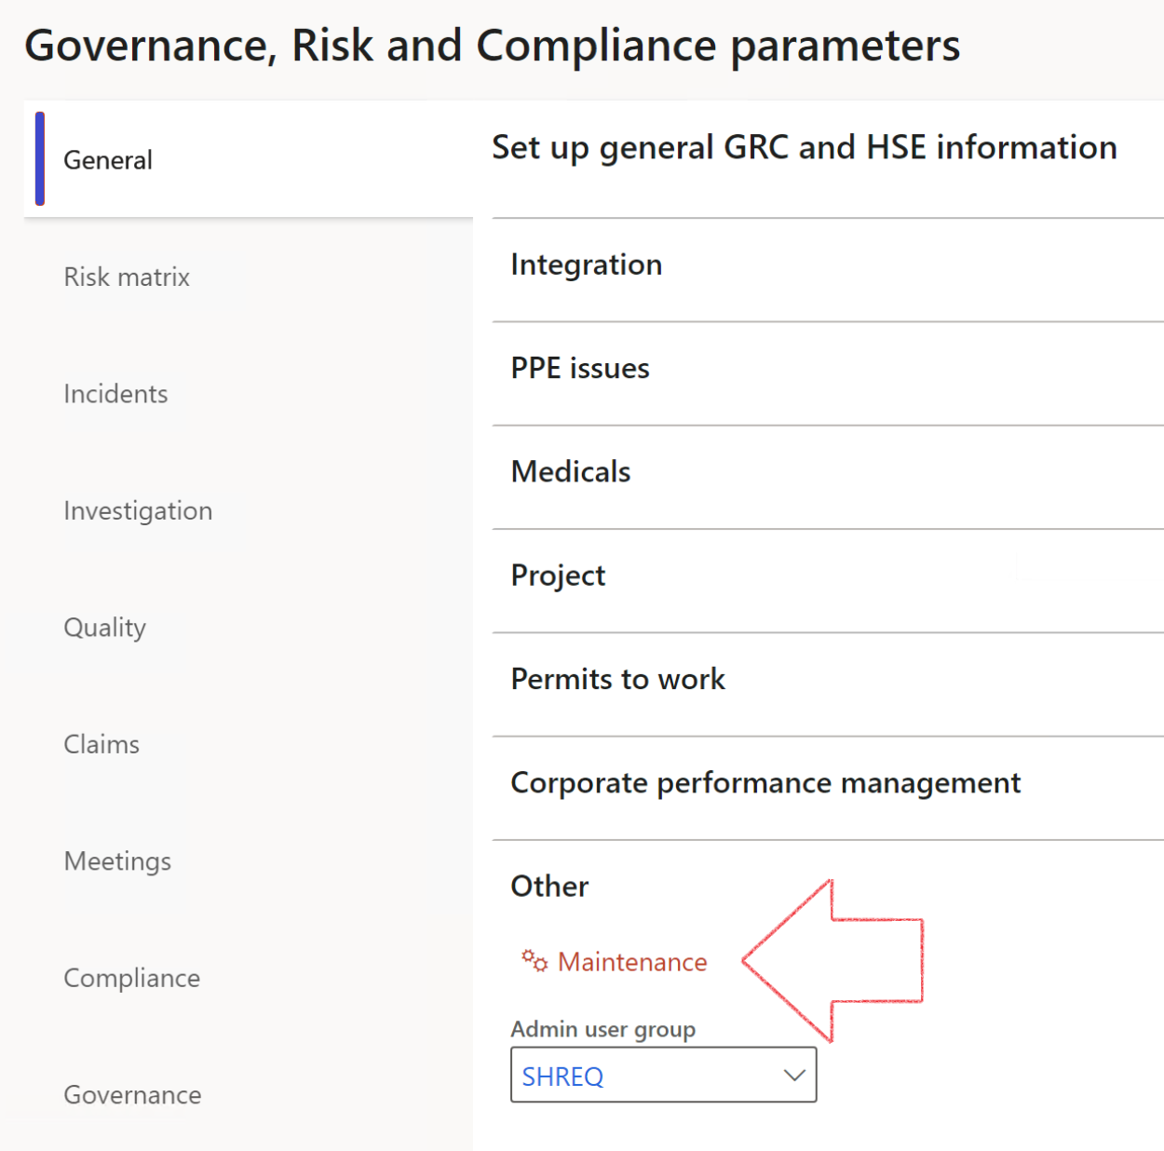

|  |  |
| --- | --- |
|  | The **Maintenance** button is there for designated user. This button repairs any possible data issues. For a full history of all Data related repairs; see table below: |

|  |  |  |
| --- | --- | --- |
| **Process** | **Description/notes** | **Release** |
| Fix location vs. work centres | Populate the new **LocationRecID** field with the related location associated with previously used work centre location (Location) fields on the following tables:   * OHSHazardLocations, * OHSRiskHazard, * OHSRiskHazardWizard, * OHSRiskRegister, * OHSRisksWizard, * OHSSafetyLocations, * OHSSafetyPermit, * OHSSafetyPermitLocations * OHSSafetyPermitOverlap, * OHSSafetyPlan, * OHSInvestigation | 10.0.80.10 |
| Fix risk hazards | Assigning the value "Default Risk" to the new mandatory field **RiskID** (Key field) where empty | 10.0.80.10 |
| Fix incident HRM injury link | Delete all orphaned records from the **OHSIncidentHRMInjuryLnk** table | 10.0.11785.3 |
| Populate SRS analysis enums | Still in concept phase. To provide a link between enum numerical value and value name for use with BYOD data entities. Enums available:   * OHSIncidentType, * OHSIncidentSeverityType.   Table populated: **SRSAnalysisEnums** | 10.0.11785.3 |
| Fix budget transaction lines stock\item dimension | Set **OHSInventDimId** field value to "**AllBlank**" on table **BudgetTransactionLine**, where no value was recorded. This will solve the issue of records not displaying in the form.  **Note: this step will only fix existing budget transaction records in the system. Should any new transactions be uploaded or changed via the data entity Budget Account Entries, special care needs to be taken to specify the Stock dimension = AllBlank and the Item on the excel sheet to import.** | 10.1.1366.6 |
| Update existing incidents with the new **Incident types** | Update existing incidents with the **Incident types** that are setup on the new **Incident type** setup form. (IncidentTypeRecId) | 10.17.1250 |
| Update existing risks with the new **Control types** | Update existing risks with the **Control types** that are setup on the new **Control type** setup form. | 10.17.1250 |

The information contained in this document represents the current view of Axnosis and Microsoft Corporation on the issues discussed as of the date of publication. Because Axnosis and Microsoft must respond to changing market conditions, this document should not be interpreted to be a commitment on the part of Axnosis and Microsoft, and Axnosis and Microsoft cannot guarantee the accuracy of any information presented after the date of publication.

This test script is for informational purposes only. AXNOSIS AND MICROSOFT MAKE NO WARRANTIES, EXPRESS, IMPLIED, OR STATUTORY, AS TO THE INFORMATION IN THIS DOCUMENT.

Complying with all applicable copyright laws is the responsibility of the user. Without limiting the rights under copyright, no part of this document may be reproduced, stored in or introduced into a retrieval system, or transmitted in any form or by any means (electronic, mechanical, photocopying, recording, or otherwise), or for any purpose, without the express written permission of Axnosis and Microsoft Corporation.

Axnosis and Microsoft may have patents, patent applications, trademarks, copyrights, or other intellectual property rights covering subject matter in this document. Except as expressly provided in any written license agreement from Axnosis and Microsoft, the furnishing of this document does not give you any license to these patents, trademarks, copyrights, or other intellectual property.

© 2021 Microsoft Corporation. All rights reserved. Any use or distribution of these materials without express authorization of Microsoft Corp. is strictly prohibited.

Microsoft and Windows are both registered trademarks of Microsoft Corporation in the United States and/or other countries.

The names of actual companies and products mentioned herein may be the trademarks of their respective owners.