

D365FO GRC/HSE Release notes



Governance Risk & Compliance

Health, Safety & Environment

for

**Microsoft Dynamics 365 for Finance & Operations™**

*D365FO GRC/HSE version* 10.19.1307.2

2022-08-08

## 

|  |  |  |
| --- | --- | --- |
| Dynamics 365 FO GRC module GRC is an add-on for Dynamics 365 suite of business application software.  This software provides functionality to support Governance, Risk management and Compliance as per the depicted sub-modules. |  | |
|  | | Dynamics 365 FO HSE module HSE is an add-on for Dynamics 365 suite of business application software.  This software provides functionality to support Health, Safety and Environment as per the depicted sub-modules. |

Release version

**GRC/HSE Package version:** OHSDeployablePackage_10_19_1307_2

This package was created on Microsoft Dynamics 365 for Finance and Operations:

|  |  |  |
| --- | --- | --- |
| **Release** | **Version** | **Build number** |
| Application release | 10.0.28 | 10.19.1307 |
| Platform release | Platform update 52 | 7.0.6441.41 |

# New additions:

|  |  |
| --- | --- |
| **Module** | **Description** |
| Inspections | A new **Graphical inspection sheet** was created for printing the inspection sheet with the images added on **Header** lines |

# Enhancements:

|  |  |
| --- | --- |
| **Module** | **Description** |
| Internal audit | On the **Control matrix**:   * The **row height** on the left-hand side of the form was adjusted to conform to the standard * A new **Risk assessment** button group was added for creating a **New risk register and line** * A **Business process** lookup was added under the **General** Fast tab, **Business process** Index tab |
| Risk management | * Users can now choose to use the “**scale risk rating option**” on **Operational** and **Environmental** risk registers (instead of the risk matrix) * Risks will soon be able to **consolidate** risk assessments from child registers   + On the **Risk register Header**, under the Hierarchy Fast tab, a **Use for consolidation** slider was added   + On the Action pane, a button was added for **Consolidate child lines**. This button opens a dialog where the parameters for the consolidation can be selected. * A **Sub-category** field was added on all risk register lines, under the **General** Fast tab. The **Sub-category** lookupis filtered on the selected **Risk category** * The **notifications** that appear when a risk has been created, have been updated to accommodate all risk classes * From the **All risk register** list page; user can now create an environmental risk. * The spelling of **Bowtie** is now consistently used * Users with the **Risk administrator** security role can now also see the **Risk management reports** * The “**Top X**“ filter was added to the **Risk worksheets** |

|  |  |
| --- | --- |
| **Module** | **Description** |
| Inspections | * On the **Inspection journal**:   + On the **Inspection journal list page,** the **Compliance** type label was changed to **Yes/No**   + On the L**ines:**     - The **Skull and bone** icon is now also displayed     - Under the Lines Fast tab, the **Hazard** **Description** is displayed instead of the **Hazard ID**     - Under the **Line details** Fast tab, a **Description** box was added under the Activities Index tab   + On the **Header:**     - Under the **General** Fast tab, a new **Result** field group was added. When the journal is posted, a **large icon** indicates whether the journal has passed/failed     - Under the **Jobs and work** Fast tab:       * A **Worker** lookup with a **Position** display was added       * A **Vendor account** lookup with a **Name** display was added * On the **Inspection list** setup form:   + Under the **General** Fast tab:     - a field for **Reporting threshold** was added     - a "**Passing %"** number field was added   + A **Yes/No** field was added to indicate what the **Correct answer** for each inspection line is. This will assist with the decision of whether the inspection **passes/fails**   + Under the Lines Fast tab, the **Hazard** **Description** is displayed instead of the **Hazard ID** * A new menu item was added under Inspections for **Job observations** * On the **Inspection journal name**, **Job observation** was added to the inspection **Type** enum * On the **Inspection journal report** for **Yes/No** type answers, the **yellow** (Comply – but room for improvement) icon was removed |
| Incidents | * An info message will appear when a non **SHREQ admin user** tries to access confidential incidents form from an incident list page * There is now a dedicated list page for **All confidential incidents** * On the **Incident** detail form, under the **Incident** Fast tab, **Reportable** Index tab, the **Note** field was extended to the maximum length |

|  |  |
| --- | --- |
| **Module** | **Description** |
| Action plans | * On the **Action plan**:   + The **Action plan** tab on the Action pane is now hidden   + A **Create activity** button was added which opens the **Create activity** dialog   + A new Fast tab was added for Authorities   When a new Action plan is created, the user can indicate whether a **Notice** was received from **Authorities**, as well as enter the date on which the notice was received |
| General | * The layout of the **Workspaces** has been changed to support the **Vertical** form patterns * On the **HSE/GRC parameters**, under the Notifications tab, a **Due date notification** field was added under the Email templates for batch use Fast tab * On the **Activity type** setup form:   + A field for **Auto escalate** was added   + A new Fast tab for **Escalation** was added * On the **Terminate** **workers** dialog, a Field group was added for **Responsibility matrix** (RACI) replacement. This will enable users (in future releases) to select a worker to replace a worker that is being terminated, where the worker was selected in the **RACI** fields. |

# Bug fixes:

|  |  |
| --- | --- |
| **Module** | **Description** |
| Risk management | On the **Risk wizard:**   * The **Remove** button was greyed out on steps 2 and 6 * A **warning** popped up that prevented the user from continuing with the wizard   These issues have been resolved |
| Incidents | The form pattern of the **Incident type** setup form was fixed |

Release Data impact

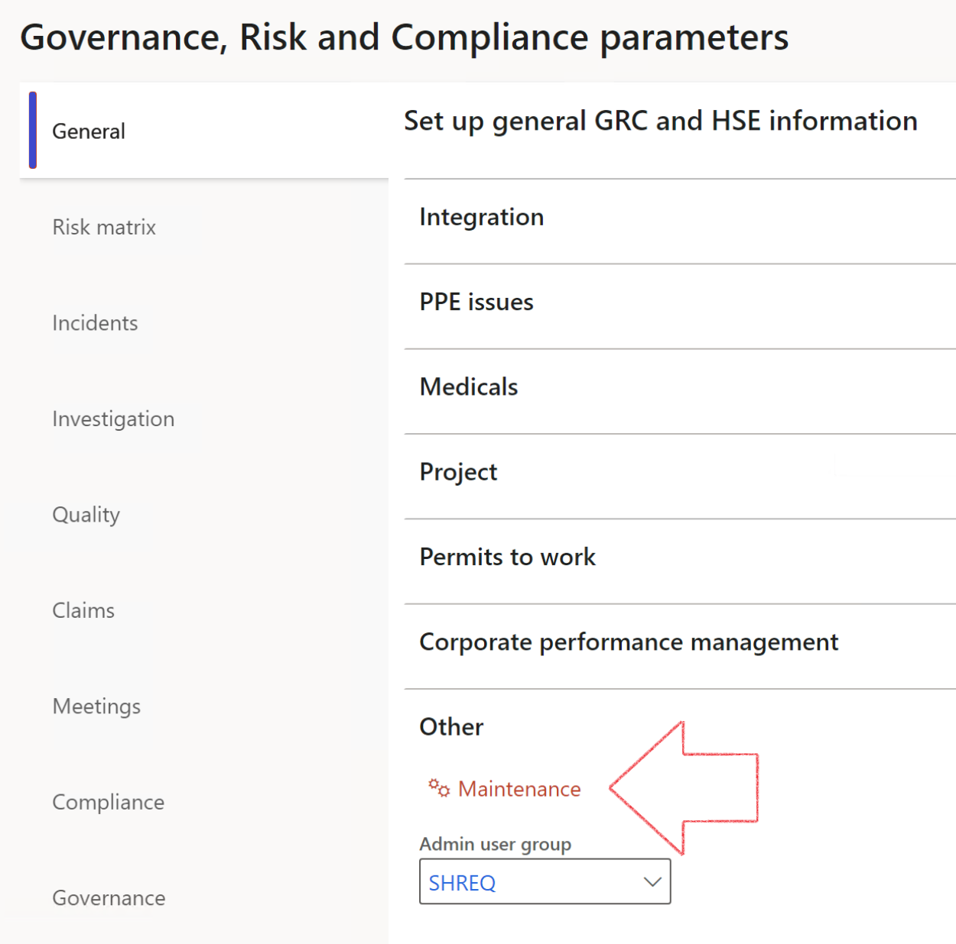

|  |  |
| --- | --- |
|  | The **Maintenance** button is there for designated user. This button repairs any possible data issues. For a full history of all Data related repairs; see table below: |

|  |  |  |
| --- | --- | --- |
| **Process** | **Description/notes** | **Release** |
| Fix location vs. work centres | Populate the new **LocationRecID** field with the related location associated with previously used work centre location (Location) fields on the following tables:   * OHSHazardLocations, * OHSRiskHazard, * OHSRiskHazardWizard, * OHSRiskRegister, * OHSRisksWizard, * OHSSafetyLocations, * OHSSafetyPermit, * OHSSafetyPermitLocations * OHSSafetyPermitOverlap, * OHSSafetyPlan, * OHSInvestigation | 10.0.80.10 |
| Fix risk hazards | Assigning the value "Default Risk" to the new mandatory field **RiskID** (Key field) where empty | 10.0.80.10 |
| Fix incident HRM injury link | Delete all orphaned records from the **OHSIncidentHRMInjuryLnk** table | 10.0.11785.3 |
| Populate SRS analysis enums | Still in concept phase. To provide a link between enum numerical value and value name for use with BYOD data entities. Enums available:   * OHSIncidentType, * OHSIncidentSeverityType.   Table populated: **SRSAnalysisEnums** | 10.0.11785.3 |
| Fix budget transaction lines stock\item dimension | Set **OHSInventDimId** field value to "**AllBlank**" on table **BudgetTransactionLine**, where no value was recorded. This will solve the issue of records not displaying in the form.  **Note: this step will only fix existing budget transaction records in the system. Should any new transactions be uploaded or changed via the data entity Budget Account Entries, special care needs to be taken to specify the Stock dimension = AllBlank and the Item on the excel sheet to import.** | 10.1.1366.6 |
| Update existing incidents with the new **Incident types** | Update existing incidents with the **Incident types** that are setup on the new **Incident type** setup form. (IncidentTypeRecId) | 10.17.1250 |
| Update existing risks with the new **Control types** | Update existing risks with the **Control types** that are setup on the new **Control type** setup form. | 10.17.1250 |

The information contained in this document represents the current view of Axnosis and Microsoft Corporation on the issues discussed as of the date of publication. Because Axnosis and Microsoft must respond to changing market conditions, this document should not be interpreted to be a commitment on the part of Axnosis and Microsoft, and Axnosis and Microsoft cannot guarantee the accuracy of any information presented after the date of publication.

This test script is for informational purposes only. AXNOSIS AND MICROSOFT MAKE NO WARRANTIES, EXPRESS, IMPLIED, OR STATUTORY, AS TO THE INFORMATION IN THIS DOCUMENT.

Complying with all applicable copyright laws is the responsibility of the user. Without limiting the rights under copyright, no part of this document may be reproduced, stored in or introduced into a retrieval system, or transmitted in any form or by any means (electronic, mechanical, photocopying, recording, or otherwise), or for any purpose, without the express written permission of Axnosis and Microsoft Corporation.

Axnosis and Microsoft may have patents, patent applications, trademarks, copyrights, or other intellectual property rights covering subject matter in this document. Except as expressly provided in any written license agreement from Axnosis and Microsoft, the furnishing of this document does not give you any license to these patents, trademarks, copyrights, or other intellectual property.

© 2021 Microsoft Corporation. All rights reserved. Any use or distribution of these materials without express authorization of Microsoft Corp. is strictly prohibited.

Microsoft and Windows are both registered trademarks of Microsoft Corporation in the United States and/or other countries.

The names of actual companies and products mentioned herein may be the trademarks of their respective owners.