

D365FO GRC/HSE Release notes



Governance Risk & Compliance

Health, Safety & Environment

for

**Microsoft Dynamics 365 for Finance & Operations™**

*D365FO GRC/HSE version* 10.19.1307.18

2022-11-17

|  |  |  |  |
| --- | --- | --- | --- |
| Dynamics 365 FO GRC module GRC is an add-on for Dynamics 365 suite of business application software.  This software provides compelling functionality to support Governance, Risk management and Compliance. |  | | |
| Dynamics 365 FO OHS/HSE OHS/HSE is an add-on for Dynamics 365 suite of business application software.  This software adds to GRC in that compliance is now deeper with explicit functionality for Health, Safety and Environment as per the depicted sub-modules below. | | | |
|  | |  |

Release version

**GRC/HSE Package version:** OHSDeployablePackage_10_19_1307_18

This package was created on Microsoft Dynamics 365 for Finance and Operations:

|  |  |  |
| --- | --- | --- |
| **Release** | **Version** | **Build number** |
| Application release | 10.0.28 | 10.19.1307 |
| Platform release | Platform update 52 | 7.0.6441.41 |

# New additions:

|  |  |
| --- | --- |
| **Module** | **Description** |
| General | **Questionnaires** can now be used to update controls as being critical or not:   * On the **Question** form, under the **General** Fast tab, a yes/no slider was added for **If yes, update control** * A new menu item for **Critical control questionnaire**, was added under **Risk** and **Safety and security**. This menu item opens a list page where these questionnaires can be completed from. * The control will be marked as **critical** if the outcome of the questionnaire indicates it to be critical |

# Enhancements:

|  |  |
| --- | --- |
| **Module** | **Description** |
| Contract management | * On the **Legal, Contracts and Tender management** workspace, under the **Enterprise legal** Index tab, the following tiles were added:   + **Supply chain contracts**   + **Worker contracts** * On the **Contract** detail form, under the **Cover page** Index tab, help text for the **Worker** field was added * On the **Contract register** list page, a **View options** button was added to give the user the ability to add filters on the list page * On the **Contract** detail form, under the **Trading partner** Index tab, a button was added to enable the user to **View related orders** (Purchase orders/Sales orders) |
| Internal audit | The help text for the **Create audit** button on the **Audit universe** was improved |

|  |  |
| --- | --- |
| **Module** | **Description** |
| Risk management | * On the **Control galaxy**, a yes/no field was added to indicate whether the control is **Critical**   On the **Auditable entity**, under the **Controls** Fast tab, filters were added on the **Control** lookups to only show **active** controls in the drop-down list |
| Corporate performance management | Under **GRC, Performance, Human resources**:   * The **Appraisals** menu item was changed to **Evaluations** * The **HR Goals** menu item was copied |

# Bug fixes:

|  |  |
| --- | --- |
| **Module** | **Description** |
| Contract management | The **Contract register** list page is now non-editable |

Release Data impact

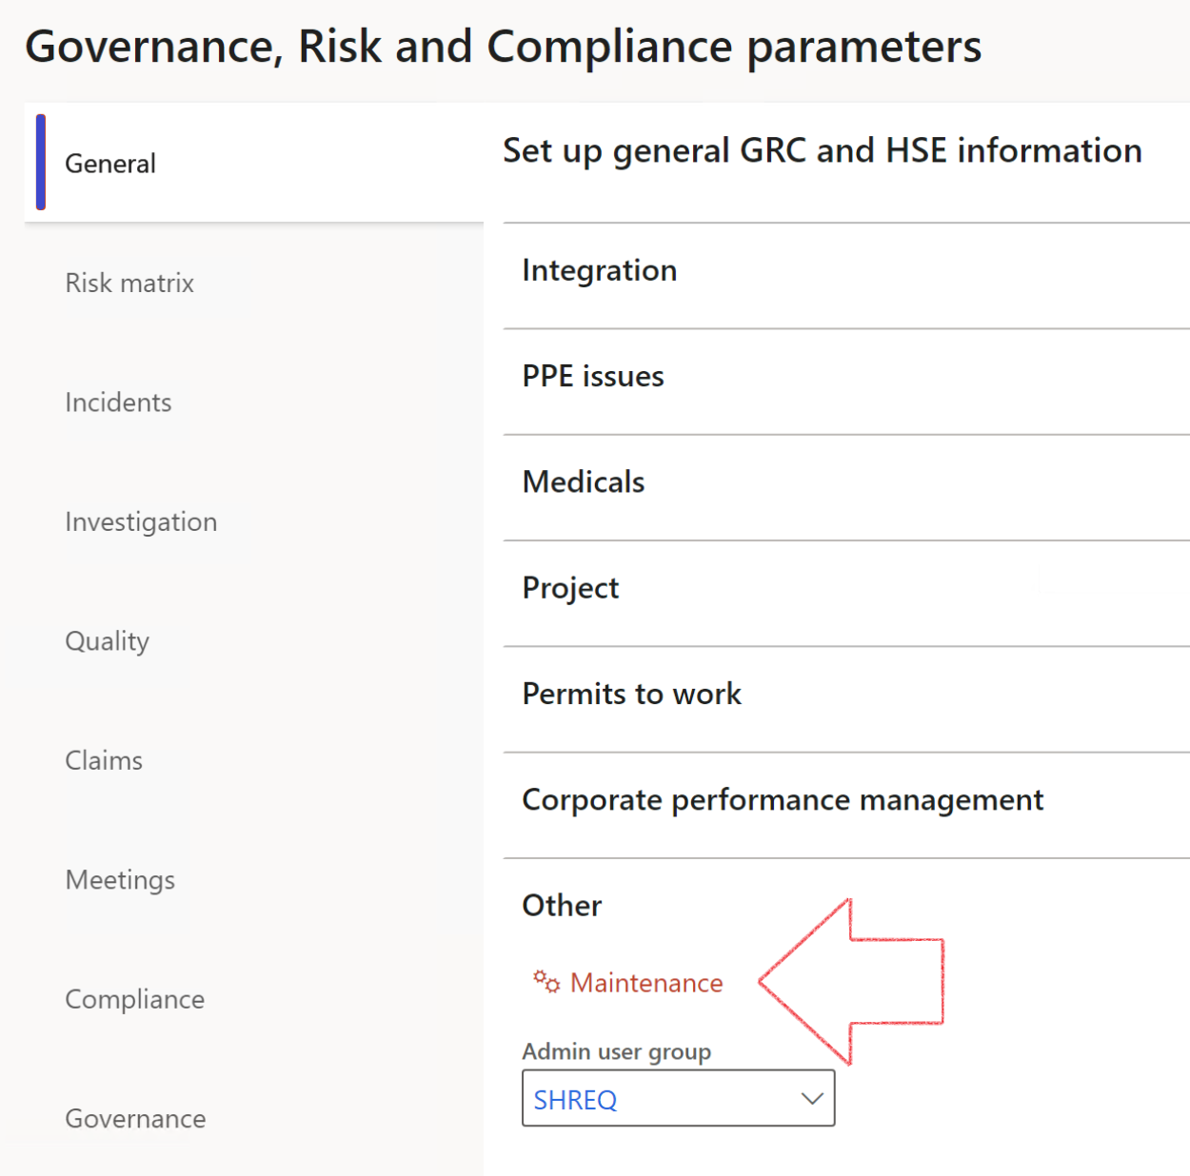

|  |  |
| --- | --- |
|  | The **Maintenance** button is there for designated user. This button repairs any possible data issues. For a full history of all Data related repairs; see table below: |

|  |  |  |
| --- | --- | --- |
| **Process** | **Description/notes** | **Release** |
| Fix location vs. work centres | Populate the new **LocationRecID** field with the related location associated with previously used work centre location (Location) fields on the following tables:   * OHSHazardLocations, * OHSRiskHazard, * OHSRiskHazardWizard, * OHSRiskRegister, * OHSRisksWizard, * OHSSafetyLocations, * OHSSafetyPermit, * OHSSafetyPermitLocations * OHSSafetyPermitOverlap, * OHSSafetyPlan, * OHSInvestigation | 10.0.80.10 |
| Fix risk hazards | Assigning the value "Default Risk" to the new mandatory field **RiskID** (Key field) where empty | 10.0.80.10 |
| Fix incident HRM injury link | Delete all orphaned records from the **OHSIncidentHRMInjuryLnk** table | 10.0.11785.3 |
| Populate SRS analysis enums | Still in concept phase. To provide a link between enum numerical value and value name for use with BYOD data entities. Enums available:   * OHSIncidentType, * OHSIncidentSeverityType.   Table populated: **SRSAnalysisEnums** | 10.0.11785.3 |
| Fix budget transaction lines stock\item dimension | Set **OHSInventDimId** field value to "**AllBlank**" on table **BudgetTransactionLine**, where no value was recorded. This will solve the issue of records not displaying in the form.  **Note: this step will only fix existing budget transaction records in the system. Should any new transactions be uploaded or changed via the data entity Budget Account Entries, special care needs to be taken to specify the Stock dimension = AllBlank and the Item on the excel sheet to import.** | 10.1.1366.6 |
| Update existing incidents with the new **Incident types** | Update existing incidents with the **Incident types** that are setup on the new **Incident type** setup form. (IncidentTypeRecId) | 10.17.1250 |
| Update existing risks with the new **Control types** | Update existing risks with the **Control types** that are setup on the new **Control type** setup form. | 10.17.1250 |

The information contained in this document represents the current view of Axnosis and Microsoft Corporation on the issues discussed as of the date of publication. Because Axnosis and Microsoft must respond to changing market conditions, this document should not be interpreted to be a commitment on the part of Axnosis and Microsoft, and Axnosis and Microsoft cannot guarantee the accuracy of any information presented after the date of publication.

This test script is for informational purposes only. AXNOSIS AND MICROSOFT MAKE NO WARRANTIES, EXPRESS, IMPLIED, OR STATUTORY, AS TO THE INFORMATION IN THIS DOCUMENT.

Complying with all applicable copyright laws is the responsibility of the user. Without limiting the rights under copyright, no part of this document may be reproduced, stored in or introduced into a retrieval system, or transmitted in any form or by any means (electronic, mechanical, photocopying, recording, or otherwise), or for any purpose, without the express written permission of Axnosis and Microsoft Corporation.

Axnosis and Microsoft may have patents, patent applications, trademarks, copyrights, or other intellectual property rights covering subject matter in this document. Except as expressly provided in any written license agreement from Axnosis and Microsoft, the furnishing of this document does not give you any license to these patents, trademarks, copyrights, or other intellectual property.

© 2021 Microsoft Corporation. All rights reserved. Any use or distribution of these materials without express authorization of Microsoft Corp. is strictly prohibited.

Microsoft and Windows are both registered trademarks of Microsoft Corporation in the United States and/or other countries.

The names of actual companies and products mentioned herein may be the trademarks of their respective owners.