

D365FO GRC/HSE Release notes



Governance Risk & Compliance

Health, Safety & Environment

for

**Microsoft Dynamics 365 for Finance & Operations™**

*D365FO GRC/HSE version* 10.19.1307.10

2022-09-22

|  |  |  |  |
| --- | --- | --- | --- |
| Dynamics 365 FO GRC module GRC is an add-on for Dynamics 365 suite of business application software.  This software provides compelling functionality to support Governance, Risk management and Compliance. |  | | |
| Dynamics 365 FO OHS/HSE OHS/HSE is an add-on for Dynamics 365 suite of business application software.  This software adds to GRC in that compliance is now deeper with explicit functionality for Health, Safety and Environment as per the depicted sub-modules below. | | | |
|  | |  |

Release version

**GRC/HSE Package version:** OHSDeployablePackage_10_19_1307_10

This package was created on Microsoft Dynamics 365 for Finance and Operations:

|  |  |  |
| --- | --- | --- |
| **Release** | **Version** | **Build number** |
| Application release | 10.0.28 | 10.19.1307 |
| Platform release | Platform update 52 | 7.0.6441.41 |

# Enhancements:

|  |  |
| --- | --- |
| **Module** | **Description** |
| Internal audit | * On the **Internal audit**, under the **Internal audit** Fast tab, a button was added for doing **feedback** under the following index tabs:   + **Audit initiation**   + **QUIP** * On the **Internal audit** **file Header**, under the **Documents** Fast tab:   + The **Document pack** grid was moved to the right-hand side of the Fast tab   + Details of the **Audit report** are now displayed on the left * A new **Create audit** button was added to the **Audit universe.** This button opens a similar dialog to the manual audit button on the Auditable entity Fast tab with the auditable entity lines. In addition, the **Auditable entity** lines are displayed as an extra to exclude/include from the dialog itself. * On the **Fieldwork** form, a **Show** button was added in the Action pane. This opens a drop dialog where the user can specify the fields that he/she would like to hide on the **Fieldwork** form * On the **Auditable entity**, when lines are “auto” created by clicking on the buttons in the Button strip, the **Description** field is now also populated from the base table |
| Document management | For Document type **Risk management** and **Report**, the following Fast tabs are hidden:   * **Standard operating procedures (SOP)** * **Policy rules** |
| Risk management | A menu item for **Baseline environmental risk registers** was added |
| Investigations | When an Incident is removed from an Investigation, the **Amount** on the **Investigation**, under the **Conclusion** Fast tab will never be lower than “0” |
| Inspections | The inspection reports can now be printed for **Job observation journals** |
| Claims | On creation of a new claim, existing “open” claims can be replaced:   * On the Create claim dialog, a slider was added to indicate whether the claim is a Replacement claim * On the Claim form, under the General Fast tab, the following was added: * A display for Replaced by * A slider to indicate whether the claim is a Replacement |

# Bug fixes:

|  |  |
| --- | --- |
| **Module** | **Description** |
| Internal audit | The **Internal audit issue register** now only displays issues where the **Case category type** = **Internal audit** |
| Inspections | On the **All scheduled inspections** list page, the **Create new audit** dialog opened when a scheduled inspection was being **Approved**. The issue has been resolved |
| Investigations | The **Create investigation** button is now greyed out when there is no incident selected to create one from |
| Risk management | * On the **Environmental incident** form, when the **Risk assessment** button was clicked, the **Operational risk assessment** dialog opened up * The wrong list of **Baseline risk registers** was being displayed in the **Baseline risk** field on the **Environmental risk assessment** dialog   These issues have been resolved |
| Safety view | The **Inspections** button on the **Safety view workspace**, now opens the linked inspections in a grid view |

Release Data impact

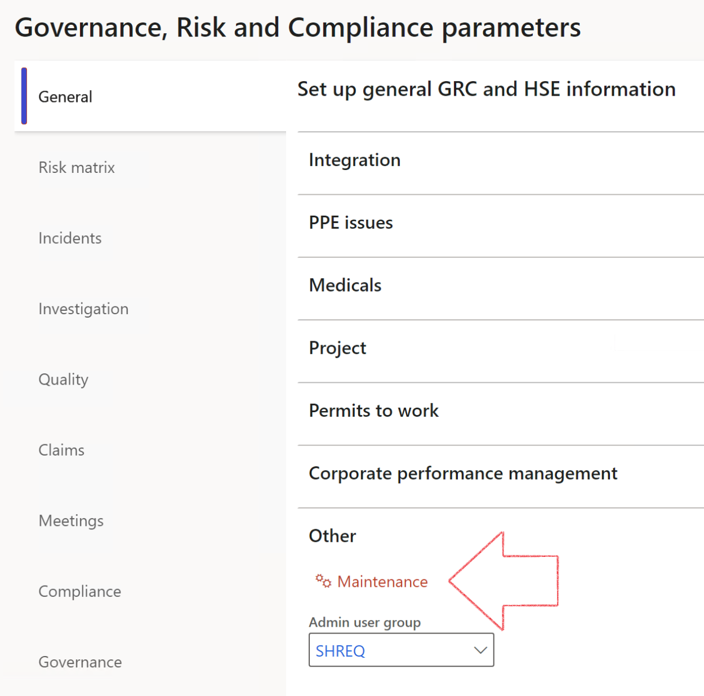

|  |  |
| --- | --- |
|  | The **Maintenance** button is there for designated user. This button repairs any possible data issues. For a full history of all Data related repairs; see table below: |

|  |  |  |
| --- | --- | --- |
| **Process** | **Description/notes** | **Release** |
| Fix location vs. work centres | Populate the new **LocationRecID** field with the related location associated with previously used work centre location (Location) fields on the following tables:   * OHSHazardLocations, * OHSRiskHazard, * OHSRiskHazardWizard, * OHSRiskRegister, * OHSRisksWizard, * OHSSafetyLocations, * OHSSafetyPermit, * OHSSafetyPermitLocations * OHSSafetyPermitOverlap, * OHSSafetyPlan, * OHSInvestigation | 10.0.80.10 |
| Fix risk hazards | Assigning the value "Default Risk" to the new mandatory field **RiskID** (Key field) where empty | 10.0.80.10 |
| Fix incident HRM injury link | Delete all orphaned records from the **OHSIncidentHRMInjuryLnk** table | 10.0.11785.3 |
| Populate SRS analysis enums | Still in concept phase. To provide a link between enum numerical value and value name for use with BYOD data entities. Enums available:   * OHSIncidentType, * OHSIncidentSeverityType.   Table populated: **SRSAnalysisEnums** | 10.0.11785.3 |
| Fix budget transaction lines stock\item dimension | Set **OHSInventDimId** field value to "**AllBlank**" on table **BudgetTransactionLine**, where no value was recorded. This will solve the issue of records not displaying in the form.  **Note: this step will only fix existing budget transaction records in the system. Should any new transactions be uploaded or changed via the data entity Budget Account Entries, special care needs to be taken to specify the Stock dimension = AllBlank and the Item on the excel sheet to import.** | 10.1.1366.6 |
| Update existing incidents with the new **Incident types** | Update existing incidents with the **Incident types** that are setup on the new **Incident type** setup form. (IncidentTypeRecId) | 10.17.1250 |
| Update existing risks with the new **Control types** | Update existing risks with the **Control types** that are setup on the new **Control type** setup form. | 10.17.1250 |

The information contained in this document represents the current view of Axnosis and Microsoft Corporation on the issues discussed as of the date of publication. Because Axnosis and Microsoft must respond to changing market conditions, this document should not be interpreted to be a commitment on the part of Axnosis and Microsoft, and Axnosis and Microsoft cannot guarantee the accuracy of any information presented after the date of publication.

This test script is for informational purposes only. AXNOSIS AND MICROSOFT MAKE NO WARRANTIES, EXPRESS, IMPLIED, OR STATUTORY, AS TO THE INFORMATION IN THIS DOCUMENT.

Complying with all applicable copyright laws is the responsibility of the user. Without limiting the rights under copyright, no part of this document may be reproduced, stored in or introduced into a retrieval system, or transmitted in any form or by any means (electronic, mechanical, photocopying, recording, or otherwise), or for any purpose, without the express written permission of Axnosis and Microsoft Corporation.

Axnosis and Microsoft may have patents, patent applications, trademarks, copyrights, or other intellectual property rights covering subject matter in this document. Except as expressly provided in any written license agreement from Axnosis and Microsoft, the furnishing of this document does not give you any license to these patents, trademarks, copyrights, or other intellectual property.

© 2021 Microsoft Corporation. All rights reserved. Any use or distribution of these materials without express authorization of Microsoft Corp. is strictly prohibited.

Microsoft and Windows are both registered trademarks of Microsoft Corporation in the United States and/or other countries.

The names of actual companies and products mentioned herein may be the trademarks of their respective owners.