

D365FO GRC/HSE Release notes



Governance Risk & Compliance

Health, Safety & Environment

for

**Microsoft Dynamics 365 for Finance & Operations™**

*D365FO GRC/HSE version* 10.17.1250.7

2022-07-21

## 

|  |  |  |
| --- | --- | --- |
| Dynamics 365 FO GRC module GRC is an add-on for Dynamics 365 suite of business application software.  This software provides functionality to support Governance, Risk management and Compliance as per the depicted sub-modules. |  | |
|  | | Dynamics 365 FO HSE module HSE is an add-on for Dynamics 365 suite of business application software.  This software provides functionality to support Health, Safety and Environment as per the depicted sub-modules. |

Release version

**GRC/HSE Package version:** OHSDeployablePackage_10_17_1250_7

This package was created on Microsoft Dynamics 365 for Finance and Operations:

|  |  |  |
| --- | --- | --- |
| **Release** | **Version** | **Build number** |
| Application release | 10.0.26 | 10.17.1250 |
| Platform release | Platform update 50 | 7.0.6354.52 |

# New additions:

|  |  |
| --- | --- |
| **Module** | **Description** |
| Risk management | A new **Bow tie risk report** can now be printed from the Risk register detail form |
| Matrix of operation | Under the **HSE** **setups**, a new menu item and setup form was created for **Operation barriers and conditions** |

# Enhancements:

|  |  |
| --- | --- |
| **Module** | **Description** |
| Risk management | * On the **Risk register lines** view:   + Under the **General** Fast tab, Identification Index tab, a lookup for **Risk category** was added   + A new Fast tab with label **Other** was added. There are two large **Note boxes** under this new Fast tab with user definable labels on the parameters form. * On the **Risk configuration** setup form, under the **Risk categories** tab, a grid was added where users can add **Sub-categories** * On the **Enterprise risk** **register**:   + For **non-conformance**:     - Under the **Associations** Fast tab, **Non-conformance** was added to the **Entity type** enum     - On the Action pane, a button was added for **Create non-conformance**. By clicking on this button, the user can create a non-conformance of type **Risk assessment**     - The **associated** non-conformance record is then displayed on the Risk register   + For **Financial statement assertions**:     - On The Action pane, a button was added for **Assertions**. When the user clicks on this button, a dialog opens where the user has the option to indicate which assertions are relevant to the risk register * On the **Risk register**, Lines view, under the General fast tab, a display method for **Risk score** was added. This to allow easy “**Top x**” filtering. |

|  |  |
| --- | --- |
| **Module** | **Description** |
| Tender management | * The wording on the notification on the **Tender specification**, when a change request has been created, has been changed from “**Change request created for contract…**” to “**Change request created for specification…**” * On the **Change request**, under the General Fast tab, the **Contract register reference** label was changed to **Specification reference** |
| Inspections | * On the **Inspection list** setup form:   + Under the **General** Fast tab:     - The **Compliance type** label was changed to **Allow Yes/No answers**     - The **Pass-fail score** field is now hidden   + Under the **Lines** Fast tab:     - The **Weight** column is now hidden     - The **Reporting threshold** column is now hidden     - In the **Related information** pane, an **image** can now be displayed for every line * On the **Inspection journal** lines view:   + The **images** that are now added on the Inspection list setup form, are copied to the Related information pane on the Inspection journal   + Under the Lines Fast tab, in the Hazard field, the **Hazard description** in now displayed instead of the **Hazard ID** |
| Incidents | * On **The Actions: (injured or killed while…)** setup form, the **Action ID** field has been extended to accommodate 25 characters * On the **Incident** detail form, Action pane: The fields on the dialogs that open when the **Fire** an **Explosives** buttons are clicked, have been rearranged so that the user does not have to scroll to see all the fields * The following was added to the **Report of an injury**:   + **Incident number**   + **Response** (First aid details) * On the **Incident graphs** report:   + The report is now printed in **landscape**   + The following labels were changed:     - **Near misses** is now **Near misses for all legal entities**     - **Vehicle incidents global** is now **Vehicle incidents for all legal entities** |
| General | * Under the **HSE setups**, on the **Pre-activity conditions** setup form, a column for **Key** was added with specific **colors** for the different values * **Multiple scheduled** records can now be approved at once   Please note that the **exception** is **Scheduled audits** |

# Bug fixes:

|  |  |
| --- | --- |
| **Module** | **Description** |
| Inspections | **Questionnaires** selected on the **Journal name**, are now displayed on the Inspection journal created from the **approved** schedule |

Release Data impact

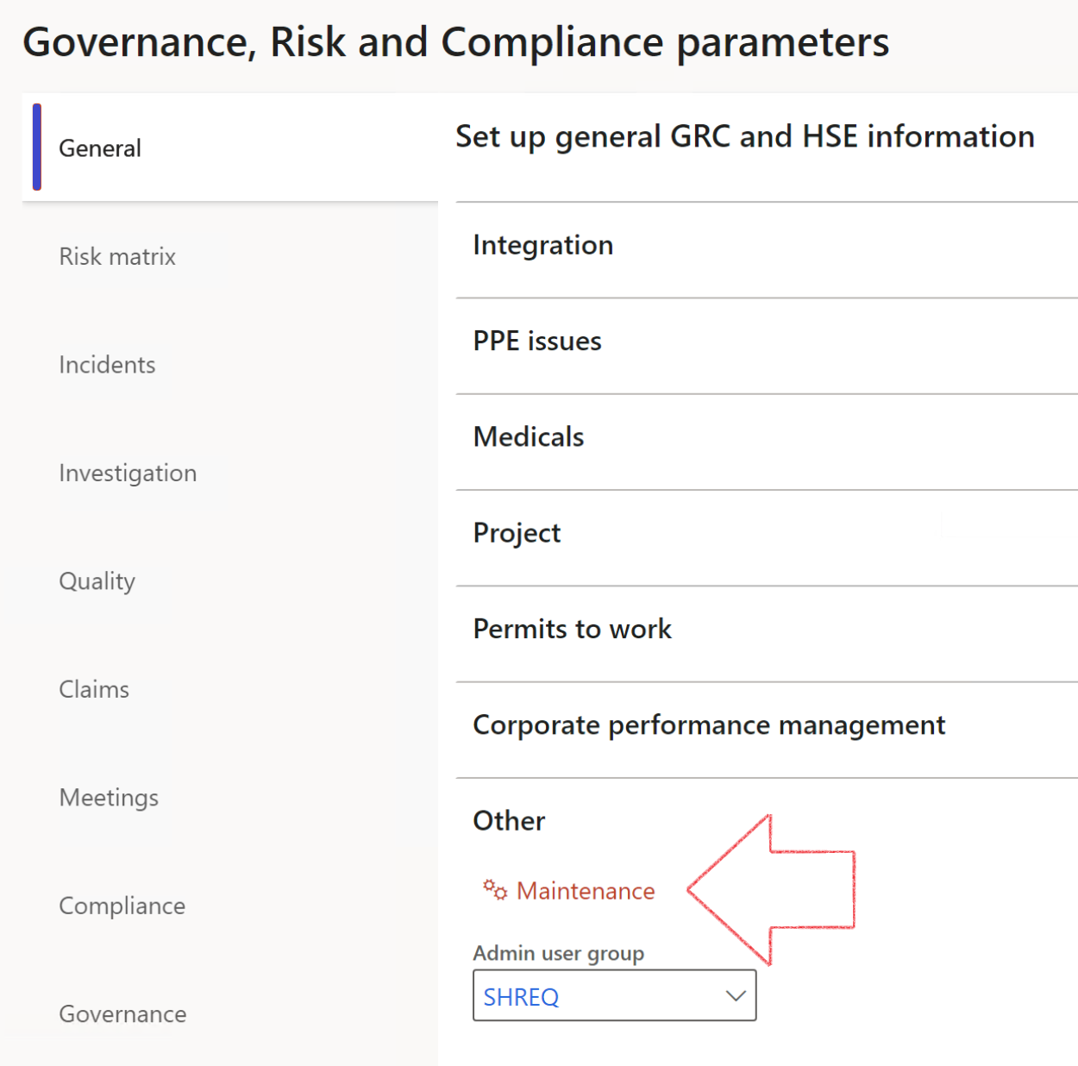

|  |  |
| --- | --- |
|  | The **Maintenance** button is there for designated user. This button repairs any possible data issues. For a full history of all Data related repairs; see table below: |

|  |  |  |
| --- | --- | --- |
| **Process** | **Description/notes** | **Release** |
| Fix location vs. work centres | Populate the new **LocationRecID** field with the related location associated with previously used work centre location (Location) fields on the following tables:   * OHSHazardLocations, * OHSRiskHazard, * OHSRiskHazardWizard, * OHSRiskRegister, * OHSRisksWizard, * OHSSafetyLocations, * OHSSafetyPermit, * OHSSafetyPermitLocations * OHSSafetyPermitOverlap, * OHSSafetyPlan, * OHSInvestigation | 10.0.80.10 |
| Fix risk hazards | Assigning the value "Default Risk" to the new mandatory field **RiskID** (Key field) where empty | 10.0.80.10 |
| Fix incident HRM injury link | Delete all orphaned records from the **OHSIncidentHRMInjuryLnk** table | 10.0.11785.3 |
| Populate SRS analysis enums | Still in concept phase. To provide a link between enum numerical value and value name for use with BYOD data entities. Enums available:   * OHSIncidentType, * OHSIncidentSeverityType.   Table populated: **SRSAnalysisEnums** | 10.0.11785.3 |
| Fix budget transaction lines stock\item dimension | Set **OHSInventDimId** field value to "**AllBlank**" on table **BudgetTransactionLine**, where no value was recorded. This will solve the issue of records not displaying in the form.  **Note: this step will only fix existing budget transaction records in the system. Should any new transactions be uploaded or changed via the data entity Budget Account Entries, special care needs to be taken to specify the Stock dimension = AllBlank and the Item on the excel sheet to import.** | 10.1.1366.6 |
| Update existing incidents with the new **Incident types** | Update existing incidents with the **Incident types** that are setup on the new **Incident type** setup form. (IncidentTypeRecId) | 10.17.1250 |
| Update existing risks with the new **Control types** | Update existing risks with the **Control types** that are setup on the new **Control type** setup form. | 10.17.1250 |

The information contained in this document represents the current view of Axnosis and Microsoft Corporation on the issues discussed as of the date of publication. Because Axnosis and Microsoft must respond to changing market conditions, this document should not be interpreted to be a commitment on the part of Axnosis and Microsoft, and Axnosis and Microsoft cannot guarantee the accuracy of any information presented after the date of publication.

This test script is for informational purposes only. AXNOSIS AND MICROSOFT MAKE NO WARRANTIES, EXPRESS, IMPLIED, OR STATUTORY, AS TO THE INFORMATION IN THIS DOCUMENT.

Complying with all applicable copyright laws is the responsibility of the user. Without limiting the rights under copyright, no part of this document may be reproduced, stored in or introduced into a retrieval system, or transmitted in any form or by any means (electronic, mechanical, photocopying, recording, or otherwise), or for any purpose, without the express written permission of Axnosis and Microsoft Corporation.

Axnosis and Microsoft may have patents, patent applications, trademarks, copyrights, or other intellectual property rights covering subject matter in this document. Except as expressly provided in any written license agreement from Axnosis and Microsoft, the furnishing of this document does not give you any license to these patents, trademarks, copyrights, or other intellectual property.

© 2021 Microsoft Corporation. All rights reserved. Any use or distribution of these materials without express authorization of Microsoft Corp. is strictly prohibited.

Microsoft and Windows are both registered trademarks of Microsoft Corporation in the United States and/or other countries.

The names of actual companies and products mentioned herein may be the trademarks of their respective owners.