

D365FO GRC/HSE Release notes



Governance Risk & Compliance

Health, Safety & Environment

for

**Microsoft Dynamics 365 for Finance & Operations™**

*D365FO GRC/HSE version* 10.17.1250.5

2022-07-04

## 

|  |  |  |
| --- | --- | --- |
| Dynamics 365 FO GRC module GRC is an add-on for Dynamics 365 suite of business application software.  This software provides functionality to support Governance, Risk management and Compliance as per the depicted sub-modules. |  | |
|  | | Dynamics 365 FO HSE module HSE is an add-on for Dynamics 365 suite of business application software.  This software provides functionality to support Health, Safety and Environment as per the depicted sub-modules. |

Release version

**GRC/HSE Package version:** OHSDeployablePackage_10_17_1250_5

This package was created on Microsoft Dynamics 365 for Finance and Operations:

|  |  |  |
| --- | --- | --- |
| **Release** | **Version** | **Build number** |
| Application release | 10.0.26 | 10.17.1250 |
| Platform release | Platform update 50 | 7.0.6354.52 |

# Enhancements:

|  |  |
| --- | --- |
| **Module** | **Description** |
| General | * The following changes were made to the **Signature type** setup form. A new table was created so that one **Signature type** can be linked to many **workers**. * On the forms where the **Signatures** Fast tab is used, the following change was made under the **Signatures** Fast tab. The **Signature type** field was moved to the front of the grid. The user can now select the relevant type and then select the worker linked to the type. |
| Action plans | **Security roles**, **Duties** and **Privileges** have been built for Action plans and Action plan lines |
| Claims | * On the **Claims** detail form * The **Print notice of loss** and the **Print claims statement** buttons can now be found in the drop-down button by clicking on the **Print** button * On the **Claim statement report**, the cost type description has been combined with the cost type in the "sub-heading" of the report |
| Inspections | The warning that pops up when an **Inspection journal** cannot be posted, has been enhanced to give the user detail of why the journal cannot be posted |
| Incidents | A **Response to incident** button was added on the Action pane of the Incident detail form. This button opens a dialog where the user can add additional information regarding first aid given etc. |
| Contractor safety and security | On the **Contractor safety and security** workspace:   * A new tile was added that counts (and on click opens a list page) all associated incidents for the logged in vendor. * A new **Upload your own support documents** button, which gives users the ability to upload attachments to the Vendor record |
| Environmental | On the **Emissions register** and the **Utilities register**, a **Show closed records** slider was added, giving the user the option to view the closed records as well |

|  |  |
| --- | --- |
| **Module** | **Description** |
| Risk management | * The **Risk wizard** now supports all three risk classes * On the **GRC** menu, a sub folder was created under **Risk** for **Worksheets** * The following changes have been made to the **Risk** tab under the **GRC parameters**:   + The **Risk matrix** tab label was changed to **Risk**   + A Fast tab for **Scale setup** was added   + The matrix **Size** and **Heat map** setups are now under the **Matrix setup** Fast tab   + The **Risk mode** Fast tab was renamed to **Risk lines** * Three new base tables were created and are used on the **Risk configuration** setup:   + **Severity**   + **Frequency**   + **Exposure** |
| Audits | * Compliance audit:   + On the Area of compliance Header and Lines:     - A new Field group for Compliance obligation was added. A lookup for Compliance obligation was added under this Field group. * Compliance audit and Internal audit:   + The Status and the Date recorded is now displayed at the top right-hand side of the Area of compliance and the Audit universe detail forms   + When record is created, the Date recorded field is populated with the current date   + An Activities button was added in the Action pane   + A Related information pane was added with a Fact box for Activities |

# Bug fixes:

|  |  |
| --- | --- |
| **Module** | **Description** |
| Claims | The following issues on the **First notice of loss** report have been resolved:   * The same incident was being printer twice * The person’s name in the **Contact** column was not printing on the report |

Release Data impact

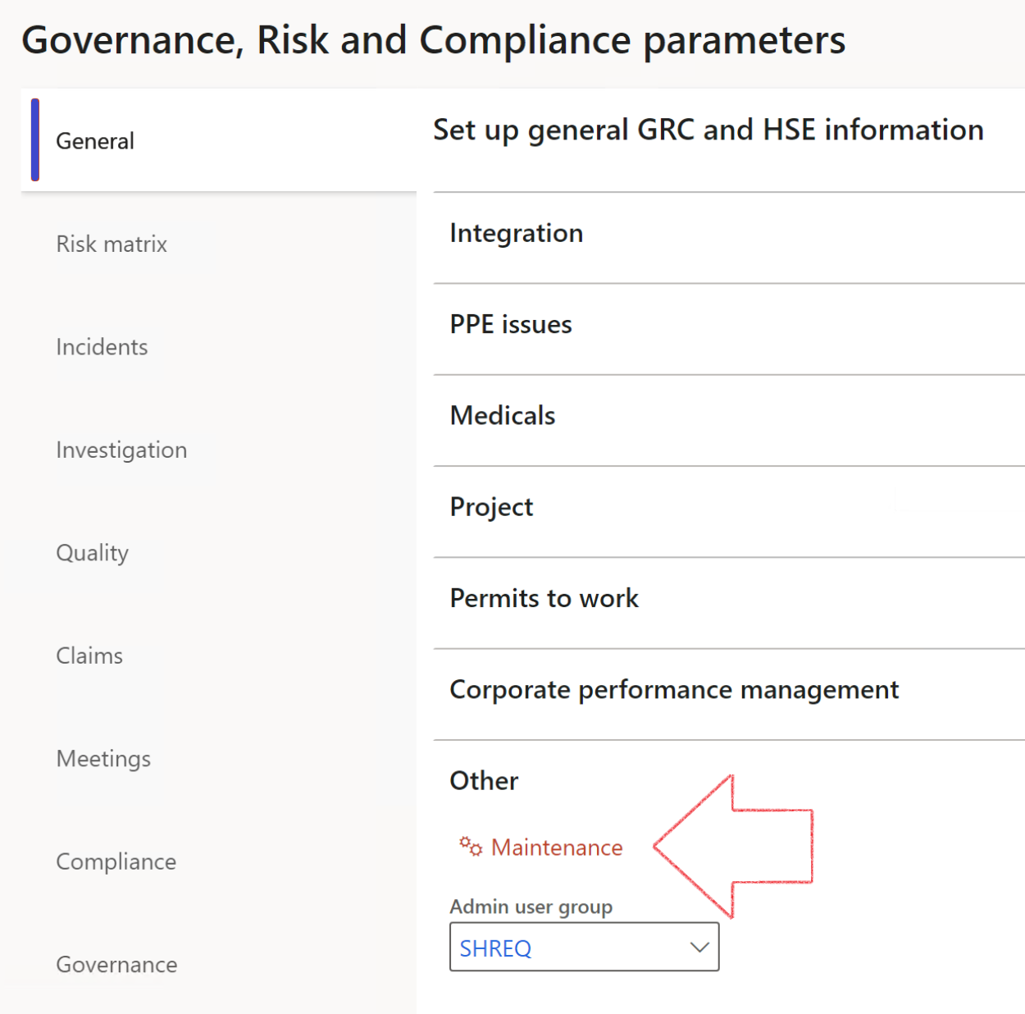

|  |  |
| --- | --- |
|  | The **Maintenance** button is there for designated user. This button repairs any possible data issues. For a full history of all Data related repairs; see table below: |

|  |  |  |
| --- | --- | --- |
| **Process** | **Description/notes** | **Release** |
| Fix location vs. work centres | Populate the new **LocationRecID** field with the related location associated with previously used work centre location (Location) fields on the following tables:   * OHSHazardLocations, * OHSRiskHazard, * OHSRiskHazardWizard, * OHSRiskRegister, * OHSRisksWizard, * OHSSafetyLocations, * OHSSafetyPermit, * OHSSafetyPermitLocations * OHSSafetyPermitOverlap, * OHSSafetyPlan, * OHSInvestigation | 10.0.80.10 |
| Fix risk hazards | Assigning the value "Default Risk" to the new mandatory field **RiskID** (Key field) where empty | 10.0.80.10 |
| Fix incident HRM injury link | Delete all orphaned records from the **OHSIncidentHRMInjuryLnk** table | 10.0.11785.3 |
| Populate SRS analysis enums | Still in concept phase. To provide a link between enum numerical value and value name for use with BYOD data entities. Enums available:   * OHSIncidentType, * OHSIncidentSeverityType.   Table populated: **SRSAnalysisEnums** | 10.0.11785.3 |
| Fix budget transaction lines stock\item dimension | Set **OHSInventDimId** field value to "**AllBlank**" on table **BudgetTransactionLine**, where no value was recorded. This will solve the issue of records not displaying in the form.  **Note: this step will only fix existing budget transaction records in the system. Should any new transactions be uploaded or changed via the data entity Budget Account Entries, special care needs to be taken to specify the Stock dimension = AllBlank and the Item on the excel sheet to import.** | 10.1.1366.6 |
| Update existing incidents with the new **Incident types** | Update existing incidents with the Incident types that are setup on the new **Incident type** setup form. (IncidentTypeRecId) | 10.17.1250 |

The information contained in this document represents the current view of Axnosis and Microsoft Corporation on the issues discussed as of the date of publication. Because Axnosis and Microsoft must respond to changing market conditions, this document should not be interpreted to be a commitment on the part of Axnosis and Microsoft, and Axnosis and Microsoft cannot guarantee the accuracy of any information presented after the date of publication.

This test script is for informational purposes only. AXNOSIS AND MICROSOFT MAKE NO WARRANTIES, EXPRESS, IMPLIED, OR STATUTORY, AS TO THE INFORMATION IN THIS DOCUMENT.

Complying with all applicable copyright laws is the responsibility of the user. Without limiting the rights under copyright, no part of this document may be reproduced, stored in or introduced into a retrieval system, or transmitted in any form or by any means (electronic, mechanical, photocopying, recording, or otherwise), or for any purpose, without the express written permission of Axnosis and Microsoft Corporation.

Axnosis and Microsoft may have patents, patent applications, trademarks, copyrights, or other intellectual property rights covering subject matter in this document. Except as expressly provided in any written license agreement from Axnosis and Microsoft, the furnishing of this document does not give you any license to these patents, trademarks, copyrights, or other intellectual property.

© 2021 Microsoft Corporation. All rights reserved. Any use or distribution of these materials without express authorization of Microsoft Corp. is strictly prohibited.

Microsoft and Windows are both registered trademarks of Microsoft Corporation in the United States and/or other countries.

The names of actual companies and products mentioned herein may be the trademarks of their respective owners.