

D365FO GRC/HSE Release notes



Governance Risk & Compliance

Health, Safety & Environment

for

**Microsoft Dynamics 365 for Finance & Operations™**

*D365FO GRC/HSE version* 10.17.1250.4

2022-06-24

## 

|  |  |  |
| --- | --- | --- |
| Dynamics 365 FO GRC module GRC is an add-on for Dynamics 365 suite of business application software.  This software provides functionality to support Governance, Risk management and Compliance as per the depicted sub-modules. |  | |
|  | | Dynamics 365 FO HSE module HSE is an add-on for Dynamics 365 suite of business application software.  This software provides functionality to support Health, Safety and Environment as per the depicted sub-modules. |

Release version

**GRC/HSE Package version:** OHSDeployablePackage_10_17_1250_4

This package was created on Microsoft Dynamics 365 for Finance and Operations:

|  |  |  |
| --- | --- | --- |
| **Release** | **Version** | **Build number** |
| Application release | 10.0.26 | 10.17.1250 |
| Platform release | Platform update 50 | 7.0.6354.52 |

# New additions:

|  |  |
| --- | --- |
| **Module** | **Description** |
| Environmental | A new **Environmental management workspace** was created with the following Index tabs:   * Waste graph * Utilities graph * Emissions graph * Monitoring point   (These were menu items under **HSE>Environmental>Reports and inquiries.** The menu items have been deleted) |
| Claims management | A new **Claims statement** report was created. This report displays the primary incident’s costs |

# Enhancements:

|  |  |
| --- | --- |
| **Module** | **Description** |
| Action plans | * On the **Create action plan** dialog, a mandatory lookup was added for **Inspector (worker)** * The following was done on the **Action plan** **Lines** view, **Line details** Fast tab: * The **Approver** field in now non-editable * A display method was added for **Last forwarded by** * The **Feedback and close** button is now only available if the logged in user is selected as the **Responsible worker** |
| Activity management | * The **Activity manager** workspace now has two Index tabs:   + **My work**   + **All open actions**     - Filters for **Site**, **From date**, **To date** were added * On the **Create activity** dialog, a field was added for **Purpose** |
| Performance management | The following was done on the **Monitoring schedule**, General Fast tab:   * A lookup for **Approval team** was added under the **Approval** Field group   + The **Status** of the Monitoring schedule can only be changed to **Approved** by users in the selected Approval group * A **Closing** Field group was added |
| Risk management | * On the **Risk and compliance** workspace:   + Under the **Enterprise risk exposure** index tab, a filter for **Site** was added   + The **All open actions** Index tab was moved to the **Activity manager** workspace   + Under the **My work** Index tab, a tab was added under the **Details** section for **All open bow tie registers**   + Under the **All risk controls** Index tab, a column was added for indicating which records are of type **Bow tie** * A new menu item was created for **Risk registers in the current legal entity** * On the **All risk registers** list page, a column was added to indicate the **Company**/**Legal entity** of the risk register * On the **Risk register**, Lines view, under the General Fast tab, an additional column was added to the **Compliance obligation** lookup * Help texts were improved * On all risk registers, Lines view, the text from the **Label** field is now displayed in the Header section |
| Contract management | * The following was added on **All contract requests**, under the Document management Fast tab:   + **Contract request** Index tab, Field groups were created for:     - **General**     - **Commercials**     - **Legal representative**     - **Conclusion**   + **Motivation** Index tab, the following fields were added:     - **Possible saving**     - **Currency** * Additional fields were added to the **New case** dialog |

|  |  |
| --- | --- |
| **Module** | **Description** |
| Compliance audit | On the **Compliance function**, under the General Fast tab, the **ISO Standard** enum was extended to accommodate the following values:   * **ISO 22301** * **ISO 27001** |
| Inspections | The following was done on the **Inspection journal**:   * The **Inspection journal ID** is displayed at the top of the form * The **Status** and **Due date** are now displayed in the top right-hand side of the form * On the **Lines** view:   + Under the **Lines** Fast tab:     - The **Hazard** column is now only visible when the **Inspection type** = **Behaviour**/**Safety**/**Construction**     - The **Inspection sheet name** column is hidden * On the Inspection journal list page, a column was added to indicate whether the inspection was **Passed** or **Failed**   + Under the **Line details** Fast tab:     - The **Approve** Field group is hidden     - The **Inspection sheet name** is displayed * On the following was added on the **Inspection list** setup form:   + On the **Header** view, a **Pass-Fail Score** field   + On The **Lines** view, a field for **Skull and Crossbones** (This is an indication that if the selected line fails, the whole inspection will fail) * On the **Inspection journal report**, the icons were changed and an icon for indicating **Not applicable** lines was added |
| Incidents | * The following was done on the **Incident type** setup form:   + All the tick boxes in the grid are hidden   + The Incident type enum lookup was moved to after the Description field   + On the **Incident type** enum:     - **Complaint/Compliment** was changed to **Complaint**     - **Compliment** was added   Please note that the **Maintenance** button on the Governance, risk and compliance parameters must be clicked to update existing incidents with the new **Incident types** |
| Claims management | * The following fields are now hidden on the **Create claim** dialog:   + - **Invoice**     - **Closed date**     - **Closed**   + On the **Claim** form, under the **Deductions and costs incurred** Fast tab, the following fields were added:     - **Description**     - **Quantity**     - **Rate**   The **Amount** field is updated with a calculation of the costs of the claim (Qty x Rate) |

# Bug fixes:

|  |  |
| --- | --- |
| **Module** | **Description** |
| Risk management | On the **Risk and compliance workspace**, under the **Enterprise risk exposure** Index tab, the grid is now non-editable |

Release Data impact

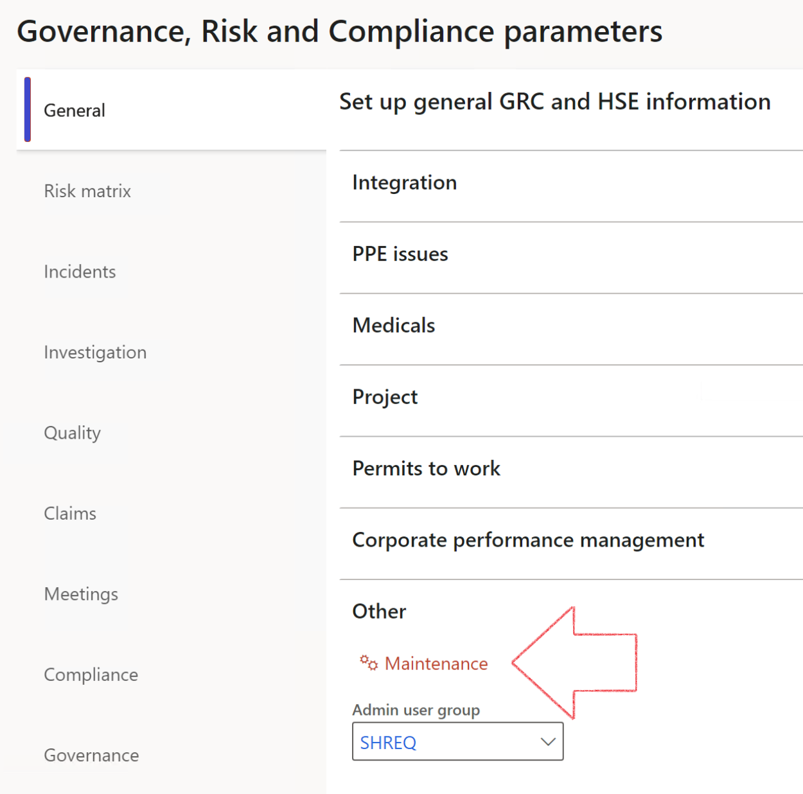

|  |  |
| --- | --- |
|  | The **Maintenance** button is there for designated user. This button repairs any possible data issues. For a full history of all Data related repairs; see table below: |

|  |  |  |
| --- | --- | --- |
| **Process** | **Description/notes** | **Release** |
| Fix location vs. work centres | Populate the new **LocationRecID** field with the related location associated with previously used work centre location (Location) fields on the following tables:   * OHSHazardLocations, * OHSRiskHazard, * OHSRiskHazardWizard, * OHSRiskRegister, * OHSRisksWizard, * OHSSafetyLocations, * OHSSafetyPermit, * OHSSafetyPermitLocations * OHSSafetyPermitOverlap, * OHSSafetyPlan, * OHSInvestigation | 10.0.80.10 |
| Fix risk hazards | Assigning the value "Default Risk" to the new mandatory field **RiskID** (Key field) where empty | 10.0.80.10 |
| Fix incident HRM injury link | Delete all orphaned records from the **OHSIncidentHRMInjuryLnk** table | 10.0.11785.3 |
| Populate SRS analysis enums | Still in concept phase. To provide a link between enum numerical value and value name for use with BYOD data entities. Enums available:   * OHSIncidentType, * OHSIncidentSeverityType.   Table populated: **SRSAnalysisEnums** | 10.0.11785.3 |
| Fix budget transaction lines stock\item dimension | Set **OHSInventDimId** field value to "**AllBlank**" on table **BudgetTransactionLine**, where no value was recorded. This will solve the issue of records not displaying in the form.  **Note: this step will only fix existing budget transaction records in the system. Should any new transactions be uploaded or changed via the data entity Budget Account Entries, special care needs to be taken to specify the Stock dimension = AllBlank and the Item on the excel sheet to import.** | 10.1.1366.6 |
| Update existing incidents with the new **Incident types** | Update existing incidents with the Incident types that are setup on the new **Incident type** setup form. (IncidentTypeRecId) | 10.17.1250 |

The information contained in this document represents the current view of Axnosis and Microsoft Corporation on the issues discussed as of the date of publication. Because Axnosis and Microsoft must respond to changing market conditions, this document should not be interpreted to be a commitment on the part of Axnosis and Microsoft, and Axnosis and Microsoft cannot guarantee the accuracy of any information presented after the date of publication.

This test script is for informational purposes only. AXNOSIS AND MICROSOFT MAKE NO WARRANTIES, EXPRESS, IMPLIED, OR STATUTORY, AS TO THE INFORMATION IN THIS DOCUMENT.

Complying with all applicable copyright laws is the responsibility of the user. Without limiting the rights under copyright, no part of this document may be reproduced, stored in or introduced into a retrieval system, or transmitted in any form or by any means (electronic, mechanical, photocopying, recording, or otherwise), or for any purpose, without the express written permission of Axnosis and Microsoft Corporation.

Axnosis and Microsoft may have patents, patent applications, trademarks, copyrights, or other intellectual property rights covering subject matter in this document. Except as expressly provided in any written license agreement from Axnosis and Microsoft, the furnishing of this document does not give you any license to these patents, trademarks, copyrights, or other intellectual property.

© 2021 Microsoft Corporation. All rights reserved. Any use or distribution of these materials without express authorization of Microsoft Corp. is strictly prohibited.

Microsoft and Windows are both registered trademarks of Microsoft Corporation in the United States and/or other countries.

The names of actual companies and products mentioned herein may be the trademarks of their respective owners.