

D365FO GRC/HSE Release notes



Governance Risk & Compliance

Health, Safety & Environment

for

**Microsoft Dynamics 365 for Finance & Operations™**

*D365FO GRC/HSE version* 10.17.1250.3

2022-06-06

## 

|  |  |  |
| --- | --- | --- |
| Dynamics 365 FO GRC module GRC is an add-on for Dynamics 365 suite of business application software.  This software provides functionality to support Governance, Risk management and Compliance as per the depicted sub-modules. |  | |
|  | | Dynamics 365 FO HSE module HSE is an add-on for Dynamics 365 suite of business application software.  This software provides functionality to support Health, Safety and Environment as per the depicted sub-modules. |

Release version

**GRC/HSE Package version:** OHSDeployablePackage_10_17_1250_3

This package was created on Microsoft Dynamics 365 for Finance and Operations:

|  |  |  |
| --- | --- | --- |
| **Release** | **Version** | **Build number** |
| Application release | 10.0.26 | 10.17.1250 |
| Platform release | Platform update 50 | 7.0.6354.52 |

# Enhancements:

|  |  |
| --- | --- |
| **Module** | **Description** |
| Risk management | * The following enhancements were done on the **Risk register** lines view, under the **General** Fast tab:   + A new Index tab, with label **Risk actions**, was added   + The following two field groups are under this new Index tab:     - **Approval and closing** – The six fields that were under the Approval and closing Index tab, have been moved to under this field group     - **Review and follow up** - The five fields that were under the Review and follow up Index tab, have been moved to under this field group   + The following Index tabs are now hidden:     - **Approval and closing**     - **Review and follow up** * When the user creates an **Approval/Follow up** record, a pop-up prompts the user to confirm that a **GRC planned action** will be created * A **Placeholder** for **Reviewed by** was added for email templates |
| Claims | * The **Claims** label on the **D365 login** dashboard has been changed to **Claims management** * On the **Object**, under the **Operators and crew** Fast tab, either a **Vendor** of an **Employee** can be selected per line |
| Investigations | * On the **Investigation**, under the General Fast tab, Identification Index tab, a display for **Workflow status** was added |

# Bug fixes:

|  |  |
| --- | --- |
| **Module** | **Description** |
| Permit to work | * When workflow is enabled, the **Approved**, **Submitted** and **Rejected** buttons should be disabled. * When workflow is disabled, all three buttons should be enabled and the current status of the PTW should disable the relevant status button. This was not working correctly.   The issue has been resolved.   * On the Projects WBS, the PTW lookup did not commit, which caused the **Projects** fields on the PTW to be empty.   The issue has been resolved.   * Three fields were added on the **Data entity** for the mobile app. |
| Risk management | * The Enterprise risk **control calculations** were not updating as expected when controls were deleted. * The ‘**Lock**’ button was not locking the **Residual consequence** value when changes were made to the Preventative controls.   The issues have been resolved |

Release Data impact

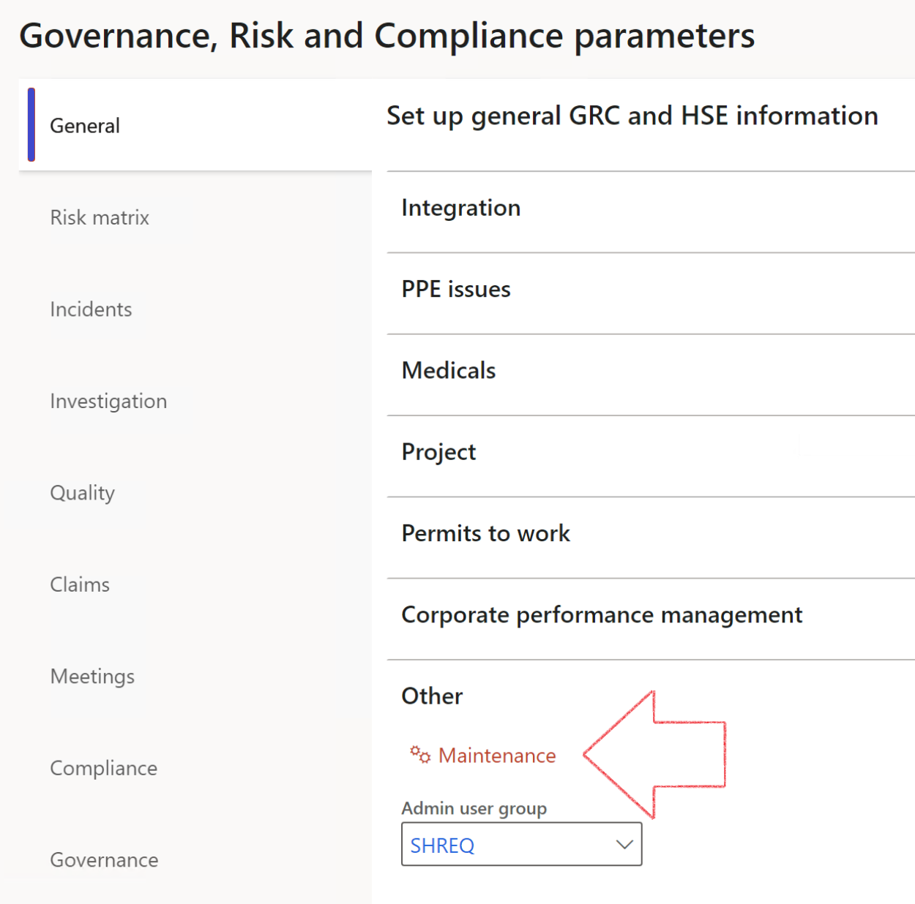

|  |  |
| --- | --- |
|  | The **Maintenance** button is there for designated user. This button repairs any possible data issues. For a full history of all Data related repairs; see table below: |

|  |  |  |
| --- | --- | --- |
| **Process** | **Description/notes** | **Release** |
| Fix location vs. work centres | Populate the new **LocationRecID** field with the related location associated with previously used work centre location (Location) fields on the following tables:   * OHSHazardLocations, * OHSRiskHazard, * OHSRiskHazardWizard, * OHSRiskRegister, * OHSRisksWizard, * OHSSafetyLocations, * OHSSafetyPermit, * OHSSafetyPermitLocations * OHSSafetyPermitOverlap, * OHSSafetyPlan, * OHSInvestigation | 10.0.80.10 |
| Fix risk hazards | Assigning the value "Default Risk" to the new mandatory field **RiskID** (Key field) where empty | 10.0.80.10 |
| Fix incident HRM injury link | Delete all orphaned records from the **OHSIncidentHRMInjuryLnk** table | 10.0.11785.3 |
| Populate SRS analysis enums | Still in concept phase. To provide a link between enum numerical value and value name for use with BYOD data entities. Enums available:   * OHSIncidentType, * OHSIncidentSeverityType.   Table populated: **SRSAnalysisEnums** | 10.0.11785.3 |
| Fix budget transaction lines stock\item dimension | Set **OHSInventDimId** field value to "**AllBlank**" on table **BudgetTransactionLine**, where no value was recorded. This will solve the issue of records not displaying in the form.  **Note: this step will only fix existing budget transaction records in the system. Should any new transactions be uploaded or changed via the data entity Budget Account Entries, special care needs to be taken to specify the Stock dimension = AllBlank and the Item on the excel sheet to import.** | 10.1.1366.6 |

The information contained in this document represents the current view of Axnosis and Microsoft Corporation on the issues discussed as of the date of publication. Because Axnosis and Microsoft must respond to changing market conditions, this document should not be interpreted to be a commitment on the part of Axnosis and Microsoft, and Axnosis and Microsoft cannot guarantee the accuracy of any information presented after the date of publication.

This test script is for informational purposes only. AXNOSIS AND MICROSOFT MAKE NO WARRANTIES, EXPRESS, IMPLIED, OR STATUTORY, AS TO THE INFORMATION IN THIS DOCUMENT.

Complying with all applicable copyright laws is the responsibility of the user. Without limiting the rights under copyright, no part of this document may be reproduced, stored in or introduced into a retrieval system, or transmitted in any form or by any means (electronic, mechanical, photocopying, recording, or otherwise), or for any purpose, without the express written permission of Axnosis and Microsoft Corporation.

Axnosis and Microsoft may have patents, patent applications, trademarks, copyrights, or other intellectual property rights covering subject matter in this document. Except as expressly provided in any written license agreement from Axnosis and Microsoft, the furnishing of this document does not give you any license to these patents, trademarks, copyrights, or other intellectual property.

© 2021 Microsoft Corporation. All rights reserved. Any use or distribution of these materials without express authorization of Microsoft Corp. is strictly prohibited.

Microsoft and Windows are both registered trademarks of Microsoft Corporation in the United States and/or other countries.

The names of actual companies and products mentioned herein may be the trademarks of their respective owners.