

D365FO GRC/HSE Release notes



Governance Risk & Compliance

Health, Safety & Environment

for

**Microsoft Dynamics 365 for Finance & Operations™**

*D365FO GRC/HSE version* 10.15.1323.7

2022-03-31

## 

|  |  |  |
| --- | --- | --- |
| Dynamics 365 FO GRC module GRC is an add-on for Dynamics 365 suite of business application software.  This software provides functionality to support Governance, Risk management and Compliance as per the depicted sub-modules. |  | |
|  | | Dynamics 365 FO HSE module HSE is an add-on for Dynamics 365 suite of business application software.  This software provides functionality to support Health, Safety and Environment as per the depicted sub-modules. |

Release version

**GRC/HSE Package version:** OHSDeployablePackage_10_15_1323_7

This package was created on Microsoft Dynamics 365 for Finance and Operations:

|  |  |  |
| --- | --- | --- |
| **Release** | **Version** | **Build number** |
| Application release | 10.0.24 | 10.15.1323 |
| Platform release | Platform update 48 | 7.0.6253.76 |

# Enhancements:

|  |  |
| --- | --- |
| **Module** | **Description** |
| General | The **Responsibility matrix** Fast tab label (on all the relevant forms), was changed to **RACI** |
| Action plans | Email functionality was added to the **Action plan Header** under the **RACI** Fast tab |
| Environmental | * The possibility to do different types of analysis on the same **Monitoring point**, has been removed * A **Baseline analysis** can be done for every **Monitoring point** * Only one sample can be marked as **Baseline** for every **Monitoring point**. The Baseline sample cannot be deleted. * A new **Monitoring point graph** was added where the following can be selected to be displayed:  |  |  | | --- | --- | | * + **From date** and **To date**   + **Monitoring point** | * + **Substance**   + **Risk category** |  * **Projects** can now be referenced from the three Environmental registers * The three **Environmental registers** can now be opened from the **Projects list page** and **detail form** * A **Color** field was added to the **Analytical requirements** form under the **Risk categories** Fast tab |
| Inspections | * **Emergency drills** was added to **Inspections**:   + A new **Emergency preparedness** Fast tab was added which is only available when the Inspection **type** on the journal header = **Drill** * **Inspections** can now be created from the **Projects** form |
| Permit to work | On the **Permit to work Header** view, under the **Work to be performed** Fast tab, the following display methods were added to reference the linked Project:   * **Project** * **WBS line number** * **Description** |
| Incidents | On the Projects form, the existing **Report an Incident** dialog was replaced with the new **Create dialog** that opens on the right-hand side of the screen |
| Safety and security | A **Project** lookup field was added on the **Gate pass** form under the General Fast tab  (Internal audit projects are excluded from the drop-down list) |

|  |  |
| --- | --- |
| **Module** | **Description** |
| Performance management | * On the **Appraisals** form, the help text for the **Add reviews** button was changed from ”**Add reviews**” to "**Assign appraisal to applicable worker reviews**" * On the **Monitoring schedule:**   + A **Copy schedule** button was added   + Under the **General** Fast tab:     - A display field was addedfor **Version** number which changes when the **Copy schedule** button is used     - A Field group for **Approval** was added   + Under the **Monitoring and measurement lines** Fast tab, the user can choose to **Show/Exclude closed records** * On the **Monitoring and measurement**:   + **Activities** can be created and displayed in a **Related information** pane   + **Projects** can be linked under the **General** Fast tab   + A **Feedback** text box was added under the **Evaluation** Fast tab |
| Risk management | * The **Enterprise risk assessment** menu item and form labels were changed to **Enterprise risk (self) assessment** * A new menu item was added for **Enterprise risk assessment**. This menu item opens the existing **Enterprise risk assessment** form. |
| Contract management | * On the **Policies, contracts, and reports** form, under the **Reference** Index tab, the help text for the **Reference ID** field was changed to **Reference ID linked to policy, contract, and reports** * On The **Contract register** detail form: (Contracts are also referenced on Projects)   + A new **Projects** Fast tab was added with the following Index tabs:     - **Statement of work**     - **Insurance**     - **Penalties** * On **Purchase** and **Sales agreements**:   + The Index tabs under the **Contracts administration** Fast tab are hidden   + The **Contracts administration** Fast tab was moved to under the **Financial dimensions** Fast tab   + On the Header:     - Under the **General** Fast tab, the **Project** Field group is hidden     - Under the **Contract commercials** Fast tab, the following fields are hidden:       * **Statement of work value**       * **Insurance value**       * **Change requests value**       * **Penalties value** |
| Legal | **Projects** can now be referenced from the **Legal register** |

# Bug fixes:

|  |  |
| --- | --- |
| **Module** | **Description** |
| Occupational health | When a new **Medical member** was created, it was immediately deleted. The issue has been resolved. |
| Document management | When workflow is disabled, the **Workflow Field** group on the **All document requests** form will be hidden |

Release Data impact

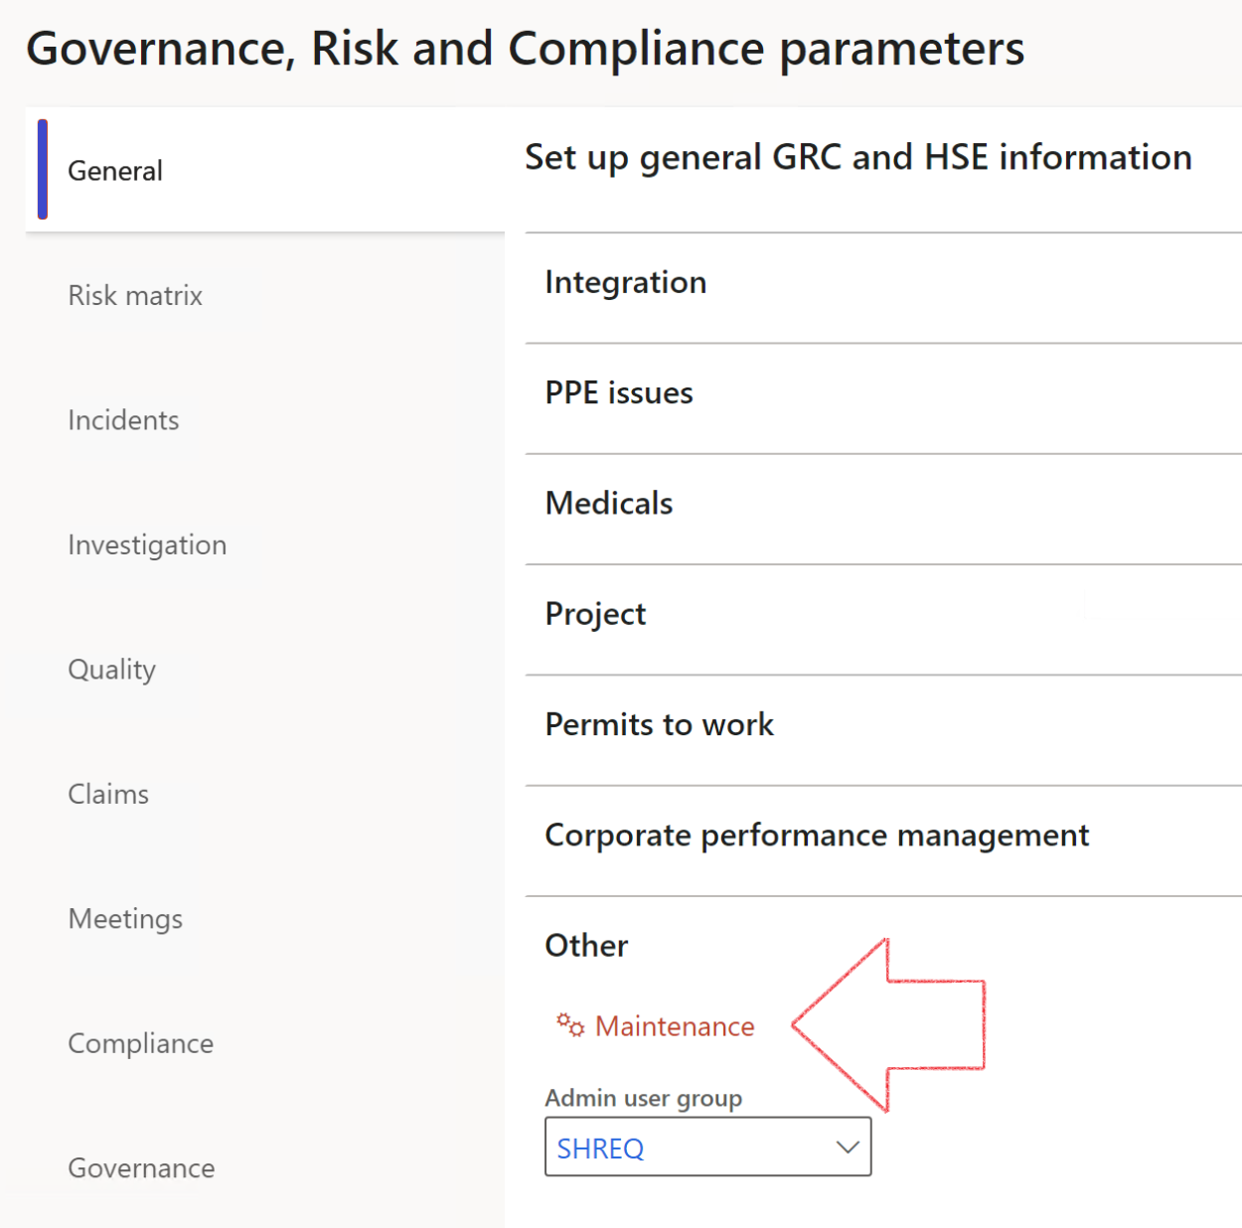

|  |  |
| --- | --- |
|  | The **Maintenance** button is there for designated user. This button repairs any possible data issues. For a full history of all Data related repairs; see table below: |

|  |  |  |
| --- | --- | --- |
| **Process** | **Description/notes** | **Release** |
| Fix location vs. work centres | Populate the new **LocationRecID** field with the related location associated with previously used work centre location (Location) fields on the following tables:   * OHSHazardLocations, * OHSRiskHazard, * OHSRiskHazardWizard, * OHSRiskRegister, * OHSRisksWizard, * OHSSafetyLocations, * OHSSafetyPermit, * OHSSafetyPermitLocations * OHSSafetyPermitOverlap, * OHSSafetyPlan, * OHSInvestigation | 10.0.80.10 |
| Fix risk hazards | Assigning the value "Default Risk" to the new mandatory field **RiskID** (Key field) where empty | 10.0.80.10 |
| Fix incident HRM injury link | Delete all orphaned records from the **OHSIncidentHRMInjuryLnk** table | 10.0.11785.3 |
| Populate SRS analysis enums | Still in concept phase. To provide a link between enum numerical value and value name for use with BYOD data entities. Enums available:   * OHSIncidentType, * OHSIncidentSeverityType.   Table populated: **SRSAnalysisEnums** | 10.0.11785.3 |
| Fix budget transaction lines stock\item dimension | Set **OHSInventDimId** field value to "**AllBlank**" on table **BudgetTransactionLine**, where no value was recorded. This will solve the issue of records not displaying in the form.  **Note: this step will only fix existing budget transaction records in the system. Should any new transactions be uploaded or changed via the data entity Budget Account Entries, special care needs to be taken to specify the Stock dimension = AllBlank and the Item on the excel sheet to import.** | 10.1.1366.6 |

The information contained in this document represents the current view of Axnosis and Microsoft Corporation on the issues discussed as of the date of publication. Because Axnosis and Microsoft must respond to changing market conditions, this document should not be interpreted to be a commitment on the part of Axnosis and Microsoft, and Axnosis and Microsoft cannot guarantee the accuracy of any information presented after the date of publication.

This test script is for informational purposes only. AXNOSIS AND MICROSOFT MAKE NO WARRANTIES, EXPRESS, IMPLIED, OR STATUTORY, AS TO THE INFORMATION IN THIS DOCUMENT.

Complying with all applicable copyright laws is the responsibility of the user. Without limiting the rights under copyright, no part of this document may be reproduced, stored in or introduced into a retrieval system, or transmitted in any form or by any means (electronic, mechanical, photocopying, recording, or otherwise), or for any purpose, without the express written permission of Axnosis and Microsoft Corporation.

Axnosis and Microsoft may have patents, patent applications, trademarks, copyrights, or other intellectual property rights covering subject matter in this document. Except as expressly provided in any written license agreement from Axnosis and Microsoft, the furnishing of this document does not give you any license to these patents, trademarks, copyrights, or other intellectual property.

© 2021 Microsoft Corporation. All rights reserved. Any use or distribution of these materials without express authorization of Microsoft Corp. is strictly prohibited.

Microsoft and Windows are both registered trademarks of Microsoft Corporation in the United States and/or other countries.

The names of actual companies and products mentioned herein may be the trademarks of their respective owners.