

D365FO GRC/HSE Release notes



Governance Risk & Compliance

Health, Safety & Environment

for

**Microsoft Dynamics 365 for Finance & Operations™**

*D365FO GRC/HSE version* 10.15.1323.5

2022-03-10

## 

|  |  |  |
| --- | --- | --- |
| Dynamics 365 FO GRC module GRC is an add-on for Dynamics 365 suite of business application software.  This software provides functionality to support Governance, Risk management and Compliance as per the depicted sub-modules. |  | |
|  | | Dynamics 365 FO HSE module HSE is an add-on for Dynamics 365 suite of business application software.  This software provides functionality to support Health, Safety and Environment as per the depicted sub-modules. |

Release version

**GRC/HSE Package version:** OHSDeployablePackage_10_15_1323_5

This package was created on Microsoft Dynamics 365 for Finance and Operations:

|  |  |  |
| --- | --- | --- |
| **Release** | **Version** | **Build number** |
| Application release | 10.0.24 | 10.15.1323 |
| Platform release | Platform update 48 | 7.0.6253.76 |

# Enhancements:

|  |  |
| --- | --- |
| **Module** | **Description** |
| Corporate performance management | * On the **KRI & Goals** form, under the **General** Fast tab:   + A slider was added to indicate whether the goal is for **GRC related** goals only. Goals where this slider is set to **Yes**, will only be visible on the **GRC>Performance>KRI & goals** list page, and not under the **HR Goals** list page   + A lookup field for **Department** was added * A new Fast tab was added for **Signatures** |
| Contract management | * The following additional security roles were created:   + **GRCContractsManager**   + **Legal manager**   + **Tender manager** * Under the **Profile** Fast tab:   + A new **Go to risk register** button was added. On click, the referenced risk register opens   + The fields were rearranged to display in a horizontal line * The **References** Index tab was put back under the **Content** Fast tab * Under the **References** Index tab:   + The following values were added to the **Element relation type** enum:     - **Amount**     - **Percentage**     - **Quantity**     - **Text**   + The following two fields were added to the grid:     - **Amount**     - **Currency** |
| Risk management | * The **Bowtie focus** button is now hidden on the **Financial risk register** Lines view * On the **Enterprise risk** register Lines view, under the **Assessment calculations and controls** Fast tab; if no line has been added under the **Summary** Index tab, the **Self-assessment** button will not be available under the **Summary**- or **Details** Index tabs * Splitting of **Risk register numbering** is now complete |
| Business continuity | On the **Continuity and disaster recovery** Header view, under the **Target** Fast tab, an Index tab for **Key contracts** was added with a grid and lookup fields to reference Contracts |

|  |  |
| --- | --- |
| **Module** | **Description** |
| Compliance audit | * On the **Compliance function**, under the **Risks** Fast tab; the risk lines that are linked from the **Operational** risk register,are displayed |
| General | Additional **Send email** buttons which allows the user to type an email (Free text) were added.   * **Contracts** (Policies and reports) * **Incidents** * **Investigations** * **Continuity and disaster recovery** * **Area of compliance** and **Audit universe**:   + Header view   + Lines view * **Corporate initiatives** * **Meetings** * **Procurement plan** * **Medical consultation** * **Case detail** form (Contract/document requests) |
| Environmental | * On the **Waste register**:   + For internal reporting, actual values per **Department** can now be recorded   + A **Reporting value** can be entered for **External reporting** * On the **Monitoring points** form:   + Additional fields were added   + New buttons were added * **Sample void** was added to the Last sample status enum |
| Incidents | * The **Environmental** button on the Incident detail form used to open a form with tabs for entering environmental details if the incident is classified as **type Environmental**. This button now opens a new **Environmental incident wizard** to guide users to enter environmental details for the incident. * The following was done on the **Incident detail** form, under the **Incident** Fast tab, in the **Which objects** Index tab:   + The **External objects affected by the incident** field was extended to accommodate more characters   + A new **Create work order** button was added in the Button strip which launches the **New work order** dialog * The following **Placeholders** were added to the email template:  |  |  | | --- | --- | | * %Supervisor% * %HOD% * %SourceOfIncident% | Supervisor: 1st level supervisor  Head of department: 2nd level supervisor  Source of incident | |
| Inspections | A new setup form was created for **Inspection type** |

# Bug fixes:

|  |  |
| --- | --- |
| **Module** | **Description** |
| Contract management | On adding a line under the **References** Index tab, an error message popped up saying the record already exists. The issue has been resolved |

Release Data impact

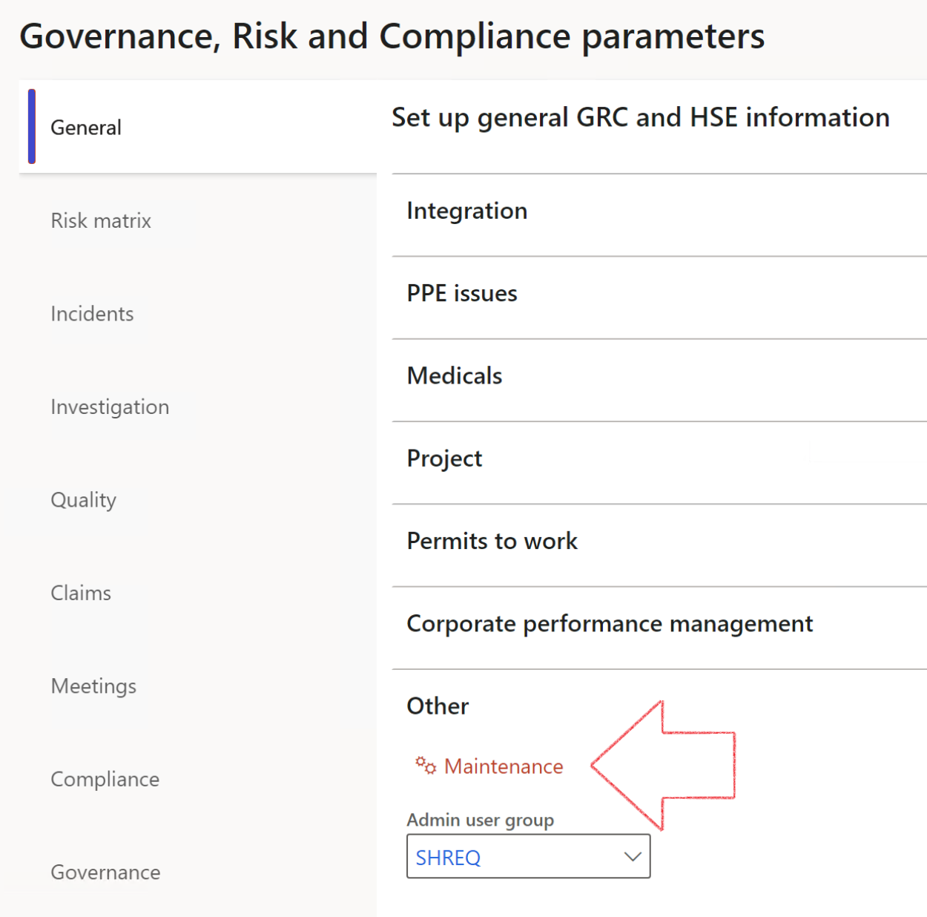

|  |  |
| --- | --- |
|  | The **Maintenance** button is there for designated user. This button repairs any possible data issues. For a full history of all Data related repairs; see table below: |

|  |  |  |
| --- | --- | --- |
| **Process** | **Description/notes** | **Release** |
| Fix location vs. work centres | Populate the new **LocationRecID** field with the related location associated with previously used work centre location (Location) fields on the following tables:   * OHSHazardLocations, * OHSRiskHazard, * OHSRiskHazardWizard, * OHSRiskRegister, * OHSRisksWizard, * OHSSafetyLocations, * OHSSafetyPermit, * OHSSafetyPermitLocations * OHSSafetyPermitOverlap, * OHSSafetyPlan, * OHSInvestigation | 10.0.80.10 |
| Fix risk hazards | Assigning the value "Default Risk" to the new mandatory field **RiskID** (Key field) where empty | 10.0.80.10 |
| Fix incident HRM injury link | Delete all orphaned records from the **OHSIncidentHRMInjuryLnk** table | 10.0.11785.3 |
| Populate SRS analysis enums | Still in concept phase. To provide a link between enum numerical value and value name for use with BYOD data entities. Enums available:   * OHSIncidentType, * OHSIncidentSeverityType.   Table populated: **SRSAnalysisEnums** | 10.0.11785.3 |
| Fix budget transaction lines stock\item dimension | Set **OHSInventDimId** field value to "**AllBlank**" on table **BudgetTransactionLine**, where no value was recorded. This will solve the issue of records not displaying in the form.  **Note: this step will only fix existing budget transaction records in the system. Should any new transactions be uploaded or changed via the data entity Budget Account Entries, special care needs to be taken to specify the Stock dimension = AllBlank and the Item on the excel sheet to import.** | 10.1.1366.6 |

The information contained in this document represents the current view of Axnosis and Microsoft Corporation on the issues discussed as of the date of publication. Because Axnosis and Microsoft must respond to changing market conditions, this document should not be interpreted to be a commitment on the part of Axnosis and Microsoft, and Axnosis and Microsoft cannot guarantee the accuracy of any information presented after the date of publication.

This test script is for informational purposes only. AXNOSIS AND MICROSOFT MAKE NO WARRANTIES, EXPRESS, IMPLIED, OR STATUTORY, AS TO THE INFORMATION IN THIS DOCUMENT.

Complying with all applicable copyright laws is the responsibility of the user. Without limiting the rights under copyright, no part of this document may be reproduced, stored in or introduced into a retrieval system, or transmitted in any form or by any means (electronic, mechanical, photocopying, recording, or otherwise), or for any purpose, without the express written permission of Axnosis and Microsoft Corporation.

Axnosis and Microsoft may have patents, patent applications, trademarks, copyrights, or other intellectual property rights covering subject matter in this document. Except as expressly provided in any written license agreement from Axnosis and Microsoft, the furnishing of this document does not give you any license to these patents, trademarks, copyrights, or other intellectual property.

© 2021 Microsoft Corporation. All rights reserved. Any use or distribution of these materials without express authorization of Microsoft Corp. is strictly prohibited.

Microsoft and Windows are both registered trademarks of Microsoft Corporation in the United States and/or other countries.

The names of actual companies and products mentioned herein may be the trademarks of their respective owners.