

D365FO GRC/HSE Release notes



Governance Risk & Compliance

Health, Safety & Environment

for

**Microsoft Dynamics 365 for Finance & Operations™**

*D365FO GRC/HSE version* 10.15.1323.4

2022-02-27

## 

|  |  |  |
| --- | --- | --- |
| Dynamics 365 FO GRC module GRC is an add-on for Dynamics 365 suite of business application software.  This software provides functionality to support Governance, Risk management and Compliance as per the depicted sub-modules. |  | |
|  | | Dynamics 365 FO HSE module HSE is an add-on for Dynamics 365 suite of business application software.  This software provides functionality to support Health, Safety and Environment as per the depicted sub-modules. |

Release version

**GRC/HSE Package version:** OHSDeployablePackage_10_15_1323_4

This package was created on Microsoft Dynamics 365 for Finance and Operations:

|  |  |  |
| --- | --- | --- |
| **Release** | **Version** | **Build number** |
| Application release | 10.0.24 | 10.15.1323 |
| Platform release | Platform update 48 | 7.0.6253.76 |

# New features:

|  |  |
| --- | --- |
| **Module** | **Description** |
| Risk management | * The following new **Risk register number sequences** were added (thus paving the way for user to have unique numbers for every class of risk): * **Risk register ID - Enterprise** * **Risk register ID - Financial** * **Risk register ID - Environmental** * A new **Risk ID number sequence** was added: * **Risk ID - Financial** |

# Enhancements:

|  |  |
| --- | --- |
| **Module** | **Description** |
| Action plans | * On all GRC/HSE forms where activities can be created from, the **Create activity** dialog was extended so that the user can add the new activity to an **existing Action plan**, or create a **new Action plan** to link the activity to * On the Action plan lines, it can now be specified whether one user, or a team is required to approve the **Request for due date extension** * On the **Action plan Header** and **Lines view**, the **Closed** Field group was moved to the right-hand side of the Fast tabs * A new **Action plan report** was created. The user can choose to print **one Action plan** or **All action plans**. |
| Business excellence and strategy | * In the **Corporate strategy wizard**, under the **Organizational design** step:   + The **Skill gap analysis** Fast tab was re-labelled to **Human resources**   + There are now four tiles under the HR Fast tab for the following:     - **HR goals** - Opens the list of HR goals     - **Recruitment projects** - Opens the list of HR recruitment projects     - **Open positions** - Opens the list of HR open positions     - **Skill gap analysis** – Opens the **Skill gap analysis job – person** form where the user can run the report for a selected worker |

|  |  |
| --- | --- |
| **Module** | **Description** |
| Document management | * The following two buttons are now hidden on all **Baseline PCR** forms, under the **Clauses** Index tab:   + **Add approved clauses**   + **Refresh** * A filter has been added so that **no Baseline** records are displayed on the **Other documents** list page |
| Inspections | * The below new **menu items** were created. These menu items filter the inspection records to **display** the relevant records **per** **type**   + **BBS inspection journals** - Type = **Behaviour**   + **Emergency drill inspection journals** – Type = **Drill**   + **Other inspection journals** - All types **EXCEPT** above two * The current **Inspection journal** was renamed to **All inspection journals** |
| Incidents | A new wizard was created for logging incidents of **type Environmental**  (This wizard relaces the old form with tabs) |
| Safety and security | On the **Hazard**, under the General Fast tab, a field for **Type of hazard** was added, with new enum with the following values**:**   * **Safety** * **Health** * **Environmental** |

Release Data impact

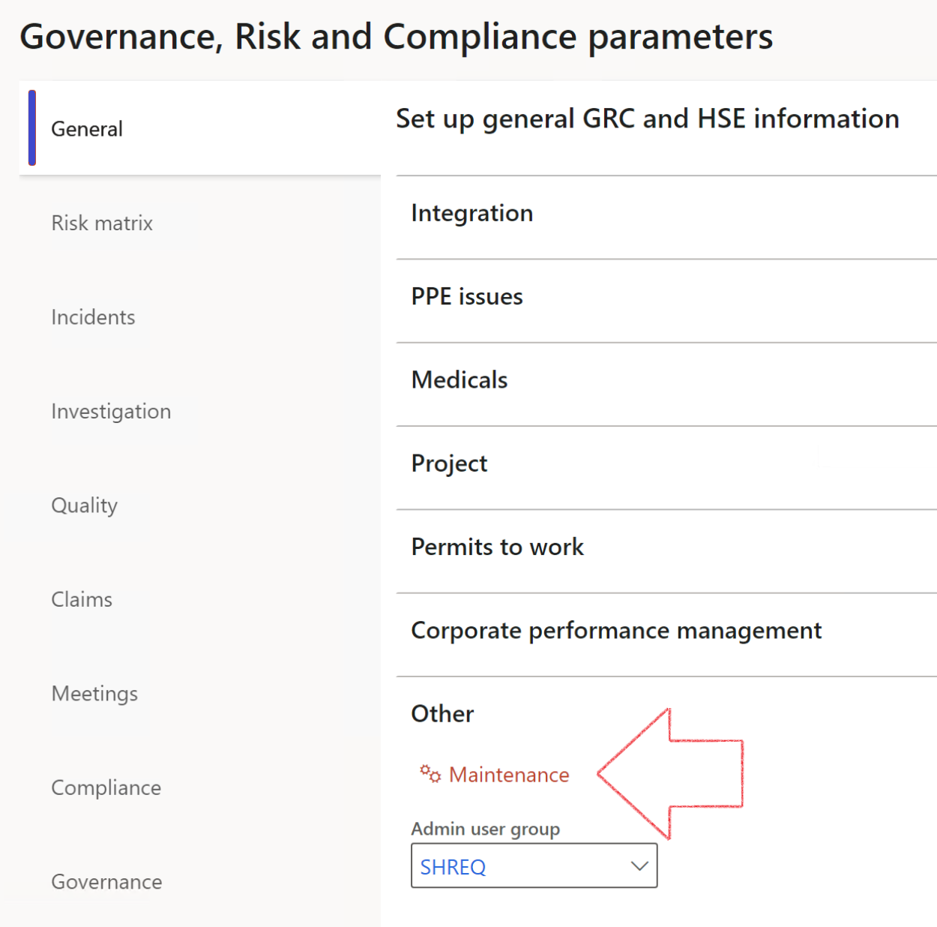

|  |  |
| --- | --- |
|  | The **Maintenance** button is there for designated user. This button repairs any possible data issues. For a full history of all Data related repairs; see table below: |

|  |  |  |
| --- | --- | --- |
| **Process** | **Description/notes** | **Release** |
| Fix location vs. work centres | Populate the new **LocationRecID** field with the related location associated with previously used work centre location (Location) fields on the following tables:   * OHSHazardLocations, * OHSRiskHazard, * OHSRiskHazardWizard, * OHSRiskRegister, * OHSRisksWizard, * OHSSafetyLocations, * OHSSafetyPermit, * OHSSafetyPermitLocations * OHSSafetyPermitOverlap, * OHSSafetyPlan, * OHSInvestigation | 10.0.80.10 |
| Fix risk hazards | Assigning the value "Default Risk" to the new mandatory field **RiskID** (Key field) where empty | 10.0.80.10 |
| Fix incident HRM injury link | Delete all orphaned records from the **OHSIncidentHRMInjuryLnk** table | 10.0.11785.3 |
| Populate SRS analysis enums | Still in concept phase. To provide a link between enum numerical value and value name for use with BYOD data entities. Enums available:   * OHSIncidentType, * OHSIncidentSeverityType.   Table populated: **SRSAnalysisEnums** | 10.0.11785.3 |
| Fix budget transaction lines stock\item dimension | Set **OHSInventDimId** field value to "**AllBlank**" on table **BudgetTransactionLine**, where no value was recorded. This will solve the issue of records not displaying in the form.  **Note: this step will only fix existing budget transaction records in the system. Should any new transactions be uploaded or changed via the data entity Budget Account Entries, special care needs to be taken to specify the Stock dimension = AllBlank and the Item on the excel sheet to import.** | 10.1.1366.6 |

The information contained in this document represents the current view of Axnosis and Microsoft Corporation on the issues discussed as of the date of publication. Because Axnosis and Microsoft must respond to changing market conditions, this document should not be interpreted to be a commitment on the part of Axnosis and Microsoft, and Axnosis and Microsoft cannot guarantee the accuracy of any information presented after the date of publication.

This test script is for informational purposes only. AXNOSIS AND MICROSOFT MAKE NO WARRANTIES, EXPRESS, IMPLIED, OR STATUTORY, AS TO THE INFORMATION IN THIS DOCUMENT.

Complying with all applicable copyright laws is the responsibility of the user. Without limiting the rights under copyright, no part of this document may be reproduced, stored in or introduced into a retrieval system, or transmitted in any form or by any means (electronic, mechanical, photocopying, recording, or otherwise), or for any purpose, without the express written permission of Axnosis and Microsoft Corporation.

Axnosis and Microsoft may have patents, patent applications, trademarks, copyrights, or other intellectual property rights covering subject matter in this document. Except as expressly provided in any written license agreement from Axnosis and Microsoft, the furnishing of this document does not give you any license to these patents, trademarks, copyrights, or other intellectual property.

© 2021 Microsoft Corporation. All rights reserved. Any use or distribution of these materials without express authorization of Microsoft Corp. is strictly prohibited.

Microsoft and Windows are both registered trademarks of Microsoft Corporation in the United States and/or other countries.

The names of actual companies and products mentioned herein may be the trademarks of their respective owners.