

D365FO GRC/HSE Release notes



Governance Risk & Compliance

Health, Safety & Environment

for

**Microsoft Dynamics 365 for Finance & Operations™**

*D365FO GRC/HSE version* 10.15.1323.3

2022-02-21

## 

|  |  |  |
| --- | --- | --- |
| Dynamics 365 FO GRC module GRC is an add-on for Dynamics 365 suite of business application software.  This software provides functionality to support Governance, Risk management and Compliance as per the depicted sub-modules. |  | |
|  | | Dynamics 365 FO HSE module HSE is an add-on for Dynamics 365 suite of business application software.  This software provides functionality to support Health, Safety and Environment as per the depicted sub-modules. |

Release version

**GRC/HSE Package version:** OHSDeployablePackage_10_15_1323_3

This package was created on Microsoft Dynamics 365 for Finance and Operations:

|  |  |  |
| --- | --- | --- |
| **Release** | **Version** | **Build number** |
| Application release | 10.0.24 | 10.15.1323 |
| Platform release | Platform update 48 | 7.0.6253.76 |

# New features:

|  |  |
| --- | --- |
| **Module** | **Description** |
| Corporate performance management | Monitoring and Evaluation (M&E) is used to assess the performance of activities/tasks projects.  The following two new menu items were added under **Performance**:   * + **Monitoring schedule** is n grouping of **Monitoring and measurement** records   + **Monitoring and measurement** |

# Enhancements:

|  |  |
| --- | --- |
| **Module** | **Description** |
| Inspections | * A field for selecting the relevant **Inspector** was added on the **Create schedule** dialog for Inspections * On the **All scheduled inspections** list page, as well as on the **Change** drop dialog, the **Owner** label was changed to **Inspector** * On the **OHS workspace**, under the **Inspections graph** Index tab, a new **Type** filter was added. If the “**Blank**” value is selected, the graph will display all Inspection types |
| Hazards | On the **Hazard**, under the General Fast tab, an enum was added for **Type of hazard**, with the following values:   * **Safety** * **Health** * **Environmental** |
| Safety and security | * On the **Gate pass**, under the General Fast tab, an indicator was added to indicate whether the facility to be visited is the **Primary facility** * The **Status** field was moved to under the **Approver** field * The **Issue access card** button is now only available when the Gate pass has been **approved** |

|  |  |
| --- | --- |
| **Module** | **Description** |
| Business continuity | * On the **Continuity and disaster recovery**, under the General Fast tab, a lookup field for **Hazard** was added * This new **Hazard** field is also on the **Lines** view under the **Continuity and disaster recovery header** Fast tab |
| Compliance audits | * The following was added to the Area of compliance Lines view:   + Under the Compliance functions Fast tab:     - The **Update manual inherent risk** button’s label was changed to **Do inherent risk assessment**     - The **Risk** label was changed to **Inherent risk**   + The risk lines, based on the **Operational risk** line link, are displayed under the **Risks** Fast tab |
| Action plans | * A menu item was added for **Action plan lines to be approved by me**. This is a grid of all the **Action plan lines** that have been assigned to the logged in user to approve * On the **Action plan Lines** view:   + The label of the **Inspection journal** Fast tab was re-named to **Action plan header**   + Under the **Lines** Fast tab, a field was added to indicate whether the selected Activity is **closed**   + A **Due date** field was added to the grid under the Lines Fast tab   + A button was added to the button strip under the Lines Fast tab; **Request due date extension**, which opens a drop dialog where the request details can be entered   + Two indicators have been added under the **Line details** Fast tab: * **Closed** * **Activity updated** * When creating an activity from the **Compliance audit scoring** form, or from the **Internal audit Fieldwork** form, the user now has the option to add the new activity to and **existing Action plan**, or to create a **new Action plan** |
| General | The **Send email notification** button (which sends an email from a template) on the **All planned GRC actions** grid, was relaced with the new **Send email** button which allows the user to type an email (Free text) |
| Meetings | Agenda, minutes, and resolutions can be selected on the Meetings form.  The linked Meeting ID is now displayed on the Agendas, minutes, or resolutions form |
| Corporate performance management | * The following was added to the Appraisals form:   + A field to display the Current department   + A button on the Action pane that opens a dialog that enables the user to “View the department score” |
| Business excellence and strategy | * In the first step of the Corporate strategy wizard, under the Business unit and department strategy Fast tab, a button was added that opens a dialog that enables the user to “View the performance score” |

Release Data impact

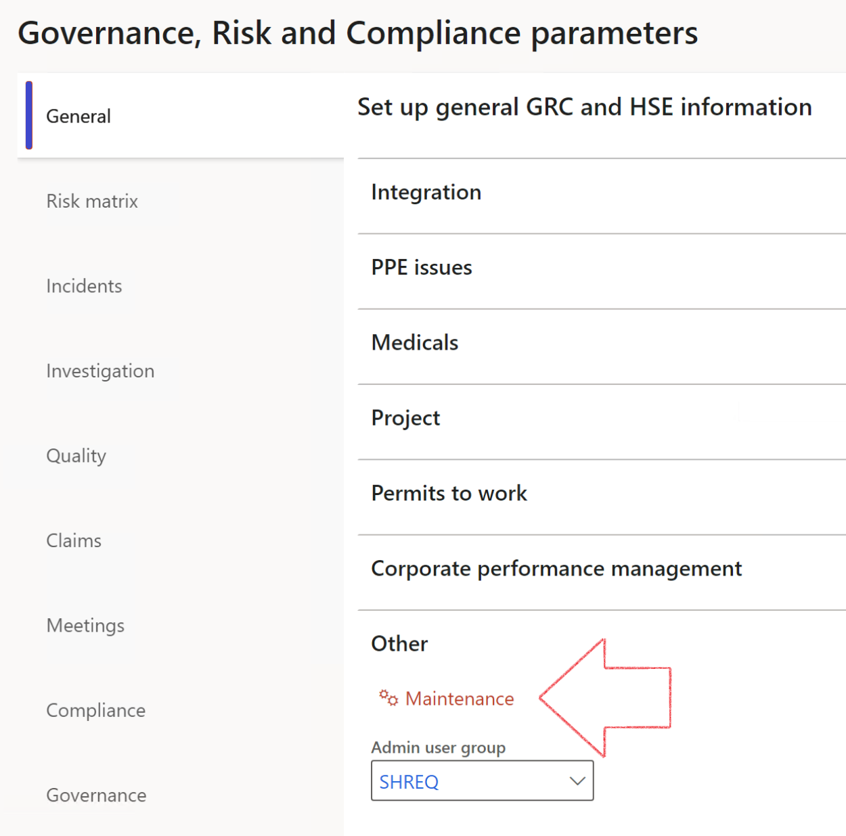

|  |  |
| --- | --- |
|  | The **Maintenance** button is there for designated user. This button repairs any possible data issues. For a full history of all Data related repairs; see table below: |

|  |  |  |
| --- | --- | --- |
| **Process** | **Description/notes** | **Release** |
| Fix location vs. work centres | Populate the new **LocationRecID** field with the related location associated with previously used work centre location (Location) fields on the following tables:   * OHSHazardLocations, * OHSRiskHazard, * OHSRiskHazardWizard, * OHSRiskRegister, * OHSRisksWizard, * OHSSafetyLocations, * OHSSafetyPermit, * OHSSafetyPermitLocations * OHSSafetyPermitOverlap, * OHSSafetyPlan, * OHSInvestigation | 10.0.80.10 |
| Fix risk hazards | Assigning the value "Default Risk" to the new mandatory field **RiskID** (Key field) where empty | 10.0.80.10 |
| Fix incident HRM injury link | Delete all orphaned records from the **OHSIncidentHRMInjuryLnk** table | 10.0.11785.3 |
| Populate SRS analysis enums | Still in concept phase. To provide a link between enum numerical value and value name for use with BYOD data entities. Enums available:   * OHSIncidentType, * OHSIncidentSeverityType.   Table populated: **SRSAnalysisEnums** | 10.0.11785.3 |
| Fix budget transaction lines stock\item dimension | Set **OHSInventDimId** field value to "**AllBlank**" on table **BudgetTransactionLine**, where no value was recorded. This will solve the issue of records not displaying in the form.  **Note: this step will only fix existing budget transaction records in the system. Should any new transactions be uploaded or changed via the data entity Budget Account Entries, special care needs to be taken to specify the Stock dimension = AllBlank and the Item on the excel sheet to import.** | 10.1.1366.6 |

The information contained in this document represents the current view of Axnosis and Microsoft Corporation on the issues discussed as of the date of publication. Because Axnosis and Microsoft must respond to changing market conditions, this document should not be interpreted to be a commitment on the part of Axnosis and Microsoft, and Axnosis and Microsoft cannot guarantee the accuracy of any information presented after the date of publication.

This test script is for informational purposes only. AXNOSIS AND MICROSOFT MAKE NO WARRANTIES, EXPRESS, IMPLIED, OR STATUTORY, AS TO THE INFORMATION IN THIS DOCUMENT.

Complying with all applicable copyright laws is the responsibility of the user. Without limiting the rights under copyright, no part of this document may be reproduced, stored in or introduced into a retrieval system, or transmitted in any form or by any means (electronic, mechanical, photocopying, recording, or otherwise), or for any purpose, without the express written permission of Axnosis and Microsoft Corporation.

Axnosis and Microsoft may have patents, patent applications, trademarks, copyrights, or other intellectual property rights covering subject matter in this document. Except as expressly provided in any written license agreement from Axnosis and Microsoft, the furnishing of this document does not give you any license to these patents, trademarks, copyrights, or other intellectual property.

© 2021 Microsoft Corporation. All rights reserved. Any use or distribution of these materials without express authorization of Microsoft Corp. is strictly prohibited.

Microsoft and Windows are both registered trademarks of Microsoft Corporation in the United States and/or other countries.

The names of actual companies and products mentioned herein may be the trademarks of their respective owners.