

D365FO GRC/HSE Release notes



Governance Risk & Compliance

Health, Safety & Environment

for

**Microsoft Dynamics 365 for Finance & Operations™**

*D365FO GRC/HSE version* 10.15.1323.13

2022-05-23

## 

|  |  |  |
| --- | --- | --- |
| Dynamics 365 FO GRC module GRC is an add-on for Dynamics 365 suite of business application software.  This software provides functionality to support Governance, Risk management and Compliance as per the depicted sub-modules. |  | |
|  | | Dynamics 365 FO HSE module HSE is an add-on for Dynamics 365 suite of business application software.  This software provides functionality to support Health, Safety and Environment as per the depicted sub-modules. |

Release version

**GRC/HSE Package version:** OHSDeployablePackage_10_15_1323_13

This package was created on Microsoft Dynamics 365 for Finance and Operations:

|  |  |  |
| --- | --- | --- |
| **Release** | **Version** | **Build number** |
| Application release | 10.0.24 | 10.15.1323 |
| Platform release | Platform update 48 | 7.0.6253.76 |

# Enhancements:

|  |  |
| --- | --- |
| **Module** | **Description** |
| Workflow | * **Approval elements** are now available for the following workflows:   + **Investigations**   + **Permit to work** * The following **manual approval** buttons are now disabled on the PTW list page and detail form, when a permit to work record goes into workflow approval:   + **Submit**   + **Reject**   + **Approve** |
| Claims | On the **Objects** detail form:   * The **Operators** Fast tab was renamed to **Operators and crew** * The following fields were added in the grid under the **Operators and crew** Fast tab:   + A **Yes/No** indicator with label **Crew**   + **Vendor** lookup   + Free text field for entering **Name and surname** * When **Yes** is selected in the abovementioned **Crew** field, a license cannot be entered on the line |
| Incidents | A field for “**From mobile**” was added to all the **Incident** list pages. When an incident was reported using the **Incident reporting mobile app**, it will be indicated in this field. |

Release Data impact

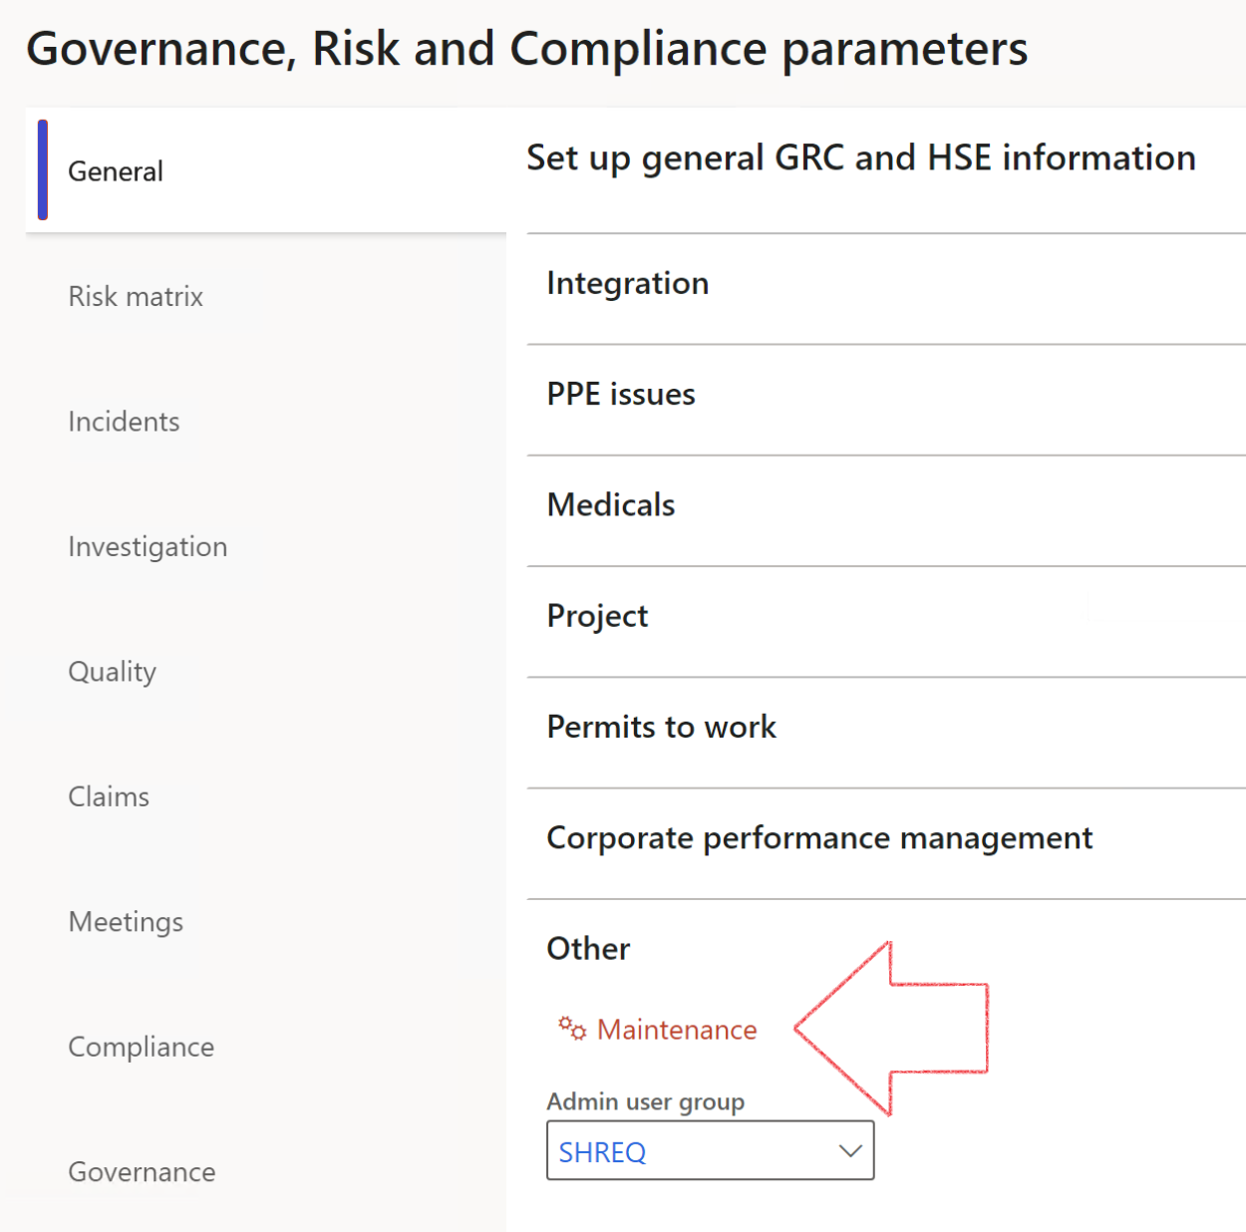

|  |  |
| --- | --- |
|  | The **Maintenance** button is there for designated user. This button repairs any possible data issues. For a full history of all Data related repairs; see table below: |

|  |  |  |
| --- | --- | --- |
| **Process** | **Description/notes** | **Release** |
| Fix location vs. work centres | Populate the new **LocationRecID** field with the related location associated with previously used work centre location (Location) fields on the following tables:   * OHSHazardLocations, * OHSRiskHazard, * OHSRiskHazardWizard, * OHSRiskRegister, * OHSRisksWizard, * OHSSafetyLocations, * OHSSafetyPermit, * OHSSafetyPermitLocations * OHSSafetyPermitOverlap, * OHSSafetyPlan, * OHSInvestigation | 10.0.80.10 |
| Fix risk hazards | Assigning the value "Default Risk" to the new mandatory field **RiskID** (Key field) where empty | 10.0.80.10 |
| Fix incident HRM injury link | Delete all orphaned records from the **OHSIncidentHRMInjuryLnk** table | 10.0.11785.3 |
| Populate SRS analysis enums | Still in concept phase. To provide a link between enum numerical value and value name for use with BYOD data entities. Enums available:   * OHSIncidentType, * OHSIncidentSeverityType.   Table populated: **SRSAnalysisEnums** | 10.0.11785.3 |
| Fix budget transaction lines stock\item dimension | Set **OHSInventDimId** field value to "**AllBlank**" on table **BudgetTransactionLine**, where no value was recorded. This will solve the issue of records not displaying in the form.  **Note: this step will only fix existing budget transaction records in the system. Should any new transactions be uploaded or changed via the data entity Budget Account Entries, special care needs to be taken to specify the Stock dimension = AllBlank and the Item on the excel sheet to import.** | 10.1.1366.6 |

The information contained in this document represents the current view of Axnosis and Microsoft Corporation on the issues discussed as of the date of publication. Because Axnosis and Microsoft must respond to changing market conditions, this document should not be interpreted to be a commitment on the part of Axnosis and Microsoft, and Axnosis and Microsoft cannot guarantee the accuracy of any information presented after the date of publication.

This test script is for informational purposes only. AXNOSIS AND MICROSOFT MAKE NO WARRANTIES, EXPRESS, IMPLIED, OR STATUTORY, AS TO THE INFORMATION IN THIS DOCUMENT.

Complying with all applicable copyright laws is the responsibility of the user. Without limiting the rights under copyright, no part of this document may be reproduced, stored in or introduced into a retrieval system, or transmitted in any form or by any means (electronic, mechanical, photocopying, recording, or otherwise), or for any purpose, without the express written permission of Axnosis and Microsoft Corporation.

Axnosis and Microsoft may have patents, patent applications, trademarks, copyrights, or other intellectual property rights covering subject matter in this document. Except as expressly provided in any written license agreement from Axnosis and Microsoft, the furnishing of this document does not give you any license to these patents, trademarks, copyrights, or other intellectual property.

© 2021 Microsoft Corporation. All rights reserved. Any use or distribution of these materials without express authorization of Microsoft Corp. is strictly prohibited.

Microsoft and Windows are both registered trademarks of Microsoft Corporation in the United States and/or other countries.

The names of actual companies and products mentioned herein may be the trademarks of their respective owners.