

D365FO GRC/HSE Release notes



Governance Risk & Compliance

Health, Safety & Environment

for

**Microsoft Dynamics 365 for Finance & Operations™**

*D365FO GRC/HSE version* 10.15.1323.1

2022-02-08

## 

|  |  |  |
| --- | --- | --- |
| Dynamics 365 FO GRC module GRC is an add-on for Dynamics 365 suite of business application software.  This software provides functionality to support Governance, Risk management and Compliance as per the depicted sub-modules. |  | |
|  | | Dynamics 365 FO HSE module HSE is an add-on for Dynamics 365 suite of business application software.  This software provides functionality to support Health, Safety and Environment as per the depicted sub-modules. |

Release version

**GRC/HSE Package version:** OHSDeployablePackage_10_15_1323_1

This package was created on Microsoft Dynamics 365 for Finance and Operations:

|  |  |  |
| --- | --- | --- |
| **Release** | **Version** | **Build number** |
| Application release | 10.0.24 | 10.15.1323 |
| Platform release | Platform update 48 | 7.0.6253.76 |

# Enhancements:

|  |  |
| --- | --- |
| **Module** | **Description** |
| General | Planned actions be followed up, can now be created from the sources listed below. When the follow up action is triggered, a record is created in the **Planned Governance, Risk and Compliance actions** list page   |  |  | | --- | --- | | * **Corporate initiatives** * **Continuity and disaster recovery** * **Internal audit findings** | * **Contracts** * **Risk lines** | |
| Internal audit | * The **Declaration of interest** for the Internal Audit project is no longer hard coded. The text is now setup on the **GRC actions and questions** form   + On the **GRC actions and questions** form, a value was added to the **Source** enum for **IAU**   + On the **Audit type**, at the end of the grid, a lookup field was added for selecting the relevant **Audit declaration** that was setup on the **GRC actions and questions** form * On the Action pane of the Audit project, a button was added for **creating a new audit file** form the Audit * **Audit type** was added to the **All internal audits** list page to identify the nature of audits from the grid * The following buttons were added to the Action pane of the **All internal audits** list page:   + **Generate audit report** – Uses the GRC documents engine and allows users to create a formal audit report from a template with related findings   + **Create audit file** * The following menu item labels were changed because of the “spitting” of Compliance audit finding records, and Internal audit finding records:   + Under **Compliance**, Findings: **Issue register** was changed to **Compliance issue** **register**   + Under **Compliance**, Reports and inquiries: **Audit findings** was changed to **Compliance audit findings**   + Under **Internal audit**, Findings: **Audit cases** was changed to **Internal audit issue register**   + Under **Internal audit**, Reports and inquiries: **Audit findings** was changed to **Internal audit findings**   + **Filters** have been added to split Compliance related and Internal audit related records accordingly |

|  |  |
| --- | --- |
| **Module** | **Description** |
| Risk management | * The Risk management **Data entities** were enhanced * A new menu item was added for **All registers for my department** * The **Line status** enum was extended to accommodate the following values:   + **Updated**   + **Challenged** * The following fields on the **Risk registers** have been lengthened to accommodate more characters:   + - * + Under the **Assessment and controls** Fast tab:   **Trigger event**  **Control description**   * + - * + Under the **Strategy and response** Fast tab:   **Control strategy**  **Responsibility**  **Further action**   * + - * An **icon** was added to indicate **Bow tie risks**       * On the **Risk worksheets**:         + **Bow tie risks** are indicated with the new icon         + A field to display the **Line status** was added         + The **Filter group** is by default collapsed when the worksheets are opened         + A new **Filter option** that filters on the **Status**, was added       * On the Enterprise risk register, General Fast tab, **RACI** Index tab, an **email** icon/button was added next to every RACI field. This enables the user to send emails to the selected workers **from within D365**       * **Enterprise** risk lines, as well as **Operational** risk lines can now be converted to **Bow tie** risks (and back to the original risk classification)       * The following was done on the **Bow tie risk** detail form:         + The following Fast tabs are hidden:   **Assessment guidance**  **Initial risk**  **Residual risk**  **Risk source**   * + - * + Buttons were added:   **Initial risk** (Opens a form to the right hand side of the screen with the details that were under the Initial risk Fast tab)  **Residual risk** (Opens a form to the right hand side of the screen with the details that were under the Residual risk Fast tab)  **Show risks from same register** (Opens a form to the right hand side of the screen with displays the risk lines from the Enterprise/Operational risk register that have not been changed to Bow tie)   * + - * A new menu item and was for **Risk management reports**         + On the Risk management report (Policies, contracts and reports form), Content Fast tab, References Index tab, the **Element relation type** enum was extended with the following two values:   **Risk lines**  **Legal register clause** |

|  |  |
| --- | --- |
| **Module** | **Description** |
| Business continuity | * On the **Continuity and disaster recovery** detail form, the **Plan ID** label was changed to **BCDR ID** * On the **Activated plans**:   + The **Status** button on the Action pane was hidden   + The help texts for the **RTO** and **RPO** fields were changed to be more descriptive   + A display method for **Created from** was added to display the **BCDR ID** from which the **Activated plan** was created |
| Business excellence and strategy | * A new field group for **Demarcation** was added on the **Corporate initiatives** with fields for **Site** and **Department** * When **follow up** is done on the Corporate initiatives form, the values from these two fields pull through to the **All planned Governance, Risk and Compliance actions** list page |

# Bug fixes:

|  |  |
| --- | --- |
| **Module** | **Description** |
| Internal audit | On the Audit universe, Auditable entity Fast tab; the wrong form opened when the link to the selected **Auditable entity** was clicked. The issue has been resolved. |
| Corporate performance management | If a PO had a line with value “0”, an error message popped up on the **Performance scorecard workspace**. The issue has been resolved. |
| Incidents | * The status change on **Incidents** is now more responsive * The **Triage button** is now greyed out when the status of the Incident is **Triage** |
| Permit to work | * A new status was added to for Permits to work for Requested * The label of the Record new permit tile on the Contractor safety and security workspace, was changed to Request new permit to work. When a permit is created by clicking on this tile, the status is Requested |
| Environmental | * Under Setup for environmental, the **Emission source** label was changed to **Emission/Utilities sources** |

Release Data impact

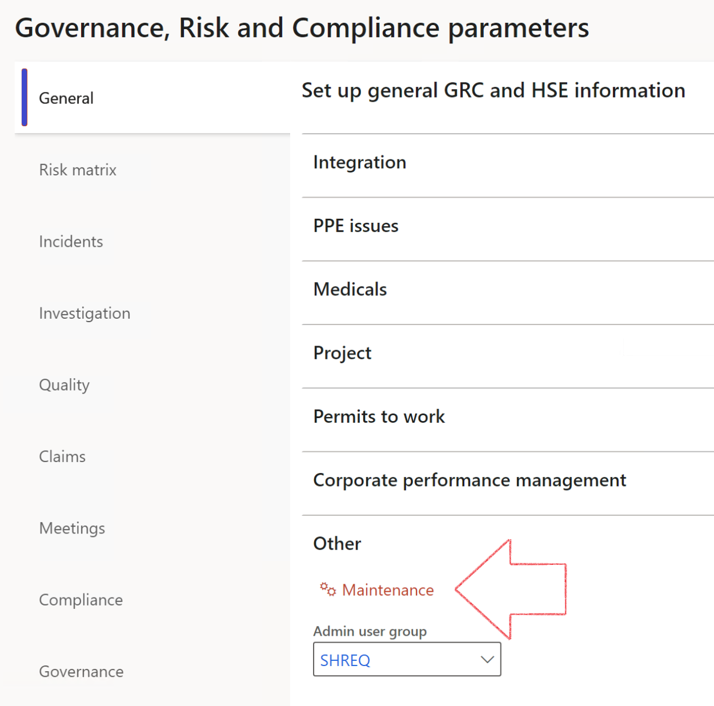

|  |  |
| --- | --- |
|  | The **Maintenance** button is there for designated user. This button repairs any possible data issues. For a full history of all Data related repairs; see table below: |

|  |  |  |
| --- | --- | --- |
| **Process** | **Description/notes** | **Release** |
| Fix location vs. work centres | Populate the new **LocationRecID** field with the related location associated with previously used work centre location (Location) fields on the following tables:   * OHSHazardLocations, * OHSRiskHazard, * OHSRiskHazardWizard, * OHSRiskRegister, * OHSRisksWizard, * OHSSafetyLocations, * OHSSafetyPermit, * OHSSafetyPermitLocations * OHSSafetyPermitOverlap, * OHSSafetyPlan, * OHSInvestigation | 10.0.80.10 |
| Fix risk hazards | Assigning the value "Default Risk" to the new mandatory field **RiskID** (Key field) where empty | 10.0.80.10 |
| Fix incident HRM injury link | Delete all orphaned records from the **OHSIncidentHRMInjuryLnk** table | 10.0.11785.3 |
| Populate SRS analysis enums | Still in concept phase. To provide a link between enum numerical value and value name for use with BYOD data entities. Enums available:   * OHSIncidentType, * OHSIncidentSeverityType.   Table populated: **SRSAnalysisEnums** | 10.0.11785.3 |
| Fix budget transaction lines stock\item dimension | Set **OHSInventDimId** field value to "**AllBlank**" on table **BudgetTransactionLine**, where no value was recorded. This will solve the issue of records not displaying in the form.  **Note: this step will only fix existing budget transaction records in the system. Should any new transactions be uploaded or changed via the data entity Budget Account Entries, special care needs to be taken to specify the Stock dimension = AllBlank and the Item on the excel sheet to import.** | 10.1.1366.6 |

The information contained in this document represents the current view of Axnosis and Microsoft Corporation on the issues discussed as of the date of publication. Because Axnosis and Microsoft must respond to changing market conditions, this document should not be interpreted to be a commitment on the part of Axnosis and Microsoft, and Axnosis and Microsoft cannot guarantee the accuracy of any information presented after the date of publication.

This test script is for informational purposes only. AXNOSIS AND MICROSOFT MAKE NO WARRANTIES, EXPRESS, IMPLIED, OR STATUTORY, AS TO THE INFORMATION IN THIS DOCUMENT.

Complying with all applicable copyright laws is the responsibility of the user. Without limiting the rights under copyright, no part of this document may be reproduced, stored in or introduced into a retrieval system, or transmitted in any form or by any means (electronic, mechanical, photocopying, recording, or otherwise), or for any purpose, without the express written permission of Axnosis and Microsoft Corporation.

Axnosis and Microsoft may have patents, patent applications, trademarks, copyrights, or other intellectual property rights covering subject matter in this document. Except as expressly provided in any written license agreement from Axnosis and Microsoft, the furnishing of this document does not give you any license to these patents, trademarks, copyrights, or other intellectual property.

© 2021 Microsoft Corporation. All rights reserved. Any use or distribution of these materials without express authorization of Microsoft Corp. is strictly prohibited.

Microsoft and Windows are both registered trademarks of Microsoft Corporation in the United States and/or other countries.

The names of actual companies and products mentioned herein may be the trademarks of their respective owners.