

D365FO GRC/HSE Release notes



Governance Risk & Compliance

Health, Safety & Environment

for

**Microsoft Dynamics 365 for Finance & Operations™**

*D365FO GRC/HSE version* 10.13.1020.9

2022-01-17

## 

|  |  |  |
| --- | --- | --- |
| Dynamics 365 FO GRC module GRC is an add-on for Dynamics 365 suite of business application software.  This software provides functionality to support Governance, Risk management and Compliance as per the depicted sub-modules. |  | |
|  | | Dynamics 365 FO HSE module HSE is an add-on for Dynamics 365 suite of business application software.  This software provides functionality to support Health, Safety and Environment as per the depicted sub-modules. |

Release version

**GRC/HSE Package version:** OHSDeployablePackage_10_13_1020_9

This package was created on Microsoft Dynamics 365 for Finance and Operations:

|  |  |  |
| --- | --- | --- |
| **Release** | **Version** | **Build number** |
| Application release | 10.0.22 | 10.13.1020 |
| Platform release | Platform update 46 | 7.0.6164 |

# Enhancements:

|  |  |
| --- | --- |
| **Module** | **Description** |
| Risk management | * Thesystem now calculates the **Next review date** according to the selected **Review frequency** and **Last review date**, on all risk registers * New **Data entities** were created for the following:   + **Risk objectives**   + **Risk controls** * For the risk lines to be identified on the following existing **Data entities**, three fields have to be populated:   + **Who or what affected risk link**:     - Risk line is a combination of Risk ID and Hazard (Default param value), Aspect ID (default param value)   + **Consequences risk link**:     - Risk line is a combination of Risk ID and Hazard (Default param value), Aspect ID (default param value)   + **Risk assessment calculations**:     - Risk line is a combination of Risk ID and Hazard (Default param value), Aspect ID (default param value)     - A new field, **Trigger event** (Reference) was added to the existing entity |
| Checklists | * The **New** button group in the action pane is now hidden * A new **Create new checklist** dialog was created |
| Business excellence | A **Skill-gap-analysis** can now be done under the **Organizational design** step of the **Corporate strategy wizard** |
| Contract management | Thesystem now calculates the **Next review date** according to the selected **Review frequency** (new enum added on the Contract detail form under the Review and follow up Fast tab)and **Last review date**, on all contracts |

# Bug fixes:

|  |  |
| --- | --- |
| **Module** | **Description** |
| Case management | Suppression bug on workflow was fixed |

Release Data impact

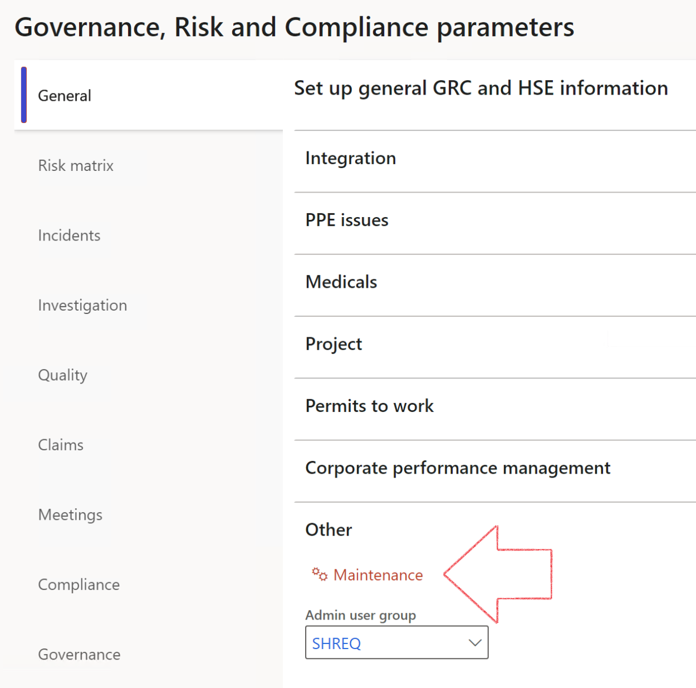

|  |  |
| --- | --- |
|  | The **Maintenance** button is there for designated user. This button repairs any possible data issues. For a full history of all Data related repairs; see table below: |

|  |  |  |
| --- | --- | --- |
| **Process** | **Description/notes** | **Release** |
| Fix location vs. work centres | Populate the new **LocationRecID** field with the related location associated with previously used work centre location (Location) fields on the following tables:   * OHSHazardLocations, * OHSRiskHazard, * OHSRiskHazardWizard, * OHSRiskRegister, * OHSRisksWizard, * OHSSafetyLocations, * OHSSafetyPermit, * OHSSafetyPermitLocations * OHSSafetyPermitOverlap, * OHSSafetyPlan, * OHSInvestigation | 10.0.80.10 |
| Fix risk hazards | Assigning the value "Default Risk" to the new mandatory field **RiskID** (Key field) where empty | 10.0.80.10 |
| Fix incident HRM injury link | Delete all orphaned records from the **OHSIncidentHRMInjuryLnk** table | 10.0.11785.3 |
| Populate SRS analysis enums | Still in concept phase. To provide a link between enum numerical value and value name for use with BYOD data entities. Enums available:   * OHSIncidentType, * OHSIncidentSeverityType.   Table populated: **SRSAnalysisEnums** | 10.0.11785.3 |
| Fix budget transaction lines stock\item dimension | Set **OHSInventDimId** field value to "**AllBlank**" on table **BudgetTransactionLine**, where no value was recorded. This will solve the issue of records not displaying in the form.  **Note: this step will only fix existing budget transaction records in the system. Should any new transactions be uploaded or changed via the data entity Budget Account Entries, special care needs to be taken to specify the Stock dimension = AllBlank and the Item on the excel sheet to import.** | 10.1.1366.6 |

The information contained in this document represents the current view of Axnosis and Microsoft Corporation on the issues discussed as of the date of publication. Because Axnosis and Microsoft must respond to changing market conditions, this document should not be interpreted to be a commitment on the part of Axnosis and Microsoft, and Axnosis and Microsoft cannot guarantee the accuracy of any information presented after the date of publication.

This test script is for informational purposes only. AXNOSIS AND MICROSOFT MAKE NO WARRANTIES, EXPRESS, IMPLIED, OR STATUTORY, AS TO THE INFORMATION IN THIS DOCUMENT.

Complying with all applicable copyright laws is the responsibility of the user. Without limiting the rights under copyright, no part of this document may be reproduced, stored in or introduced into a retrieval system, or transmitted in any form or by any means (electronic, mechanical, photocopying, recording, or otherwise), or for any purpose, without the express written permission of Axnosis and Microsoft Corporation.

Axnosis and Microsoft may have patents, patent applications, trademarks, copyrights, or other intellectual property rights covering subject matter in this document. Except as expressly provided in any written license agreement from Axnosis and Microsoft, the furnishing of this document does not give you any license to these patents, trademarks, copyrights, or other intellectual property.

© 2021 Microsoft Corporation. All rights reserved. Any use or distribution of these materials without express authorization of Microsoft Corp. is strictly prohibited.

Microsoft and Windows are both registered trademarks of Microsoft Corporation in the United States and/or other countries.

The names of actual companies and products mentioned herein may be the trademarks of their respective owners.