

D365FO GRC/HSE Release notes



Governance Risk & Compliance

Health, Safety & Environment

for

**Microsoft Dynamics 365 for Finance & Operations™**

*D365FO GRC/HSE version* 10.13.1020.11

2022-01-31

## 

|  |  |  |
| --- | --- | --- |
| Dynamics 365 FO GRC module GRC is an add-on for Dynamics 365 suite of business application software.  This software provides functionality to support Governance, Risk management and Compliance as per the depicted sub-modules. |  | |
|  | | Dynamics 365 FO HSE module HSE is an add-on for Dynamics 365 suite of business application software.  This software provides functionality to support Health, Safety and Environment as per the depicted sub-modules. |

Release version

**GRC/HSE Package version:** OHSDeployablePackage_10_13_1020_11

This package was created on Microsoft Dynamics 365 for Finance and Operations:

|  |  |  |
| --- | --- | --- |
| **Release** | **Version** | **Build number** |
| Application release | 10.0.22 | 10.13.1020 |
| Platform release | Platform update 46 | 7.0.6164 |

# Enhancements:

|  |  |
| --- | --- |
| **Module** | **Description** |
| Internal audit | * The following was added on the **Auditable entity**:   + Under the **General** Fast tab, a field was added for **Accounting area**   + Under the **Controls** Fast tab, **Computerized** was added to the **Control type** enum   + A new **Add from template** button was added so that users can import generally accepted accounting controls * A new menu item for **Accounting controls** was added under Internal audit, Setup for Internal audit * A label was added on the Internal audit, **QAIP** Index tab to clarify which Job plan is selected (**Quality Assurance and Improvement Program**) |
| Compliance audit | * The filter on the **Audit RAG report** was fixed to only list Compliance audits |
| The **Maintenance** button on the **GRC parameters** will have to be clicked in order to run the maintenance script which will populate the new **Accounting** **area** field in the background, to accommodate the new primary key | |
| Risk management | * The following two Fast tabs are now hidden on the **Bow tie risk register** (lines view)  |  |  | | --- | --- | | * **Assessment guidance** * **Initial risk** | * **Residual risk** * **Risk source** |  * + - * A new **Lines** column was added to all the **Risk register list pages** to display the number of lines in each risk register       * An additional **filter** (Show Open, All, Closed) was added on the following list pages:         + **All financial risk registers**         + **All environmental risk registers**         + **All enterprise risk registers**         + **All operational risk registers**       * A **Hazard/Risk line** on a Risk register can be switched to a **Bow tie** risk register record. The inverse can also be done.   To make the above possible, the following buttons were added:   * + - * + A **Bow tie focus** button on the Risk register Lines view         + A **Line focus** button on the Bow tie risk register |
| The **Maintenance** button on the **GRC parameters** will have to be clicked in order to run the maintenance script which will fix the existing **Bow tie risk registers** | |

|  |  |
| --- | --- |
| **Module** | **Description** |
| Safety and security | * The following was done on the **Visitor log sheet**:   + The **Date** field’s label was changed to **Date in**   + The following fields were added:     - **Date out**     - **Pass ID** (which is now a reference to the **Gate pass**) * The following was added on the **Gate pass**:   + Four non-editable fields:     - **Date in**     - **Time in**     - **Date out**     - **Time out**   + Two buttons:     - **In** – Populates **Date in** and **Time in** fields and creates a record on the **Visitor log sheet**     - **Out** - Populates **Date out** and **Time out** fields and updates the record on the **Visitor log sheet** |

# Bug fixes:

|  |  |
| --- | --- |
| **Module** | **Description** |
| Internal audit | Audit files could not be selected on the **Fieldwork** form when an activity is created. The bug was fixed |

Release Data impact

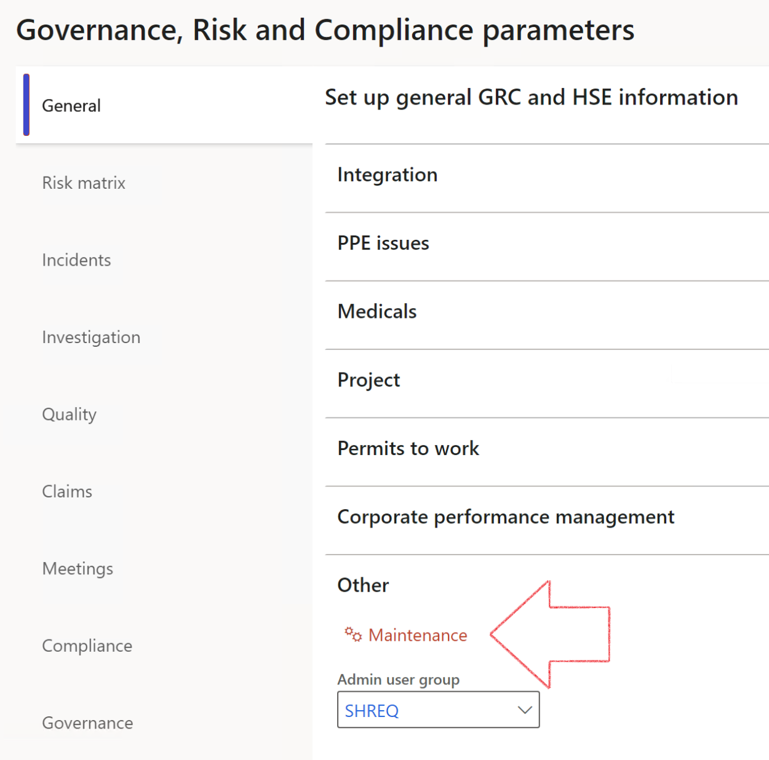

|  |  |
| --- | --- |
|  | The **Maintenance** button is there for designated user. This button repairs any possible data issues. For a full history of all Data related repairs; see table below: |

|  |  |  |
| --- | --- | --- |
| **Process** | **Description/notes** | **Release** |
| Fix location vs. work centres | Populate the new **LocationRecID** field with the related location associated with previously used work centre location (Location) fields on the following tables:   * OHSHazardLocations, * OHSRiskHazard, * OHSRiskHazardWizard, * OHSRiskRegister, * OHSRisksWizard, * OHSSafetyLocations, * OHSSafetyPermit, * OHSSafetyPermitLocations * OHSSafetyPermitOverlap, * OHSSafetyPlan, * OHSInvestigation | 10.0.80.10 |
| Fix risk hazards | Assigning the value "Default Risk" to the new mandatory field **RiskID** (Key field) where empty | 10.0.80.10 |
| Fix incident HRM injury link | Delete all orphaned records from the **OHSIncidentHRMInjuryLnk** table | 10.0.11785.3 |
| Populate SRS analysis enums | Still in concept phase. To provide a link between enum numerical value and value name for use with BYOD data entities. Enums available:   * OHSIncidentType, * OHSIncidentSeverityType.   Table populated: **SRSAnalysisEnums** | 10.0.11785.3 |
| Fix budget transaction lines stock\item dimension | Set **OHSInventDimId** field value to "**AllBlank**" on table **BudgetTransactionLine**, where no value was recorded. This will solve the issue of records not displaying in the form.  **Note: this step will only fix existing budget transaction records in the system. Should any new transactions be uploaded or changed via the data entity Budget Account Entries, special care needs to be taken to specify the Stock dimension = AllBlank and the Item on the excel sheet to import.** | 10.1.1366.6 |

The information contained in this document represents the current view of Axnosis and Microsoft Corporation on the issues discussed as of the date of publication. Because Axnosis and Microsoft must respond to changing market conditions, this document should not be interpreted to be a commitment on the part of Axnosis and Microsoft, and Axnosis and Microsoft cannot guarantee the accuracy of any information presented after the date of publication.

This test script is for informational purposes only. AXNOSIS AND MICROSOFT MAKE NO WARRANTIES, EXPRESS, IMPLIED, OR STATUTORY, AS TO THE INFORMATION IN THIS DOCUMENT.

Complying with all applicable copyright laws is the responsibility of the user. Without limiting the rights under copyright, no part of this document may be reproduced, stored in or introduced into a retrieval system, or transmitted in any form or by any means (electronic, mechanical, photocopying, recording, or otherwise), or for any purpose, without the express written permission of Axnosis and Microsoft Corporation.

Axnosis and Microsoft may have patents, patent applications, trademarks, copyrights, or other intellectual property rights covering subject matter in this document. Except as expressly provided in any written license agreement from Axnosis and Microsoft, the furnishing of this document does not give you any license to these patents, trademarks, copyrights, or other intellectual property.

© 2021 Microsoft Corporation. All rights reserved. Any use or distribution of these materials without express authorization of Microsoft Corp. is strictly prohibited.

Microsoft and Windows are both registered trademarks of Microsoft Corporation in the United States and/or other countries.

The names of actual companies and products mentioned herein may be the trademarks of their respective owners.