
Dynamics TMS Release notes



Treasury Management Software

for

Microsoft Dynamics 365 for Finance and Operations™

Dynamics TMS product version: 10.37.1974.3

2026-05-06



Dynamics 365 FO TMS module  TMS is an add-on for Dynamics 365 suite of business application software.  This software provides functionality to support Treasury management as per the depicted sub-modules. The D365 Finance and Operations core is developed and owned by Microsoft. | 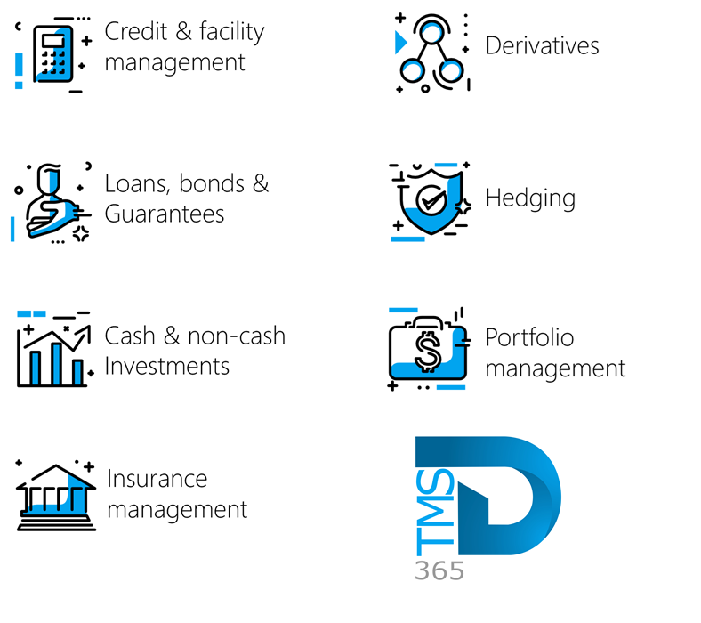

Release version

TMS Package version: TMS_DeployablePackage_10_37_1974_3

This package was created on Microsoft Dynamics 365 for Finance and Operations:

Release | Version | Build number
Application release | 10.0.47 | 10.0.2527.93
Platform release | Platform update 71 | 7.0.7858.80
Treasury management system | 10.35.2157.8 (isv)

Enhancements:
Module | Description
Loans | - New enhancements on Loan providers and receivers:  - When navigating to Treasury > Loans > Setup for Loans > Loan providers and receivers and expanding the General FastTab, a new section named Tracking is now available.  - This Tracking section includes the following fields:  - Created by  - Modified by  - Created date and time  - Modified date and time  - In addition, the Loan providers and receivers table data entity has been updated to include the following fields:  - Created by  - Modified by  - Created date and time  - Modified date and time  - Users can now export the Loan providers and receivers table data entity and view these tracking details in the exported data.

The information contained in this document represents the current view of Axnosis and Microsoft Corporation on the issues discussed as of the date of publication. Because Axnosis and Microsoft must respond to changing market conditions, this document should not be interpreted to be a commitment on the part of Axnosis and Microsoft, and Axnosis and Microsoft cannot guarantee the accuracy of any information presented after the date of publication.
This test script is for informational purposes only. AXNOSIS AND MICROSOFT MAKE NO WARRANTIES, EXPRESS, IMPLIED, OR STATUTORY, AS TO THE INFORMATION IN THIS DOCUMENT.
Complying with all applicable copyright laws is the responsibility of the user. Without limiting the rights under copyright, no part of this document may be reproduced, stored in or introduced into a retrieval system, or transmitted in any form or by any means (electronic, mechanical, photocopying, recording, or otherwise), or for any purpose, without the express written permission of Axnosis and Microsoft Corporation.
Axnosis and Microsoft may have patents, patent applications, trademarks, copyrights, or other intellectual property rights covering subject matter in this document. Except as expressly provided in any written license agreement from Axnosis and Microsoft, the furnishing of this document does not give you any license to these patents, trademarks, copyrights, or other intellectual property.

© 2026 Axnosis and Microsoft Corporation. All rights reserved.
Axnosis and Microsoft, The Axnosis and Microsoft Dynamics Logo, are either registered trademarks or trademarks of Axnosis and Microsoft Corporation or Axnosis and Microsoft Corporation in the United States and/or other countries. Axnosis and Microsoft Corporation is a subsidiary of Axnosis and Microsoft Corporation.

