
Dynamics TMS Release notes

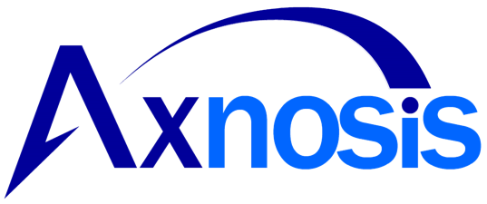

Treasury Management Software

for

Microsoft Dynamics 365 for Finance and Operations™

Dynamics TMS product version: 10.37.1974.2

2026-04-24

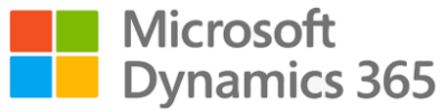

Dynamics 365 FO TMS module  TMS is an add-on for Dynamics 365 suite of business application software.  This software provides functionality to support Treasury management as per the depicted sub-modules. The D365 Finance and Operations core is developed and owned by Microsoft. | 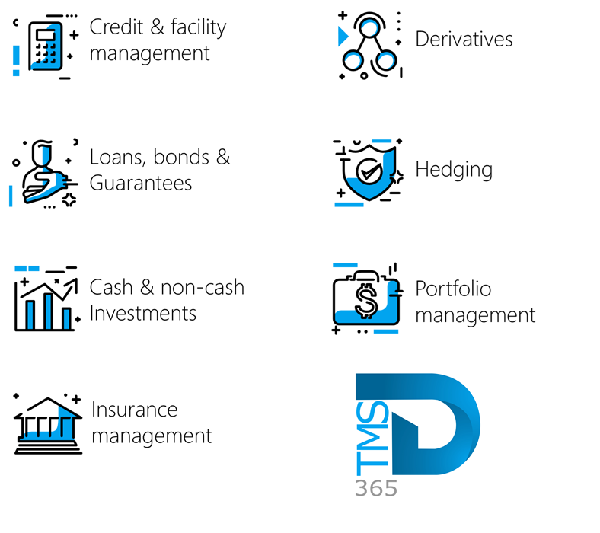

Release version

TMS Package version: TMS_DeployablePackage_10_37_1974_2

This package was created on Microsoft Dynamics 365 for Finance and Operations:

Release | Version | Build number
Application release | 10.0.47 | 10.0.2527.93
Platform release | Platform update 71 | 7.0.7858.80
Treasury management system | 10.35.2157.8 (isv)

Enhancements:
Module | Description
Registers | - On the Lines index tab of the Credit facility register, when expanding the Facility fees FastTab,  - The percentage column on the Facility FastTab was renamed  - Previously it displayed as Percentage  - Now it displays as Percentage %
Loans | - On the Loan Groups setup page (Treasury > Loans > Setup for Loans > Loan Groups), under the Posting Profiles FastTab, the requirement for Term Allocation Posting Profile when creating a new loan group has been removed, allowing loan groups to be created without it.

Bug fixes:
Module | Description
Registers | - Two fields on the Guarantee register were displaying incorrectly.  - On the Guarantee register list page, the column previously displayed as @LIR:GuaranteeFee. This has been corrected and now displays as Guarantee Fee.  - On the Guarantee register details page, under the Insurance fees FastTab, one of the columns also displayed as @LIR:GuaranteeFee. This has been corrected and now displays as Guarantee Fee.

The information contained in this document represents the current view of Axnosis and Microsoft Corporation on the issues discussed as of the date of publication. Because Axnosis and Microsoft must respond to changing market conditions, this document should not be interpreted to be a commitment on the part of Axnosis and Microsoft, and Axnosis and Microsoft cannot guarantee the accuracy of any information presented after the date of publication.
This test script is for informational purposes only. AXNOSIS AND MICROSOFT MAKE NO WARRANTIES, EXPRESS, IMPLIED, OR STATUTORY, AS TO THE INFORMATION IN THIS DOCUMENT.
Complying with all applicable copyright laws is the responsibility of the user. Without limiting the rights under copyright, no part of this document may be reproduced, stored in or introduced into a retrieval system, or transmitted in any form or by any means (electronic, mechanical, photocopying, recording, or otherwise), or for any purpose, without the express written permission of Axnosis and Microsoft Corporation.
Axnosis and Microsoft may have patents, patent applications, trademarks, copyrights, or other intellectual property rights covering subject matter in this document. Except as expressly provided in any written license agreement from Axnosis and Microsoft, the furnishing of this document does not give you any license to these patents, trademarks, copyrights, or other intellectual property.

© 2026 Axnosis and Microsoft Corporation. All rights reserved.
Axnosis and Microsoft, The Axnosis and Microsoft Dynamics Logo, are either registered trademarks or trademarks of Axnosis and Microsoft Corporation or Axnosis and Microsoft Corporation in the United States and/or other countries. Axnosis and Microsoft Corporation is a subsidiary of Axnosis and Microsoft Corporation.

