
Dynamics TMS Release notes



Treasury Management Software

for

Microsoft Dynamics 365 for Finance and Operations™

Dynamics TMS product version: 10.35.2157.24

2026-04-01



Dynamics 365 FO TMS module  TMS is an add-on for Dynamics 365 suite of business application software.  This software provides functionality to support Treasury management as per the depicted sub-modules. The D365 Finance and Operations core is developed and owned by Microsoft. | 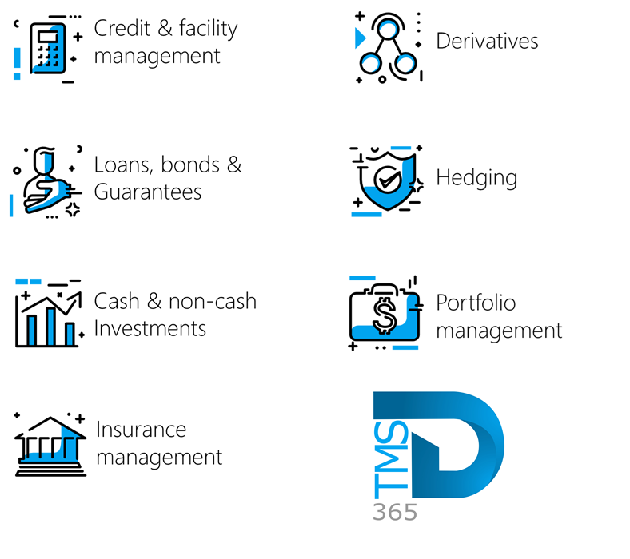

Release version

TMS Package version: TMS_DeployablePackage_10_35_2157_24

This package was created on Microsoft Dynamics 365 for Finance and Operations:

Release | Version | Build number
Application release | 10.0.46 | 10.0.2428.114
Platform release | Platform update 70 | 7.0.7778.56
Treasury management system | 10.35.2157.8 (isv)

Enhancements:
Module | Description
General | - The Amount Currency columns have been renamed to Amount across the Treasury Management Module for consistency:  - Loan Charges FastTab (Treasury > Loans > Loans)  - Loan Penalties FastTab (Treasury > Loans > Loans)  - Bank Interest FastTab (Treasury > Loans > Loans)  - Facility Fees FastTab (Treasury > Registers > Credit Facility Register)
Loans | - The Interest accrual transaction type now mirrors the functionality of Payment posting profiles by supporting Amount direction logic.  - A new Use amount direction check box has been added to the header; once enabled, an Amount direction column appears in the Account structure grid.  - So the new Amount direction column in the Account structure grid is hidden until you manually select the checkbox in the header  - This allows users to assign specific account rules for Positive, Negative, or Both amount directions via a new dropdown menu.  - When the Use amount direction is active for interest accrual journals:  - Journal Generation: Postings will be structured to reflect the specific direction of the funds (debit/credit) as defined by the transaction type.  - Loan Statements: The system will display unpaid balances as distinct, separate line items rather than a consolidated figure, providing better visibility into outstanding amounts.  - If the Use amount direction toggle is enabled on the Interest accrual posting profile, it must also be enabled on the Payment posting profile.  - Keeping these settings identical ensures that both accruals and payments are handled with a consistent accounting logic.
Loans | - The Loan charges FastTab has been modified as follows:  - On the Loans page (Treasury > Loans > Loans), under the Lines Index tab and the Loan Charges FastTab, the New and Delete buttons have been updated to Add and Remove.
Loans | - Within the Loans action pane, the button formerly known as Other (under the Journals section) is now labeled All journals

The information contained in this document represents the current view of Axnosis and Microsoft Corporation on the issues discussed as of the date of publication. Because Axnosis and Microsoft must respond to changing market conditions, this document should not be interpreted to be a commitment on the part of Axnosis and Microsoft, and Axnosis and Microsoft cannot guarantee the accuracy of any information presented after the date of publication.
This test script is for informational purposes only. AXNOSIS AND MICROSOFT MAKE NO WARRANTIES, EXPRESS, IMPLIED, OR STATUTORY, AS TO THE INFORMATION IN THIS DOCUMENT.
Complying with all applicable copyright laws is the responsibility of the user. Without limiting the rights under copyright, no part of this document may be reproduced, stored in or introduced into a retrieval system, or transmitted in any form or by any means (electronic, mechanical, photocopying, recording, or otherwise), or for any purpose, without the express written permission of Axnosis and Microsoft Corporation.
Axnosis and Microsoft may have patents, patent applications, trademarks, copyrights, or other intellectual property rights covering subject matter in this document. Except as expressly provided in any written license agreement from Axnosis and Microsoft, the furnishing of this document does not give you any license to these patents, trademarks, copyrights, or other intellectual property.

© 2026 Axnosis and Microsoft Corporation. All rights reserved.
Axnosis and Microsoft, The Axnosis and Microsoft Dynamics Logo, are either registered trademarks or trademarks of Axnosis and Microsoft Corporation or Axnosis and Microsoft Corporation in the United States and/or other countries. Axnosis and Microsoft Corporation is a subsidiary of Axnosis and Microsoft Corporation.

