
Dynamics TMS Release notes



Treasury Management Software

for

Microsoft Dynamics 365 for Finance and Operations™

Dynamics TMS product version: 10.35.2157.19

2026-02-13



Dynamics 365 FO TMS module  TMS is an add-on for Dynamics 365 suite of business application software.  This software provides functionality to support Treasury management as per the depicted sub-modules. The D365 Finance and Operations core is developed and owned by Microsoft. | 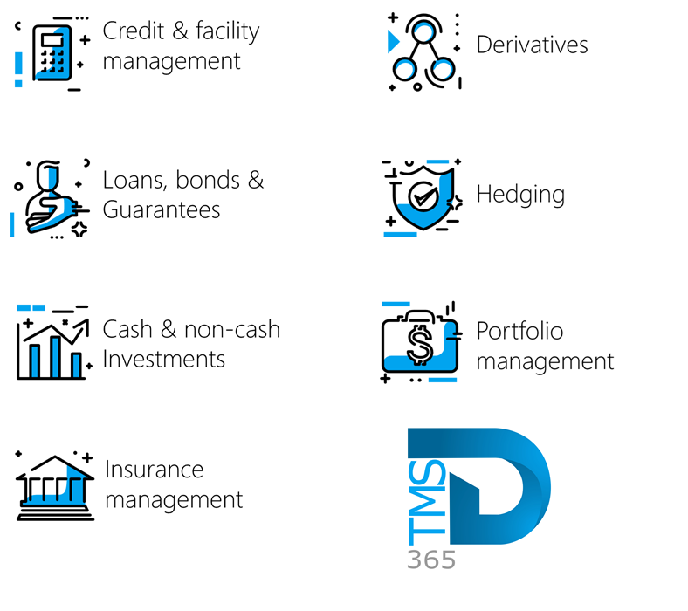

Release version

TMS Package version: TMS_DeployablePackage_10_35_2157_19

This package was created on Microsoft Dynamics 365 for Finance and Operations:

Release | Version | Build number
Application release | 10.0.46 | 10.0.2428.63
Platform release | Platform update 70 | 7.0.7778.29
Treasury management system | 10.35.2157.7 (isv)

Enhancements:
Module | Description
Registers | - The guarantee register has been enhanced as follows:  - Previously, after a journal was posted, the Delete button on the Guarantee Fees FastTab remained available. This has been changed, and now, once a journal is posted, the Delete button is now greyed out.
Registers | - Previously, when creating Guarantee Fees journals for Recurring fees, the journal did not appear on the Action menu under Recurring fees.  - This has been resolved. When a journal is created with a posting profile configured for Recurring fees, it now appears on the Action menu > Journals > Recurring fees as expected.
Registers | - On the Guarantee register, the following statuses have been updated:  - Review is now Reviewed  - Approve is now Approved
Registers | - Some minor changes have been done on the Guarantee register:  - The Guarantee Fees FastTab has been renamed to Guarantee fees, with a lowercase “f” in fees.  - The Percent column has been renamed to Percentage %.  - The total column has been renamed to Total, now starting with a capital “T”.
General | - The Integration setup menu has been moved from Treasury>Setup>Integration setup to Treasury>Setup>Interest rate>Integration setup

Bug fixes:
Module | Description
Loans | - When “Use amount direction” was enabled on the Payment posting profile, the Payment journal did not consider all relevant amounts. This issue has been resolved. The “Use amount direction” functionality now operates as intended and correctly references the Projected statement.
Loans | - The Interest Accrual report has been updated.  - Previously, the Calendar Month drop-down in the report dialog only displayed values up to 2025. This has been corrected. The drop-down now provides a range from 2015 through 2036.

The information contained in this document represents the current view of Axnosis and Microsoft Corporation on the issues discussed as of the date of publication. Because Axnosis and Microsoft must respond to changing market conditions, this document should not be interpreted to be a commitment on the part of Axnosis and Microsoft, and Axnosis and Microsoft cannot guarantee the accuracy of any information presented after the date of publication.
This test script is for informational purposes only. AXNOSIS AND MICROSOFT MAKE NO WARRANTIES, EXPRESS, IMPLIED, OR STATUTORY, AS TO THE INFORMATION IN THIS DOCUMENT.
Complying with all applicable copyright laws is the responsibility of the user. Without limiting the rights under copyright, no part of this document may be reproduced, stored in or introduced into a retrieval system, or transmitted in any form or by any means (electronic, mechanical, photocopying, recording, or otherwise), or for any purpose, without the express written permission of Axnosis and Microsoft Corporation.
Axnosis and Microsoft may have patents, patent applications, trademarks, copyrights, or other intellectual property rights covering subject matter in this document. Except as expressly provided in any written license agreement from Axnosis and Microsoft, the furnishing of this document does not give you any license to these patents, trademarks, copyrights, or other intellectual property.

© 2026 Axnosis and Microsoft Corporation. All rights reserved.
Axnosis and Microsoft, The Axnosis and Microsoft Dynamics Logo, are either registered trademarks or trademarks of Axnosis and Microsoft Corporation or Axnosis and Microsoft Corporation in the United States and/or other countries. Axnosis and Microsoft Corporation is a subsidiary of Axnosis and Microsoft Corporation.

