
Dynamics TMS Release notes



Treasury Management Software

for

Microsoft Dynamics 365 for Finance and Operations™

Dynamics TMS product version: 10.35.2157.17

2026-01-23



Dynamics 365 FO TMS module  TMS is an add-on for Dynamics 365 suite of business application software.  This software provides functionality to support Treasury management as per the depicted sub-modules. The D365 Finance and Operations core is developed and owned by Microsoft. | 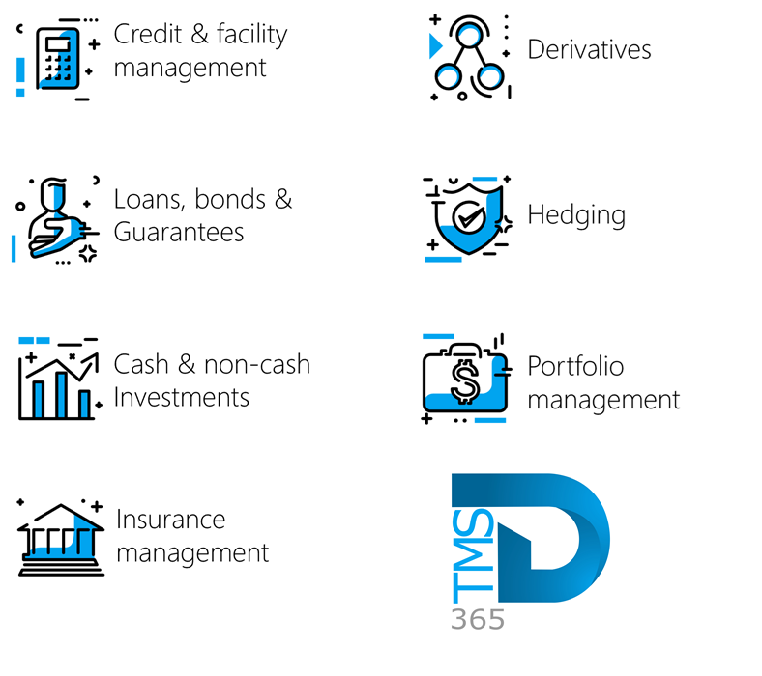

Release version

TMS Package version: TMS_DeployablePackage_10_35_2157_17

This package was created on Microsoft Dynamics 365 for Finance and Operations:

Release | Version | Build number
Application release | 10.0.45 | 10.0.2345.140
Platform release | Platform update 69 | 7.0.7690.99
Treasury management system | 10.35.2157.6 (isv)

Enhancements:
Module | Description
Registers | - The Percentage field in the Facility Fee Types setup now has active functionality.  - Entering a percentage in this field will automatically calculate the fee as a percentage of the Amount currency field for Credit Facilities.  - In the Credit Facility register, the Administration FastTab has been renamed to Facility fees.  - On the Facility Fees FastTab, the Percentage field now automatically calculates the fee based on the Amount currency field.
General | - The Treasury accountant role now has full access to loan Adjustments, which is located under Treasury > Loans > Periodic > Adjustments. This includes:  - Loan journal reversal  - Mark invoice reverse from csv  - Re-invoice invoices
Loans | - A new field, labelled Voucher, has been added to the Loan journal reversal dialogue.  - This is located under Treasury > Loans > Periodic > Adjustments > Loan journal reversal  - The new voucher field will greatly assist when reversing journal batches with multiple loans, where a loan number was left blank.
Workflow | - All workflow functionality was assigned to the Treasury Administrator role and the Treasury Accountant role.  - Issues on the existing Loan workflow were addressed:  - The Workflow button was previously only available on the loans list page when creating a new loan. It did not appear when a loan was copied. So, the Workflow button was updated to also display when a loan is created by copying an existing loan.  - When the workflow had been submitted, the following options were made available upon clicking the Workflow button again:  - Cancel workflow  - View history

Bug fixes:
Module | Description
Data management | - Previously, the Loan Balance column in the Customer Loan Balance data entity showed an incorrect amount, not matching the Total Outstanding column on the loan statement. This issue has now been resolved.

The information contained in this document represents the current view of Axnosis and Microsoft Corporation on the issues discussed as of the date of publication. Because Axnosis and Microsoft must respond to changing market conditions, this document should not be interpreted to be a commitment on the part of Axnosis and Microsoft, and Axnosis and Microsoft cannot guarantee the accuracy of any information presented after the date of publication.
This test script is for informational purposes only. AXNOSIS AND MICROSOFT MAKE NO WARRANTIES, EXPRESS, IMPLIED, OR STATUTORY, AS TO THE INFORMATION IN THIS DOCUMENT.
Complying with all applicable copyright laws is the responsibility of the user. Without limiting the rights under copyright, no part of this document may be reproduced, stored in or introduced into a retrieval system, or transmitted in any form or by any means (electronic, mechanical, photocopying, recording, or otherwise), or for any purpose, without the express written permission of Axnosis and Microsoft Corporation.
Axnosis and Microsoft may have patents, patent applications, trademarks, copyrights, or other intellectual property rights covering subject matter in this document. Except as expressly provided in any written license agreement from Axnosis and Microsoft, the furnishing of this document does not give you any license to these patents, trademarks, copyrights, or other intellectual property.

© 2026 Axnosis and Microsoft Corporation. All rights reserved.
Axnosis and Microsoft, The Axnosis and Microsoft Dynamics Logo, are either registered trademarks or trademarks of Axnosis and Microsoft Corporation or Axnosis and Microsoft Corporation in the United States and/or other countries. Axnosis and Microsoft Corporation is a subsidiary of Axnosis and Microsoft Corporation.

