
Dynamics TMS Release notes



Treasury Management Software

for

Microsoft Dynamics 365 for Finance and Operations™

Dynamics TMS product version: 10.35.2157.16

2026-01-16



Dynamics 365 FO TMS module  TMS is an add-on for Dynamics 365 suite of business application software.  This software provides functionality to support Treasury management as per the depicted sub-modules. The D365 Finance and Operations core is developed and owned by Microsoft. | 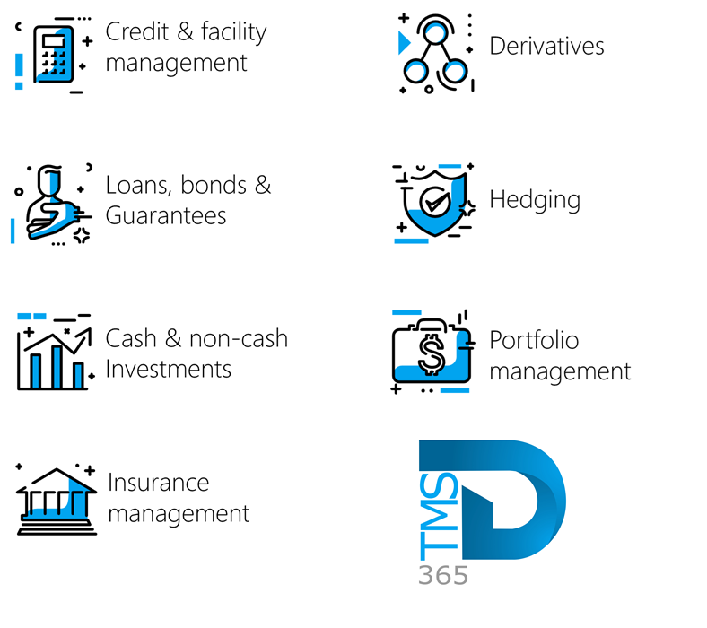

Release version

TMS Package version: TMS_DeployablePackage_10_35_2157_16

This package was created on Microsoft Dynamics 365 for Finance and Operations:

Release | Version | Build number
Application release | 10.0.45 | 10.0.2345.140
Platform release | Platform update 69 | 7.0.7690.99
Treasury management system | 10.35.2157.6 (isv)

Enhancements:
Module | Description
Registers | - A new page for the setup of Facility fee types was created. This page is located under Treasury > Registers > Setup for registers > Facility fee types  - The page includes the following FastTabs:  - General  - Posting profiles  - Fee parameters  - Financial dimensions  - General FastTab:  - Identification:  - ID  - Name  - Description  - Posting profiles FastTab:  - Posting profile for journals  - Fee parameters FastTab:  - Parameters:  - Calculation basis (Fixed or Percentage)  - Recurring (Yes or No toggle)  - Frequency (Monthly or Annually)  - Percentage  - Financial dimensions FastTab:  - Default financial dimensions
Registers | - The Credit facility register had the following enhancements:  - On the Credit facility register, the Administration fees FastTab on the Lines Index tab now includes two new columns:  - Percentage and  - Facility fee type
Data management | - A new data entity, Treasury customer invoices, has been implemented and is now available via Data Management.  - Treasury customer invoice data entity consists of the following fields:  - Customer account  - Customer name  - Loan number  - Invoice number  - Invoice status  - Address  - One-time customer indicator  - Invoice date  - Currency  - Accounting status  - Posted status  - Invoice reversed indicator  - Recurring invoice indicator  - Workflow status  - Invoice amount  - Open amount  - Loan balance  - Legal entity (dataAreaId)  - Due date

Bug fixes:
Module | Description
Hedge and derivatives | - Previously, information entered under the Derivative values FastTab in the derivative register was not retained and was cleared when the page was refreshed. This issue has been resolved, and data entered in the Derivative values FastTab is now saved and remains visible after a page refresh.

The information contained in this document represents the current view of Axnosis and Microsoft Corporation on the issues discussed as of the date of publication. Because Axnosis and Microsoft must respond to changing market conditions, this document should not be interpreted to be a commitment on the part of Axnosis and Microsoft, and Axnosis and Microsoft cannot guarantee the accuracy of any information presented after the date of publication.
This test script is for informational purposes only. AXNOSIS AND MICROSOFT MAKE NO WARRANTIES, EXPRESS, IMPLIED, OR STATUTORY, AS TO THE INFORMATION IN THIS DOCUMENT.
Complying with all applicable copyright laws is the responsibility of the user. Without limiting the rights under copyright, no part of this document may be reproduced, stored in or introduced into a retrieval system, or transmitted in any form or by any means (electronic, mechanical, photocopying, recording, or otherwise), or for any purpose, without the express written permission of Axnosis and Microsoft Corporation.
Axnosis and Microsoft may have patents, patent applications, trademarks, copyrights, or other intellectual property rights covering subject matter in this document. Except as expressly provided in any written license agreement from Axnosis and Microsoft, the furnishing of this document does not give you any license to these patents, trademarks, copyrights, or other intellectual property.

© 2026 Axnosis and Microsoft Corporation. All rights reserved.
Axnosis and Microsoft, The Axnosis and Microsoft Dynamics Logo, are either registered trademarks or trademarks of Axnosis and Microsoft Corporation or Axnosis and Microsoft Corporation in the United States and/or other countries. Axnosis and Microsoft Corporation is a subsidiary of Axnosis and Microsoft Corporation.

