
Dynamics TMS Release notes



Treasury Management Software

for

Microsoft Dynamics 365 for Finance and Operations™

Dynamics TMS product version: 10.35.2157.8

2025-11-03



Dynamics 365 FO TMS module  TMS is an add-on for Dynamics 365 suite of business application software.  This software provides functionality to support Treasury management as per the depicted sub-modules. The D365 Finance and Operations core is developed and owned by Microsoft. | 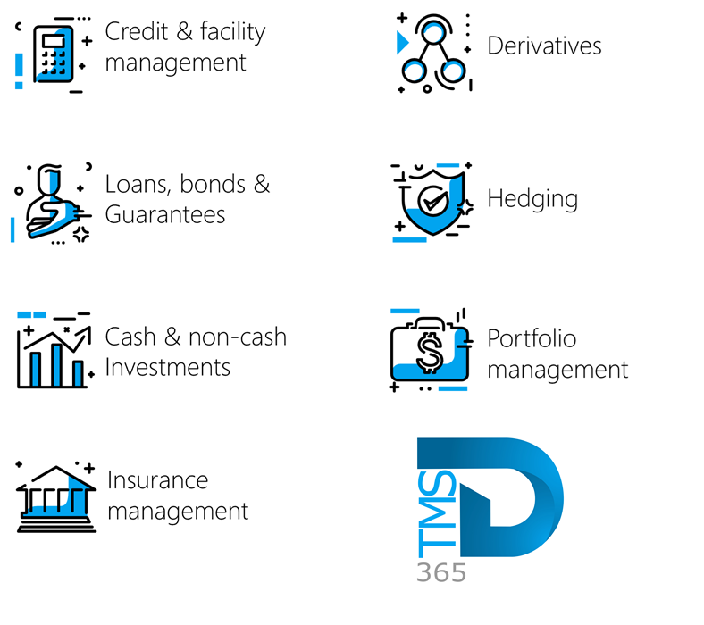

Release version

TMS Package version: TMS_DeployablePackage_10_35_2157_8

This package was created on Microsoft Dynamics 365 for Finance and Operations:

Release | Version | Build number
Application release | 10.0.45 | 10.0.2345.71
Platform release | Platform update 69 | 7.0.7690.69
Treasury management system | 10.35.2157.3 (isv)

Enhancements:
Module | Description
Budgeting | - Transactions from the Guarantee register are now incorporated into budgeting.  - Users now have the ability to manually add different types of fees, on a line-by-line basis, to a Guarantee  - To include these transactions, the new Batch cash flow budget creation batch job should be run.  - To execute the new batch job, go to Treasury > Common > Periodic > Batch cash flow budget creation  - The Batch cash flow budget creation parameters include:  - Budget model (select from a drop-down menu)  - Budget code (select from a drop-down menu)  - Add/Replace budget lines (choose to add budget lines, or to replace budget lines)  - Budget currency (Original, Default or Secondary)  - Investment status (choose between Proposed, Approved or All)  - Run for Loans Yes/No toggle  - Run for Investments Yes/No toggle  - Run for Guarantees Yes/No toggle  - The Batch cash flow budget creation logic:  - Create budget register entries going forward, using today as the start date  - If a line exists in the budget, it will not create it again  - The Date and Amount will be obtained from the Guarantee fee line  - If it is a recurring fee, it will use the future recurring lines (as configured, for example monthly)  - The account is obtained from the guarantee posting profile. It will use the first account in the setup  - It will default as an expense type  - The Budget type will default to Original  - More than one Account structure can be possible. Possibilities are setup in the General Ledger setup  - To view budget register entries, navigate to Budgeting > Workspaces > Budget register entries, and select the latest Entry number. Then, expand the Budget account entries FastTab to display the relevant information.  - On the Guarantee register, a new FastTab called Guarantee fees has been created  - It has the following buttons:  - New  - Delete  - Create fees journal  - Recurrence  - Clicking on the Recurrence button, will enable the user to setup a recurrence schedule (start date, amount, currency, frequency)  - The Guarantee Fees FastTab consist of the following columns:  - Date  - Name  - Fee type  - Amount (Fixed fee gives the user the option to type in the value)  - Percent (Percentage auto-calculates the fee as a percentage of the Total guarantee value field)  - Total  - Currency  - Journal batch  - Note  - Recurring fee

Bug fixes:
Module | Description
Loans | - The New and Delete buttons were previously displayed incorrectly at the top of the Period Interest Inquiry and Projected Interest Report screens. These buttons have now been removed.  - The Period interest inquiry is located under Treasury>Hedge and derivatives>Inquiries and reports>Period interest inquiry  - The Projected Interest report is located under Treasury>Loans>Inquiries and reports>Projected interest report

The information contained in this document represents the current view of Axnosis and Microsoft Corporation on the issues discussed as of the date of publication. Because Axnosis and Microsoft must respond to changing market conditions, this document should not be interpreted to be a commitment on the part of Axnosis and Microsoft, and Axnosis and Microsoft cannot guarantee the accuracy of any information presented after the date of publication.
This test script is for informational purposes only. AXNOSIS AND MICROSOFT MAKE NO WARRANTIES, EXPRESS, IMPLIED, OR STATUTORY, AS TO THE INFORMATION IN THIS DOCUMENT.
Complying with all applicable copyright laws is the responsibility of the user. Without limiting the rights under copyright, no part of this document may be reproduced, stored in or introduced into a retrieval system, or transmitted in any form or by any means (electronic, mechanical, photocopying, recording, or otherwise), or for any purpose, without the express written permission of Axnosis and Microsoft Corporation.
Axnosis and Microsoft may have patents, patent applications, trademarks, copyrights, or other intellectual property rights covering subject matter in this document. Except as expressly provided in any written license agreement from Axnosis and Microsoft, the furnishing of this document does not give you any license to these patents, trademarks, copyrights, or other intellectual property.

© 2025 Axnosis and Microsoft Corporation. All rights reserved.
Axnosis and Microsoft, The Axnosis and Microsoft Dynamics Logo, are either registered trademarks or trademarks of Axnosis and Microsoft Corporation or Axnosis and Microsoft Corporation in the United States and/or other countries. Axnosis and Microsoft Corporation is a subsidiary of Axnosis and Microsoft Corporation.

