
Dynamics TMS Release notes



Treasury Management Software

for

Microsoft Dynamics 365 for Finance and Operations™

Dynamics TMS product version: 10.35.2157.13

2025-12-12



Dynamics 365 FO TMS module  TMS is an add-on for Dynamics 365 suite of business application software.  This software provides functionality to support Treasury management as per the depicted sub-modules. The D365 Finance and Operations core is developed and owned by Microsoft. | 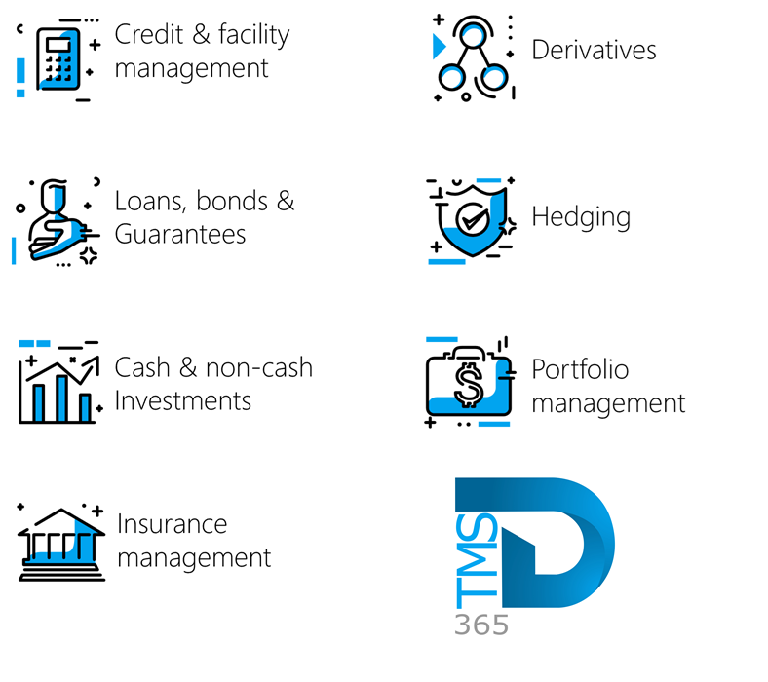

Release version

TMS Package version: TMS_DeployablePackage_10_35_2157_13

This package was created on Microsoft Dynamics 365 for Finance and Operations:

Release | Version | Build number
Application release | 10.0.45 | 10.0.2345.71
Platform release | Platform update 69 | 7.0.7690.69
Treasury management system | 10.35.2157.4 (isv)

Enhancements:
Module | Description
Hedge and derivatives | - The Period Interest Inquiry has been revised.  - Previously, the calculation included unposted interest accrual journals; going forward, these unposted journals will be disregarded by the report.
Hedge and derivatives | - The derivatives functionality has been improved. Going forward, the system will:  - No Subsequent Measurement journal will be created after a contract expires.  - Closed positions will not generate a Subsequent Measurement journal.  - Only one Subsequent Measurement journal will be created per month to prevent duplicates.
Loans | - A new filter for Loans is now available in Treasury Parameters Setup.  - A new toggle, “Enable Ledger Company Filtering,” has been added under the Filters FastTab in Treasury Parameters Setup > Features.  - When the Enable Ledger Company Filtering toggle is set to Yes, the Select companies filter becomes available on Loan Journal pages (Treasury > Loans > Journals), and the New button is hidden.  - When the Enable Ledger Company Filtering toggle is set to No , the Select companies filter is not shown on the Loan journal pages (Treasury > Loans > Journals), and the New button becomes available.  - Note: Regardless of this setting, the Select companies filter will not appear when navigating through Treasury > Loans > Loans and then opening the journals.  - On those pages, the New button is always available. Therefore, these pages are unaffected by the new filter.

Bug fixes:
Module | Description
Loans | - Refund Batch Job Improvements:  - The batch job now runs significantly faster, processing a loan refund in under a minute.  - The previous warning about “Calendar does not cover loan period” no longer appears unnecessarily.  - The system no longer searches for an end date far in the future, eliminating delays.
Loans | - Manual Loan journal creation fixed:  - The New and Delete buttons, which were previously greyed out, are now fully functional.  - Users can manually create new loan journals (Capital, Interest Accrual, Payment, Write-off, and Refund) directly under Treasury > Loans.  - Journals no longer need to be created exclusively via batch jobs.
Data management | - Customer loan balances data entity fix:  - The Loan Balance on the Customer Loan Balances data entity now aligns with the Total Outstanding amount from the Actual Loan Statement.  - Loan balances are now derived from the Actual Loan Statement rather than the Projected Loan Statement, ensuring accurate reporting.

The information contained in this document represents the current view of Axnosis and Microsoft Corporation on the issues discussed as of the date of publication. Because Axnosis and Microsoft must respond to changing market conditions, this document should not be interpreted to be a commitment on the part of Axnosis and Microsoft, and Axnosis and Microsoft cannot guarantee the accuracy of any information presented after the date of publication.
This test script is for informational purposes only. AXNOSIS AND MICROSOFT MAKE NO WARRANTIES, EXPRESS, IMPLIED, OR STATUTORY, AS TO THE INFORMATION IN THIS DOCUMENT.
Complying with all applicable copyright laws is the responsibility of the user. Without limiting the rights under copyright, no part of this document may be reproduced, stored in or introduced into a retrieval system, or transmitted in any form or by any means (electronic, mechanical, photocopying, recording, or otherwise), or for any purpose, without the express written permission of Axnosis and Microsoft Corporation.
Axnosis and Microsoft may have patents, patent applications, trademarks, copyrights, or other intellectual property rights covering subject matter in this document. Except as expressly provided in any written license agreement from Axnosis and Microsoft, the furnishing of this document does not give you any license to these patents, trademarks, copyrights, or other intellectual property.

© 2025 Axnosis and Microsoft Corporation. All rights reserved.
Axnosis and Microsoft, The Axnosis and Microsoft Dynamics Logo, are either registered trademarks or trademarks of Axnosis and Microsoft Corporation or Axnosis and Microsoft Corporation in the United States and/or other countries. Axnosis and Microsoft Corporation is a subsidiary of Axnosis and Microsoft Corporation.

