
Dynamics TMS Release notes



Treasury Management Software

for

Microsoft Dynamics 365 for Finance and Operations™

Dynamics TMS product version: 10.35.2157.10

2025-11-18



Dynamics 365 FO TMS module  TMS is an add-on for Dynamics 365 suite of business application software.  This software provides functionality to support Treasury management as per the depicted sub-modules. The D365 Finance and Operations core is developed and owned by Microsoft. | 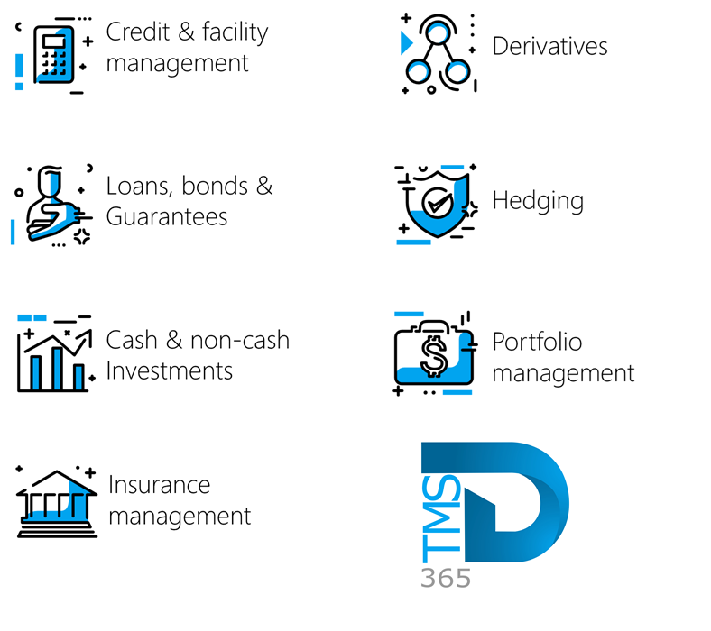

Release version

TMS Package version: TMS_DeployablePackage_10_35_2157_10

This package was created on Microsoft Dynamics 365 for Finance and Operations:

Release | Version | Build number
Application release | 10.0.45 | 10.0.2345.71
Platform release | Platform update 69 | 7.0.7690.69
Treasury management system | 10.35.2157.4 (isv)

Enhancements:
Module | Description
Loans | - A new “Select companies” filter is now available on all Treasury Loan journal pages. This enhancement allows users to view journals from one or multiple companies while remaining in a single legal entity. There is no longer a need to navigate to each company individually, the relevant journals for the selected companies will automatically display.  - The following loan journal pages now include this filter:  - Treasury > Loans > Journals > Loan capital  - Treasury > Loans > Journals > Interest accrual  - Treasury > Loans > Journals > Term allocation  - Treasury > Loans > Journals > Payments  - Treasury > Loans > Journals > Manual  - Treasury > Loans > Journals > Write-off  - Treasury > Loans > Journals > Transfer to collection  - Treasury > Loans > Journals > Refund
Registers | - A new menu item has been added for configuring Guarantee Fee Types. It can be found under Treasury > Registers > Setup for Registers > Guarantee Fee Types. The page is organized into four FastTabs:  - General  - Identification ID  - Name  - Description  - Posting profiles  - A posting profile for journals can be selected  - Fee parameters  - Calculation basis (Percentage or Fixed)  - Frequency (Monthly or Annually  - Financial dimensions  - The Default financial dimensions can be selected.

Bug fixes:
Module | Description
Investments | - Previously, journals created for a Cash Investment did not appear on the Journals FastTab. This issue has now been resolved, and all related journals are correctly displayed under the Journals FastTab of Cash Investments.
Budgeting  Registers | - Previously, the Account structure fields did not populate when running the Batch Cash Flow Budget Creation task. This issue has been resolved. The Account structure fields on the Budget Account Entries FastTab of the Budget Register Entry will now populate automatically.

The information contained in this document represents the current view of Axnosis and Microsoft Corporation on the issues discussed as of the date of publication. Because Axnosis and Microsoft must respond to changing market conditions, this document should not be interpreted to be a commitment on the part of Axnosis and Microsoft, and Axnosis and Microsoft cannot guarantee the accuracy of any information presented after the date of publication.
This test script is for informational purposes only. AXNOSIS AND MICROSOFT MAKE NO WARRANTIES, EXPRESS, IMPLIED, OR STATUTORY, AS TO THE INFORMATION IN THIS DOCUMENT.
Complying with all applicable copyright laws is the responsibility of the user. Without limiting the rights under copyright, no part of this document may be reproduced, stored in or introduced into a retrieval system, or transmitted in any form or by any means (electronic, mechanical, photocopying, recording, or otherwise), or for any purpose, without the express written permission of Axnosis and Microsoft Corporation.
Axnosis and Microsoft may have patents, patent applications, trademarks, copyrights, or other intellectual property rights covering subject matter in this document. Except as expressly provided in any written license agreement from Axnosis and Microsoft, the furnishing of this document does not give you any license to these patents, trademarks, copyrights, or other intellectual property.

© 2025 Axnosis and Microsoft Corporation. All rights reserved.
Axnosis and Microsoft, The Axnosis and Microsoft Dynamics Logo, are either registered trademarks or trademarks of Axnosis and Microsoft Corporation or Axnosis and Microsoft Corporation in the United States and/or other countries. Axnosis and Microsoft Corporation is a subsidiary of Axnosis and Microsoft Corporation.

